Inventory Management System

(IMS)

User Manual

Systems Plus Solutions

Hiranandani House,

Saraswat Lane,

Santacruz (W), Off Link Road,

Mumbai - 400054. INDIA

Web: [www.systems-plus.com](http://www.systems-plus.com/)

Contents

Overview: 5

Objective: 5

Login 6

Masters 7

Tax Master 7

Term Master 9

Item Group Master 10

Item Type Master 11

Item Master 12

Currency Master 14

Customer Group Master 15

Customer Master 17

Supplier Master 20

Transporter Master 23

Special Price Request (SPR) Master 24

Location Master 26

Replacement Item Master 27

Business Line Master..........................................................................................28

Regular 28

Internal Order 29

Replacement (IOF) 31

Stocking (IOF) 33

Sales Order 34

Purchase Order 36

Purchase Order Tracking 39

Payment Entry 40

Closing Screen 41

Credit Note ………………………………..……………………………………………………42

Debit Note ……..……………………………………………………………………………….43

Stand By 42

Stand By Given (IOF) 43

Stand By Taken (PO) 45

Stock Transfer 47

Stock De-Allocation 47

Stock Adjustment 49

Opening Balance 50

Inter Branch Stock Transfer 51

Dispatch 52

Dispatch Note 53

Delivery Challan 55

Invoice Entry 57

Inter Branch Invoice Entry 59

Goods Receipt Note 60

GRN - Against PO 61

GRN - Against Verbal 62

GRN - Against Goods Return 64

GRN - Against Inter Branch Transfer 65

GRN - Against Stand By Received 67

GRN - Against Stand by Return 68

GRN - Against Replacement 69

Report - Pending Status 70

Pending Entries 71

Pending IOF for SOF creation 73

Pending IOF for PO creation 74

Pending SOF for PO creation 75

Status Report 76

IOF Status 76

Customer Order Status 77

PO Status Supplier Wise 78

PO Status Customer Wise 79

GRN Details-Supplier Wise 80

GRN Details-Customer Wise 81

Account Manager Wise Sales 82

Product Wise Sales 83

Stock Report 82

Stock on Hand-Customer Wise 82

Stock on Hand-Item Wise 83

Stock on Hand-Item Wise as On Date 84

Stock Ledger 85

Stock Ledger as On Date 86

Stock With Tax Details 87

Item Listing 88

Weekly Stock Status 89

Billing Details 90

SOF - Invoice Details Customer Wise 90

Billing Details - Item Wise 91

Billed DC Customer wise 92

Billing Details - Summary 93

Customer Outstanding 94

Customer Ledger 95

SOF-Invoice 96

Pending DC For Invoice 97

Item Wise 97

Item Wise (Value) 98

Customer Wise 99

Customer Wise (Value) 100

Weighted Average 101

Weighted Average Customer Wise 101

Unbilled Weighted Average 102

Weighted Average (Without Tax) 103

Weighted Average - Customer Wise (Without Tax) 103

Unbilled Weighted Average Report (Without Tax) 104

Bank Report 105

Bank Report - Item Wise 105

Bank Report - Customer Wise 106

Bank Report (Without Tax) 107

Bank Report - Customer Wise (Without Tax) 107

Bank Report - Item Wise (Without Tax) 108

Stock Aging 109

Stock Ageing - Item Wise 109

Stock Ageing - Customer Wise 110

PO Reminder 112

## 

# Overview:

The Inventory Management System (INVPLUS) has been developed for Sigma Byte which is India's largest Network Cabling Integrators. Sigma Byte specializes in the field of optical fiber installation & maintenance services for large campus wide & Outside Plant networks.

With increase in business and location it’s getting quite cumbersome to keep track of the stock manually. Hence it’s getting mandatory to develop a robust system, which would provide an online stock status and stock tracking system.

The ‘Inventory Management System’ (INVPLUS) tracks the inventory for all the locations/warehouse.

# Objective:

Establish a systematic Process across the region.

# Login

**Overview**

This is the entry screen for the Application. User for a particular company is authenticated through this form.

**Page Snapshot: Login**

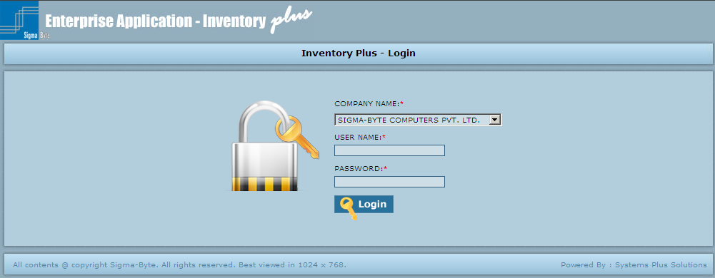

**Field Description**

|  |  |
| --- | --- |
| **Field Name** | **Description** |
| Company Name | To select the Company Name. |
| User Name | To enter User Name. |
| Password | To enter Password. |
| Login | To Login the Application by entering login details. |

# Masters

**Overview**

Masters Menu has Submenus as

* Tax Master
* Term Master
* Item Group Master
* Item Type Master
* Item Master
* Currency Master
* Customer Group Master
* Customer Master
* Supplier Master
* Transporter Master
* Special Price Request(SPR)
* Location Master
* Replacement Item Master

**Page Snapshot: Masters Menu**

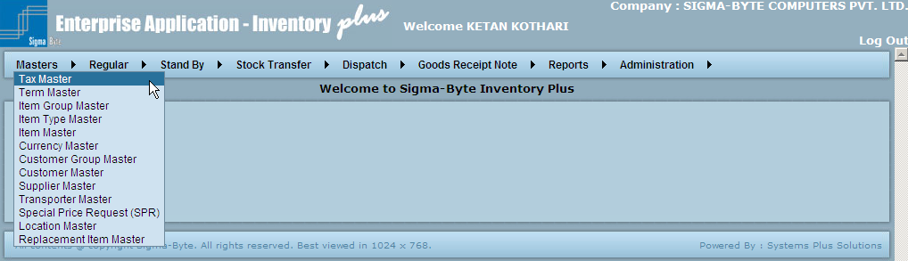

### Tax Master

**Overview**

This Master defines the various taxes that can be used in the transactions done at Branches.

The Tax type defines if it a Sales tax or Purchase Tax.

**Page Snapshot: Add Tax**

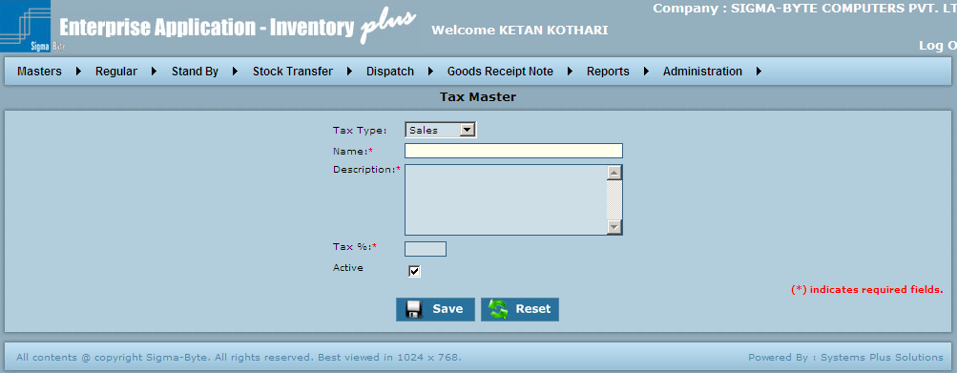

**Field Description**

|  |  |
| --- | --- |
| **Field Name** | **Description** |
| Tax Type | To select the Tax Type.(Sales, Purchase) |
| Name | To add Tax Name. |
| Description | To add Tax Description. |
| Tax % | To add Tax Percentage. |
| Save | To add Tax to the system. |
| Reset | To clear all the values in the Master screen. |

**Page Snapshot: Modify Tax**

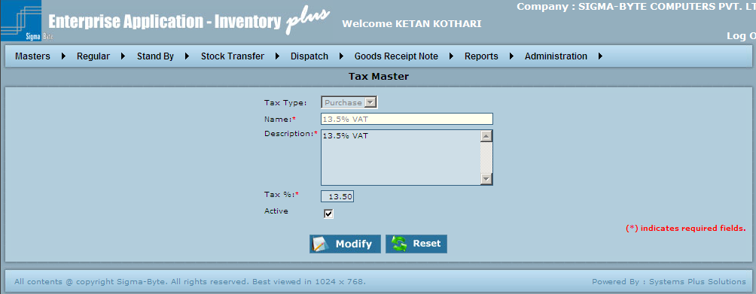

### Term Master

**Overview**

This Master defines the various terms of Payment that can be used in the transactions done at Branches.

Enter an appropriate description & name for a new term.

**Page Snapshot: Add Term**

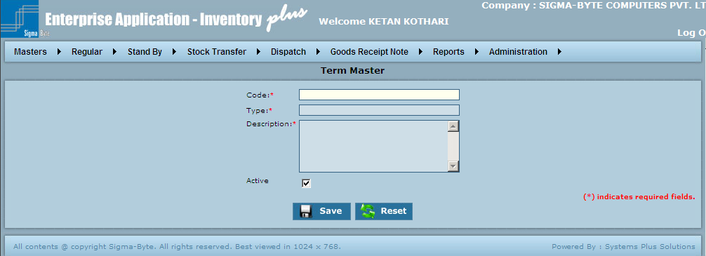

**Field Description**

|  |  |
| --- | --- |
| **Field Name** | **Description** |
| Code | To add Term Code. |
| Type | To add Term Type. |
| Description | To add Term Description. |
| Active | Shows whether the selected Term is active or not. |
| Save | To add Term to the system. |
| Reset | To clear all the values in the Master screen. |

**Page Snapshot: Modify Term**

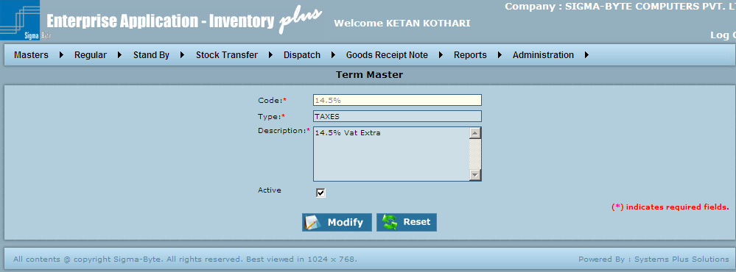

### Item Group Master

**Overview**

Items are grouped under different Groups. User can make a new Item Group through this master.

Enter an appropriate Item Group Code & Group Name for a new group.

All Items in system belong to some or the other group.

**Page Snapshot: Add Item Group**

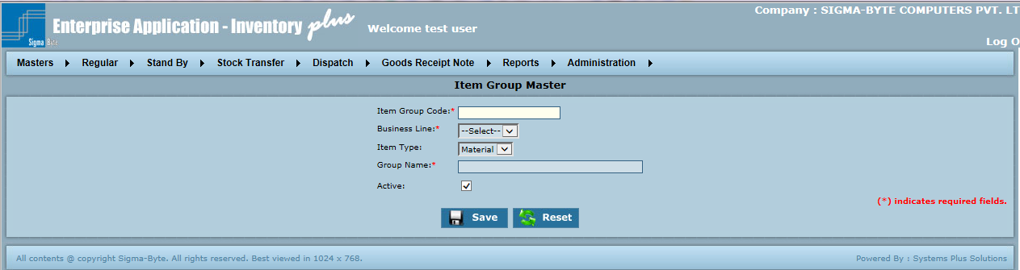

**Field Description**

|  |  |
| --- | --- |
| **Field Name** | **Description** |
| Item Group Code | To add Item Group Code. |
| Business Line | To select Business Line. |
| Item Type | To select Item Type. |
| Group Name | To add Group Name. |
| Active | Shows whether the selected Item Group is active or not. |
| Save | To add Item Group to the system. |
| Reset | To clear all the values in the Master screen. |

**Page Snapshot: Modify Item Group**

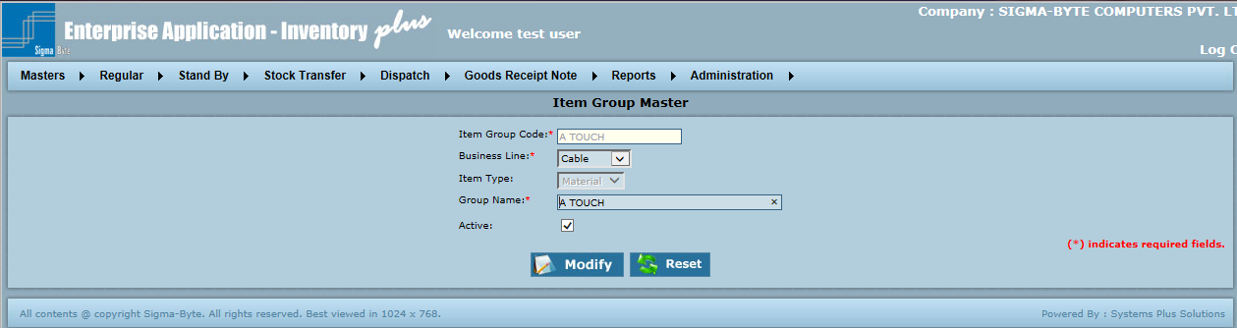

### Item Type Master

**Overview**

This Master defines the various Item Types such as Item Color, Item Category, Item Capacity, Item Unit, Item Sub Group.

Enter an appropriate Item Code, Description & Active status by selecting Item type for a new Item Code.

**Page Snapshot: Add Item Type**

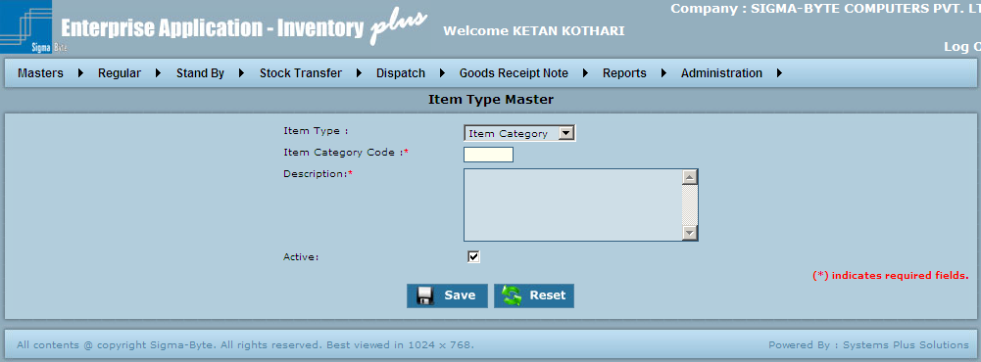

**Field Description**

|  |  |
| --- | --- |
| **Field Name** | **Description** |
| Item Type | To select Item Type. |
| Item Code | To add Item Code. |
| Description | To add Description. |
| Active | Shows whether the selected Item Type is active or not. |
| Save | To add Item Type to the system. |
| Reset | To clear all the values in the Master screen. |

**Page Snapshot: Modify Item Type**

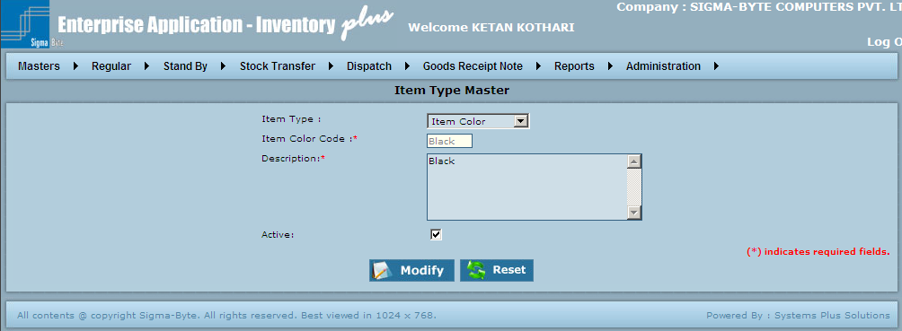

### Item Master

**Overview**

New Items can be added to the existing ones by this master. Select an Item Group in which the item is to be added.

Select appropriate Category, Capacity / Length, Category, Color, etc from the selection boxes.

Fill in other description as applicable & save the entry.

Check the Active box to enable transactions for that item. If this box is unchecked, the Item will not be visible on any screen except for the Item Master screen.

Transactions can now be done for the new item.

The Item Description is normally a combination of Item Name, Category, Color & Capacity.

Also the Item Code has to be unique irrespective of the Item Group.

**Page Snapshot: Add Item**

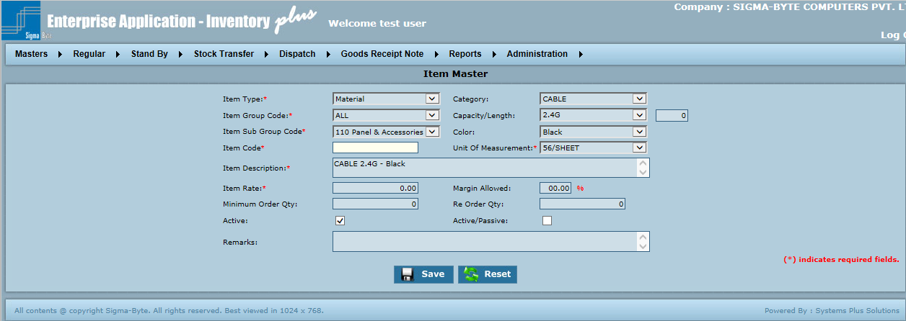

**Field Description**

|  |  |
| --- | --- |
| **Field Name** | **Description** |
| Item Type | To select Item Type. |
| Category | To select Category. |
| Item Group Code | To select Item Group Code. |
| Capacity/Length | To select Capacity/Length. |
| Item Sub Group Code | To selectItem Sub Group .Code |
| Color | To select Color. |
| Item Code | To add Item Code. |
| Unit Of Measurement | To select Unit of Measurement. |
| Item Description | To add Item Description. |
| Item Rate | To add Item Rate. |
| Margin Allowed | To add Margin allowed. |
| Minimum Order Quantity | To add Minimum Order Quantity. |
| Re Order Quantity | To add Re Order Quantity. |
| Active | Shows whether the selected Item is active or not. |
| Active/Passive | Shows whether the selected Item is active or Passive. Passive Items won’t be tracked by serial numbers whereas If this checkbox is checked particular Item will be tracked by serial nos. |
| Remarks | To add Remarks. |
| Save | To add Item Type to the system. |
| Reset | To clear all the values in the Master screen. |

**Page Snapshot: Modify Item**

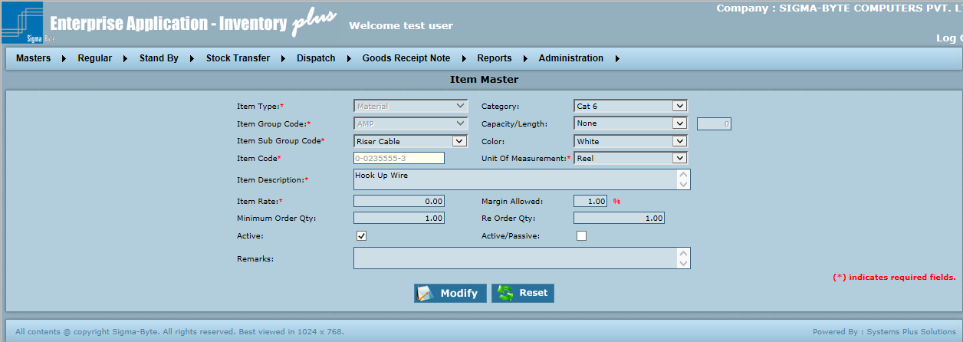

### Currency Master

**Overview**

Transactions can be done across the globe. This necessitates the use of different currencies. To enable transactions in different currencies, this master can be used.

Enter appropriate details for the new currency & save the same.

The new currency can now be taken into different transactions.

**Page Snapshot: Add Currency**

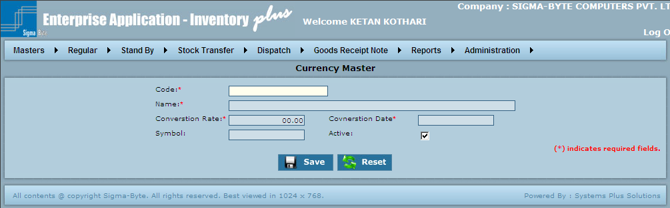

**Field Description**

|  |  |
| --- | --- |
| **Field Name** | **Description** |
| Code | To add Currency Code. |
| Name | To add Currency Name. |
| Conversion Rate | To add Conversion Rate. |
| Conversion Date | To add Conversion Date. |
| Save | To add Currency to the system. |
| Reset | To clear all the values in the Master screen. |

**Page Snapshot: Modify Currency**

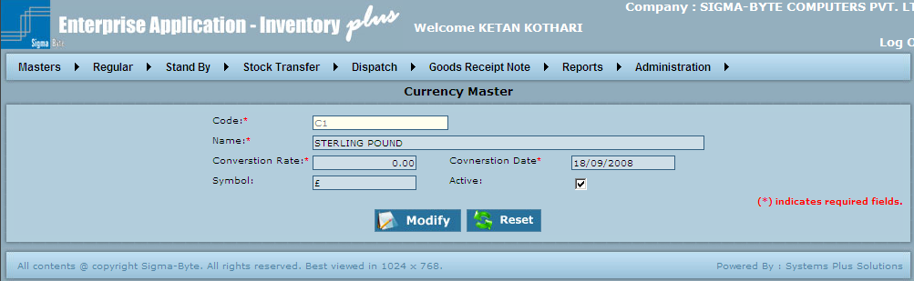

### Customer Group Master

**Overview**

This master is used to add new customer group.

**Page Snapshot: Add Customer Group Master**

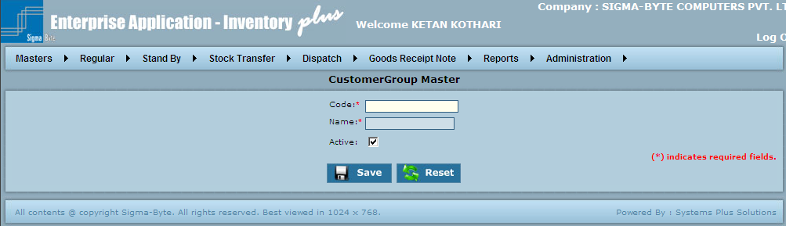

**Field Description**

|  |  |
| --- | --- |
| **Field Name** | **Description** |
| Code | To add Customer Group Code. |
| Name | To add Customer Group Name. |
| Active | Shows whether the selected Customer Group is active or not. |
| Save | To add Customer Group to the system. |
| Reset | To clear all the values in the Master screen. |

**Page Snapshot: Modify Customer Group Master**

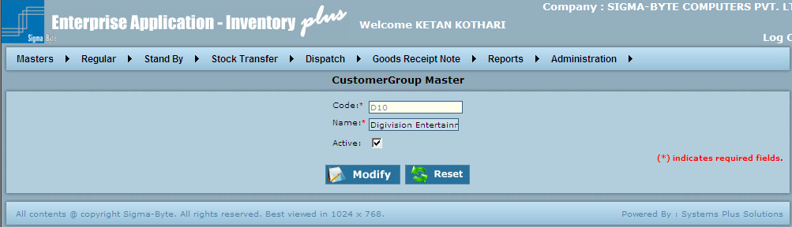

**Customer Master**

**Overview**

This Master is used to add new customer to the system.

**Page Snapshot: Add Customer**

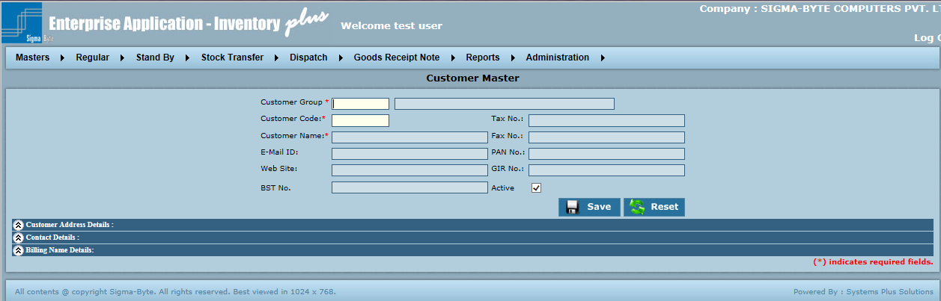

**Field Description**

|  |  |
| --- | --- |
| **Field Name** | **Description** |
| Customer Group | To add Customer Group Code. |
| Customer Code | To add Customer Group Name. |
| Tax No | To add Tax No. |
| Customer Name | To add Customer Name. |
| Fax No | To add Fax No. |
| E-Mail ID | To add E-Mail ID. |
| PAN No | To add PAN No. |
| Web Site | To add Web Site. |
| GIR No | To add GIR No. |
| TIN No | To add TIN No. |
| BST No | To add BST No. |
| Active | Shows whether the selected Customer is active or not. |
| Save | To add Customer to the system. |
| Reset | To clear all the values in the Master screen. |
| **Customer Address Details** |  |
| Address Type | To select Address Type. |
| City | To add City. |
| Site Name | To add Site Name. |
| State | To add State. |
| Address | To add Address. |
| Country | To add Country. |
| Zip | To add Zip No. |
| Active | Shows whether the selected Customer Details are active or not. |
| Save | To save Customer Address Details. |
| Reset | To clear values in Customer Address details. |
| Customer Address Details List | To Edit or Delete Customer Address Details. |
| **Contact Details Billing** |  |
| Contact Name | To add Contact Name. |
| Contact Phone | To add Contact Phone. |
| Active | Shows whether the selected Contact Details are active or not. |
| Save | To save Contact Details. |
| Reset | To Reset values in Contact Details screen. |
| Contact Details List | To Edit/Delete Contact Details. |
| **Billing Name Details** |  |
| Billing Name | To add Billing Name. |
| Active | Shows whether the selected Billing Name Details are active or not. |
| Save | To save Billing Name Details. |
| Reset | To clear all values in Billing Name details. |
| Billing Name Details | To Edit/Delete Billing Name Details. |

**Page Snapshot: Modify Customer**

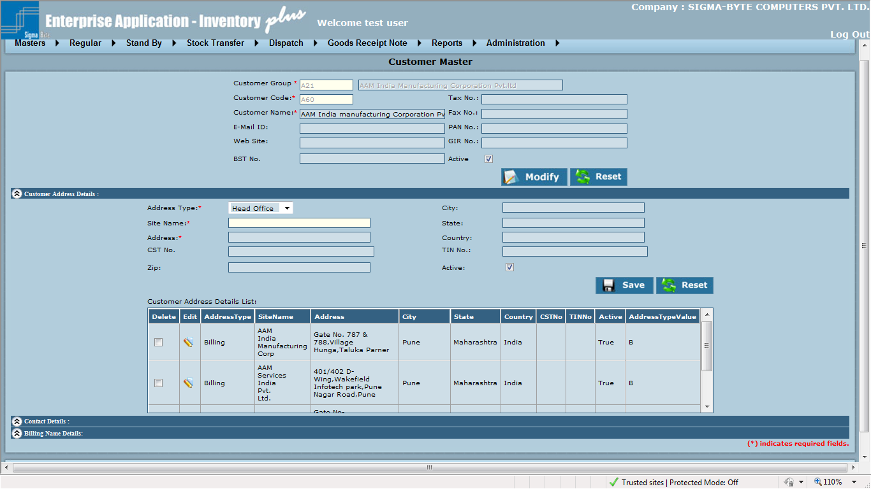

**Supplier Master**

**Overview**

This Master is used to add new supplier to the system.

**Page Snapshot: Add Supplier**

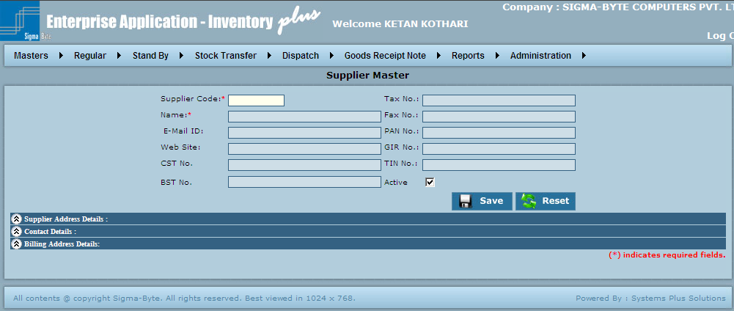

**Field Description**

|  |  |
| --- | --- |
| **Field Name** | **Description** |
| Supplier Code | To add Supplier Code. |
| Tax No | To add Tax No. |
| Name | To add Supplier Name. |
| Fax No | To add Fax No. |
| E-Mail ID | To add Email ID. |
| PAN No | To add PAN No. |
| Web Site | To add Web Site. |
| GIR No | To add GIR No. |
| CST No | To add CST No. |
| TIN No | To add TIN No. |
| BST No | To add BST No. |
| Active | Shows whether the selected Supplier is active or not. |
| Save | To add Supplier to the system. |
| Reset | To clear all the values in the Master screen. |
| **Supplier Address Details** |  |
| Address Type | To select Address Type. |
| City | To add City. |
| Address Name | To add Address Name. |
| State | To add State. |
| Address | To add Address. |
| Country | To add Country. |
| Zip | To add Zip. |
| Active | Shows whether the selected Supplier Address Details are active or not. |
| Save | To add Supplier Address Details to system. |
| Reset | To clear values in Supplier Address Details. |
| Customer Address Details List | To Edit/Delete Customer Address Details. |
| **Contact Details** |  |
| Contact Name | To add Contact Name. |
| Contact Phone | To add Contact Phone. |
| Active | Shows whether the selected Contact Details are active or not. |
| Save | To add Contact Details to system. |
| Reset | To clear all values in Contact Details. |
| Contact Detail List | To Edit/Delete Contact details. |
| **Billing Address Details** |  |
| Billing Address | To add Billing Address. |
| Active | Shows whether the selected Billing Address Details are active or not. |
| Save | To save Billing Address Details to system. |
| Reset | To clear all values in Billing Address Details. |

**Page Snapshot: Modify Supplier**

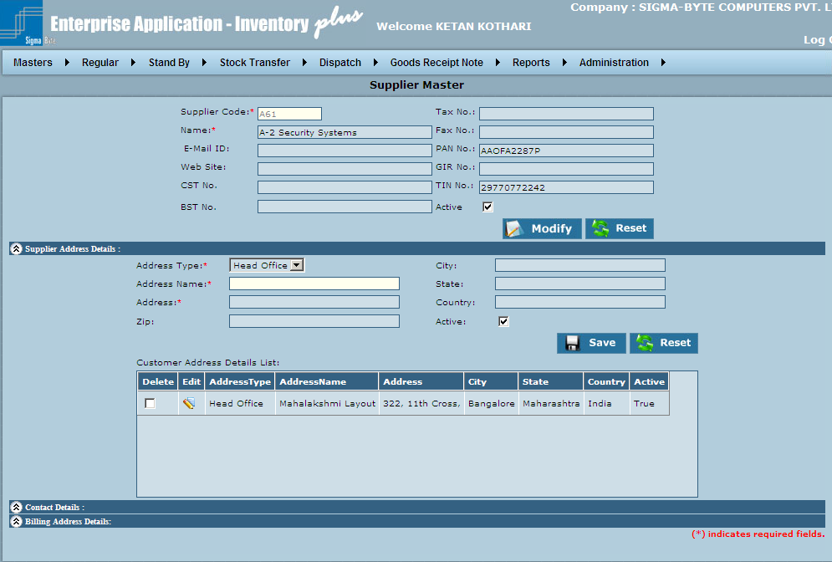

**Transporter Master**

**Overview**

The company has a list of preferred Transporters for dispatching the materials. To make a new one, this master can be used.

Also the existing details of a transporter can be modified.

**Page Snapshot: Add Transporter**

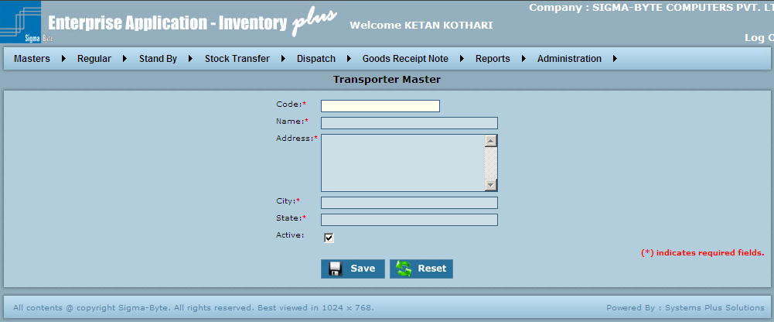

**Field Description**

|  |  |
| --- | --- |
| **Field Name** | **Description** |
| Code | To add Transporter Code. |
| Name | To add Transporter Name. |
| Address | To add Transporter Address. |
| City | To add Transporter City. |
| State | To add Transporter State. |
| Active | Shows whether the selected Transporter is active or not. |
| Save | To add Transporter to the system. |
| Reset | To clear all the values in the Master screen. |

**Page Snapshot: Modify Transporter**

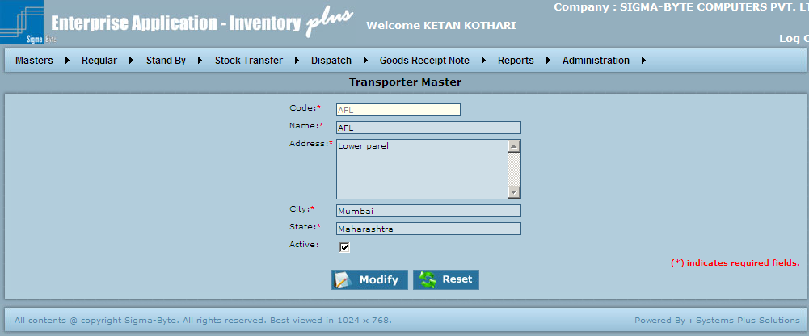

### Special Price Request (SPR) Master

**Overview**

This Master is used to add new Special Price request.

**Page Snapshot: Add Special Price Request**

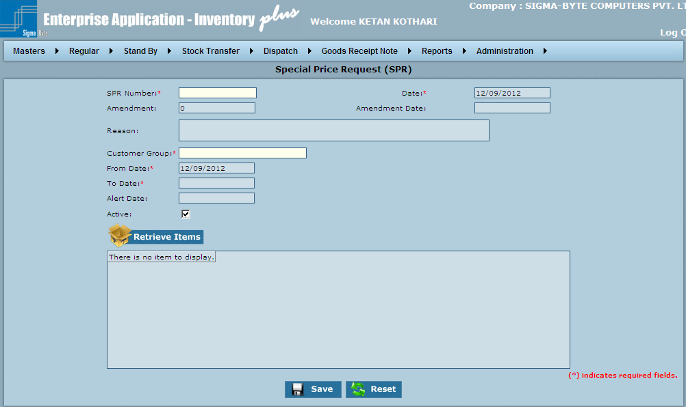

**Field Description**

|  |  |
| --- | --- |
| **Field Name** | **Description** |
| SPR Number | To add Special Price Request. |
| Date | To add SPR Date. |
| Amendment | To add Amendment Number. |
| Amendment Date | To add Amendment Date. |
| Reason | To add Reason. |
| Customer Group | To add Customer Group. |
| From Date | To add From Date. |
| To Date | To add To Date. |
| Alert Date | To add Alert Date. |
| Active | Shows whether the selected Special Price Request is active or not. |
| Retrieve Items | To Retrieve Items. |
| Save | To add Special Price Request to the system. |
| Reset | To clear all the values in the Master screen. |

**Page Snapshot: Modify Special Price Request**

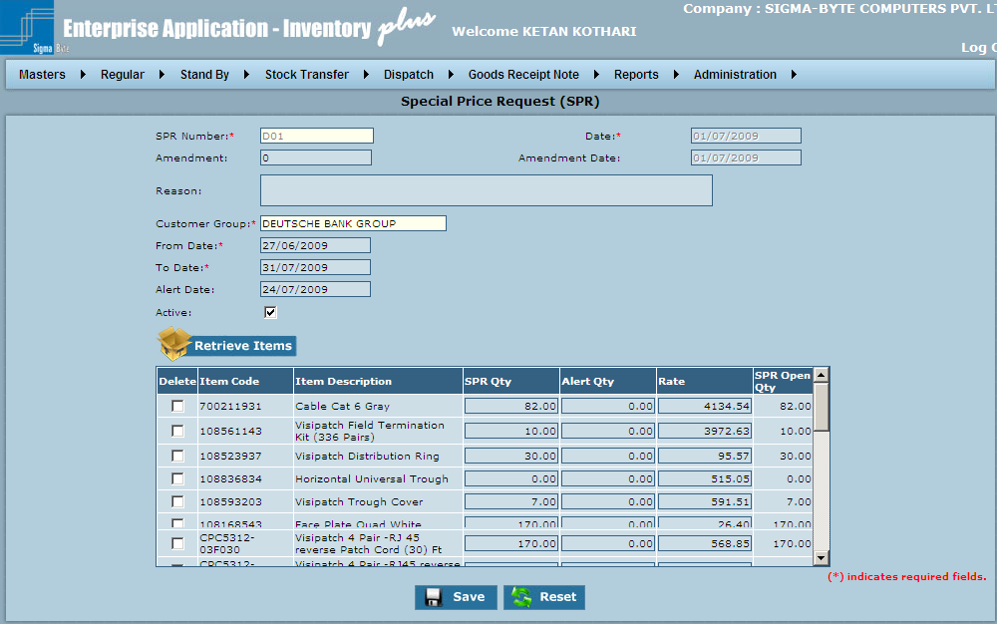

### Location Master

**Overview**

This Master is used to add new Location.

**Page Snapshot: Add Location**

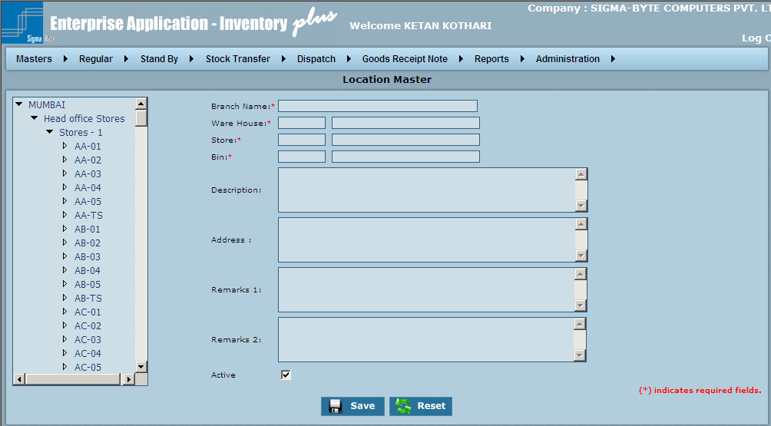

**Field Description**

|  |  |
| --- | --- |
| **Field Name** | **Description** |
| Branch Name | To add Branch Name. |
| Ware House | To add Ware House details. |
| Store | To add Store details. |
| Bin | To add Bin details. |
| Description | To add Description. |
| Address | To add Address. |
| Remarks 1/ Remarks 2 | To add Remarks. |
| Active | Shows whether the selected Location is active or not. |
| Save | To add Location to the system. |
| Reset | To clear all the values in the Master screen. |

**Page Snapshot: Modify Location**

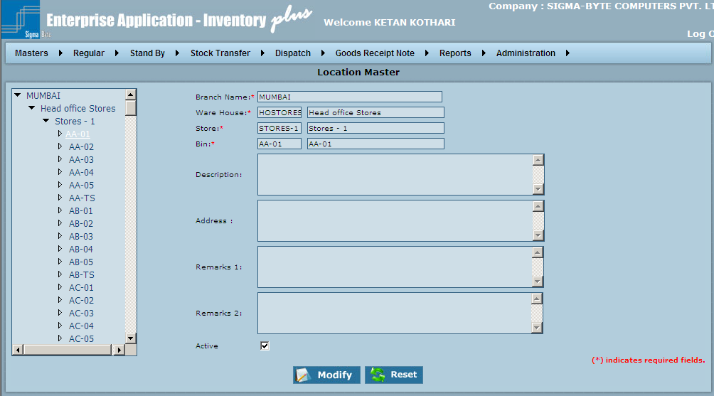

### Replacement Item Master

**Overview**

This Master is used to add new Replacement Item.

**Page Snapshot: Add Replacement Item**

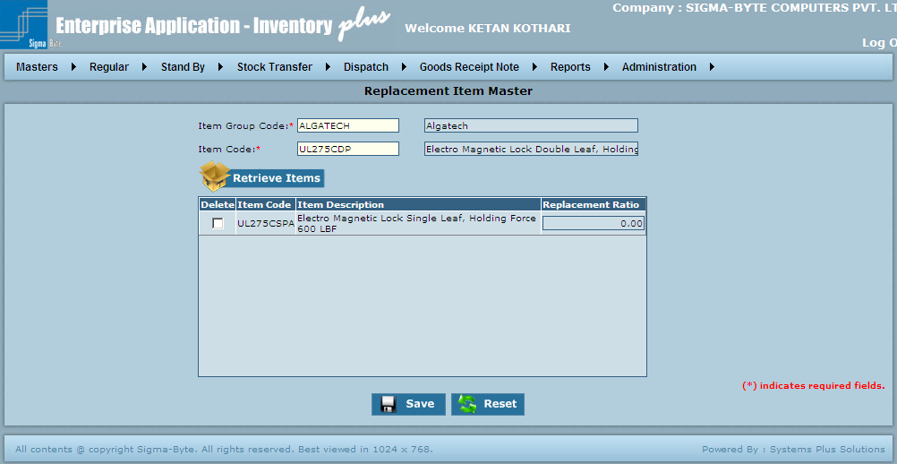

**Field Description**

|  |  |
| --- | --- |
| **Field Name** | **Description** |
| Item Group Code | To add Item Group Code. |
| Item Code | To add Item Code. |
| Retrieve Items | To select Items. |
| Save | To add Replacement Item to the system. |
| Reset | To clear all the values in the Master screen. |

### Business Line Master

**Overview**

This Master is used to add new Business Line.

**Page Snapshot: Add Business Line**

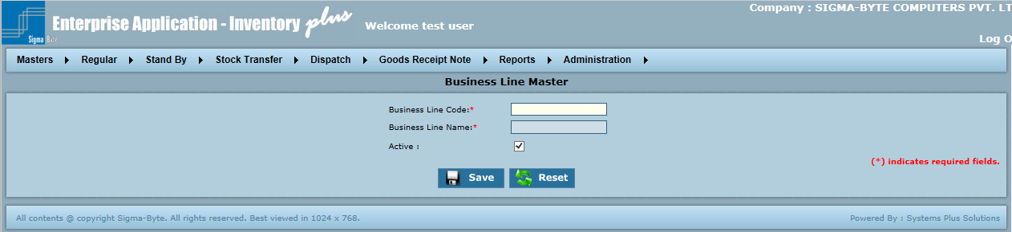

**Field Description**

|  |  |
| --- | --- |
| **Field Name** | **Description** |
| Business Line Code | To add Business Line Code. |
| Business Line Name | To add Business Line Name. |

# 

# ****Regular****

**Overview**

Regular Menu has sub menus of

* Internal Order
* Replacement(IOF)
* Stocking (IOF)
* Sales Order
* Purchase Order
* Purchase Order Tracking
* Payment Entry
* Closing Screen

**Page Snapshot: Regular Menu**

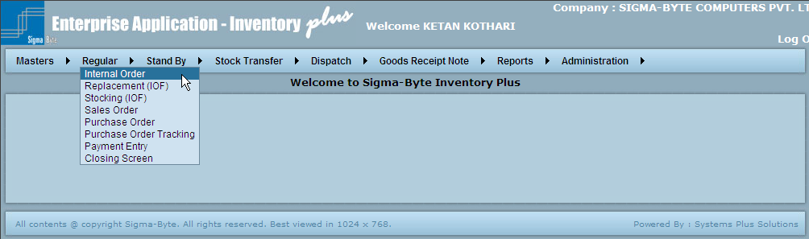

### Internal Order

**Overview**

Internal Order is made when the requirements of the clients are not on paper. A hard copy of Customer copy is not received. IOF is mostly made on verbal basis of Client’s or Technician’s Request working on that Site.

**IOF Types:**

1. Chargeable: SOF would be made and Items would be charged
2. Non-Chargeable: SOF cannot be made. It is usually made when items like cello tape etc needs to the send at Customer site.
3. Replacement: If some Items are sent as replacement to damaged / non-confirming materials.
4. Returnable / Stand by Given: In cases where the material now required by the customer shall be returned later, this type of IOF is made. For further details, please refer the Stand by transaction flow at the end.
5. Stock Transfer: For transferring material amongst branches, this type of IOF is made.

**Page Snapshot: Add Internal Order**

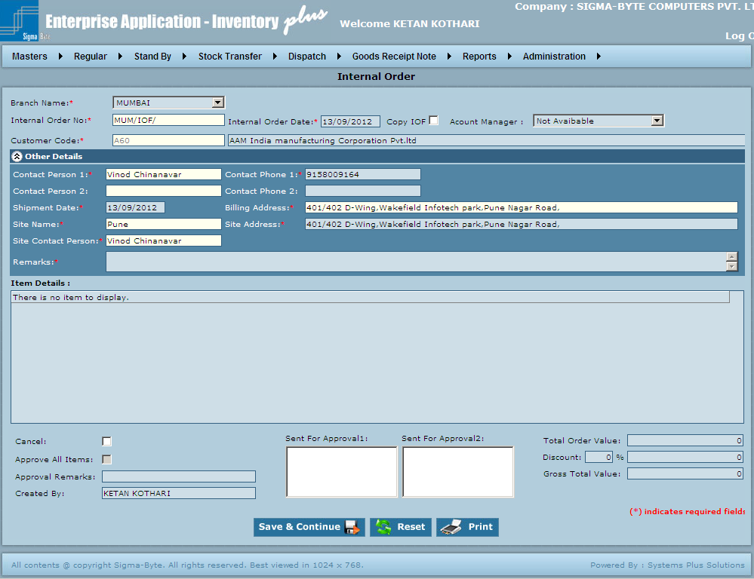

**Field Description**

|  |  |
| --- | --- |
| **Field Name** | **Description** |
| Branch Name | To select Branch Name. |
| Internal Order No | To add Internal Order No. |
| Internal Order Date | To add Internal Order Date. |
| Copy IOF | Check this to Copy IOF. |
| Account Manager | To select Account Manager. |
| Customer Code | To add Customer Code. |
| Contact Person1/ Contact Person 2 | To add Contact Person. |
| Contact Phone 1/ Contact Phone 2 | To add Contact Phone. |
| Shipment Date | To add Shipment Date. |
| Billing Address | To add Billing Address. |
| Site Name | To add Site Name. |
| Site Address | To add Site Address. |
| Site Contact Person | To add Site Contact Person. |
| Remarks | To add Remarks. |
| Cancel | If for some reason the IOF is to be cancelled, check this box. |
| Sent For Approval1/ Sent For Approval2 | To add Sent For Approval details. |
| Total Order Value | To add Total Order Value. |
| Approve All Items | It all Items to be approved, check this box. |
| Approval Remarks | To add Approval Remarks. |
| Discount | To add Discount. |
| Gross Total Value | To add Gross Total Value. |
| Save & Continue | To add Internal Order to the system. |
| Reset | To clear all the values in the Register screen. |
| Print | To Print Internal Order. |

### Replacement (IOF)

**Page Snapshot: Replacement (IOF)**

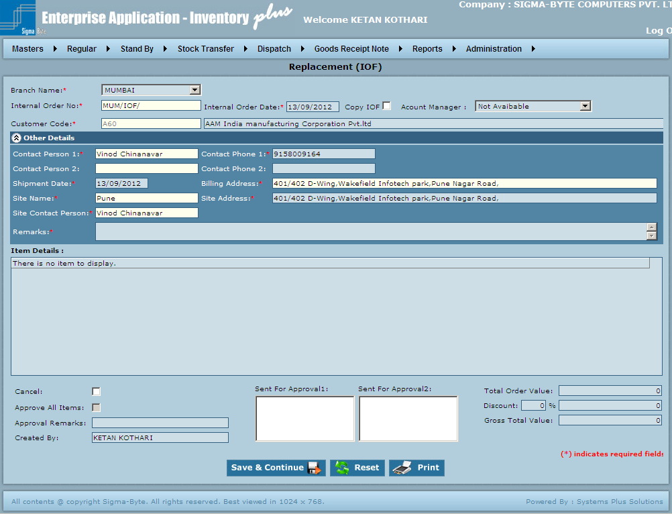

**Field Description**

|  |  |
| --- | --- |
| **Field Name** | **Description** |
| Branch Name | To select Branch Name. |
| Internal Order No | To add Internal Order No. |
| Internal Order Date | To add Internal Order Date. |
| Copy IOF | Heck this to Copy IOF. |
| Account Manager | To select Account Manager. |
| Customer Code | To add Customer Code. |
| Contact Person1/ Contact Person 2 | To add Contact Person. |
| Contact Phone 1/ Contact Phone 2 | To add Contact Phone. |
| Shipment Date | To add Shipment Date. |
| Billing Address | To add Billing Address. |
| Site Name | To add Site Name. |
| Site Address | To add Site Address. |
| Site Contact Person | To add Site Contact Person. |
| Remarks | To add Remarks. |
| Cancel | If for some reason the IOF is to be cancelled, check this box. |
| Sent For Approval1/ Sent For Approval2 | To add Sent For Approval details. |
| Total Order Value | To add Total Order Value. |
| Approve All Items | It all Items to be approved, check this box. |
| Approval Remarks | To add Approval Remarks. |
| Discount | To add Discount. |
| Gross Total Value | To add Gross Total Value. |
| Save & Continue | To add Internal Order to the system. |
| Reset | To clear all the values in the Register screen. |
| Print | To Print Replacement IOF. |

### Stocking (IOF)

**Page Snapshot: Stocking (IOF)**

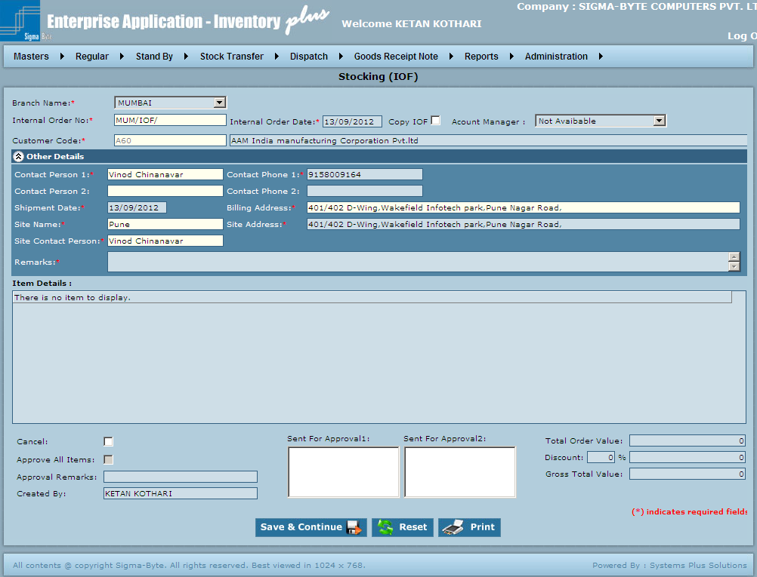

**Field Description**

|  |  |
| --- | --- |
| **Field Name** | **Description** |
| Branch Name | To select Branch Name. |
| Internal Order No | To add Internal Order No. |
| Internal Order Date | To add Internal Order Date. |
| Copy IOF | Check this to Copy IOF. |
| Account Manager | To select Account Manager. |
| Customer Code | To add Customer Code. |
| Contact Person1/ Contact Person 2 | To add Contact Person. |
| Contact Phone 1/ Contact Phone 2 | To add Contact Phone. |
| Shipment Date | To add Shipment Date. |
| Billing Address | To add Billing Address. |
| Site Name | To add Site Name. |
| Site Address | To add Site Address. |
| Site Contact Person | To add Site Contact Person. |
| Remarks | To add Remarks. |
| Cancel | If for some reason the IOF is to be cancelled, check this box. |
| Sent For Approval1/ Sent For Approval2 | To add Sent For Approval details. |
| Total Order Value | To add Total Order Value. |
| Approve All Items | It all Items to be approved, check this box. |
| Approval Remarks | To add Approval Remarks. |
| Discount | To add Discount. |
| Gross Total Value | To add Gross Total Value. |
| Save & Continue | To add Internal Order to the system. |
| Reset | To clear all the values in the Register screen. |
| Print | To Print Internal Stocking (IOF). |

### Sales Order

**Overview**

Sales Order form is made after getting the Customer’s Purchase order so that further processing of the order can be done. One SOF may contain multiple IOFs. An Invoice cannot be made for materials unless SOF for that material has been made.

**SOF Types:**

1. Materials: Made for supplying Materials required by the customer.
2. Services: Made for Services like Cable Layout, Assembly etc that are to be provided to the Customer.
3. Dummy Materials: Made when Customer shall not raise PO for the required items.
4. Dummy Services: Made when Customer shall not raise PO for the required services.

**Page Snapshot: Add Sales Order**

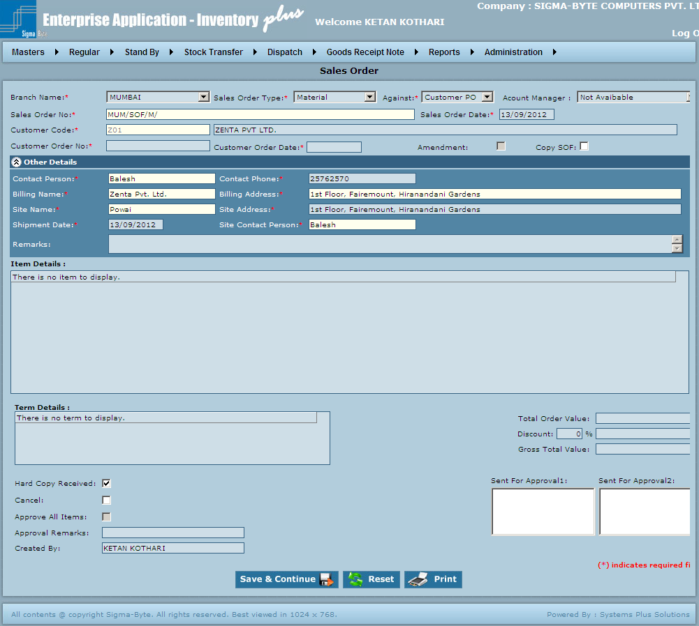

**Field Description**

|  |  |
| --- | --- |
| **Field Name** | **Description** |
| Branch Name | To Select the required Branch in which the transaction is made. |
| Sales Order Type | To Select one from Material, Services, Dummy Material, Dummy Services. |
| Against | To select Customer Order is Against Customer Po or Internal Order. |
| Account Manager | To select Account Manager. |
| Sales Order No | To select Sales Order No. |
| Sales Order Date | To add Sales Order Date. |
| Customer Code | To add Customer for which the IOF is made. |
| Customer Order No | To Enter the Customer Order Number here. |
| Customer Order Date | To add Date when the order was sent by the customer |
| Amendment |  |
| Copy SOF | If for some reason the IOF is to be cancelled, check this box. |
| Contact Person | To add Contact Person. |
| Contact Phone | To add Contact Phone. |
| Billing Name | To add Billing Name. |
| Billing Address | To add Billing Address. |
| Site Name | To add Site Name. |
| Site Address | To add Site Address. |
| Shipment Date | To add Shipment Date. |
| Site Contact Person | To add Site Contact Person. |
| Remarks | To add Remarks. |
| Total Order Value | To add Total Order Value. |
| Discount | To add Discount. |
| Gross Total Value | To add Gross Total Value. |
| Hard Copy Received | Check this field after the PO hard copy has been received. Only after the PO Hard copy has been received, the Invoice can be sent. |
| Sent For Approval1/ Sent For Approval2 | To add Sent For Approval details. |
| Cancel | Check this to Cancel SOF. |
| Approve All Items | Check this to Approve All Items. |
| Approval Remarks | To add Approval Remarks. |
| Save & Continue | To add Internal Order to the system. |
| Reset | To clear all the values in the Register screen. |
| Print | To Print Sales Order. |

### Purchase Order

**Overview**

Purchase Order is raised when material is to be procured from any Supplier. A Purchase Order may be raised against an IOF or SOF. It can also be raised against a Verbal Order to make-up stock deficiency or for any other reason. Multiple POs can be made against one IOFs or SOFs. PO Types:

1. CAP
2. NET: Made for procuring Materials.
3. SER: Made for procurement of Services.
4. COM: Made for procurement of Computers.

**Page Snapshot: Add Purchase Order**

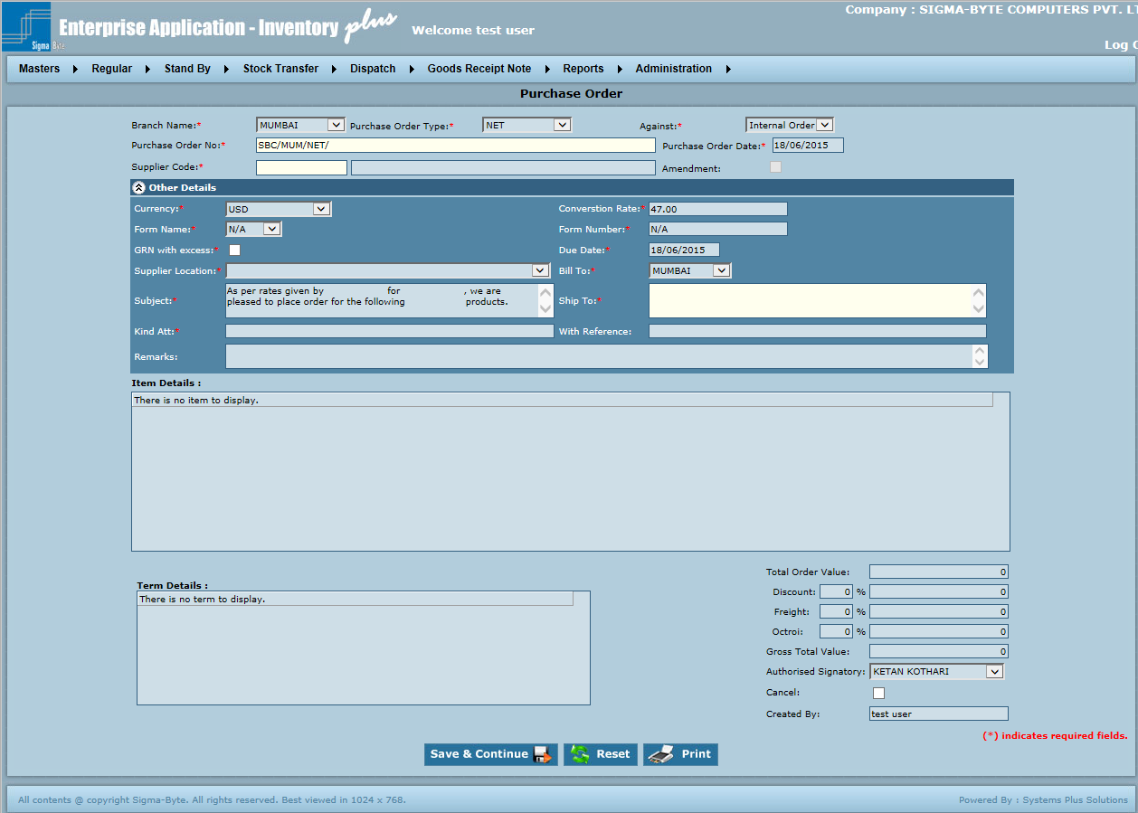

**Field Description**

|  |  |
| --- | --- |
| **Field Name** | **Description** |
| Branch Name | To Select the required Branch in which the transaction is made. |
| Purchase Order Type | To Select one from CAP*, NET*, SER*, COM*. |
| Against | To select purchase order is against Verbal Order, Internal Order or Sales Order. |
| Purchase Order No | This is an Auto Generated Number. If an existing PO has to be modified, enter / select that PO no. |
| Purchase Order Date | Date when the order was sent to the supplier. |
| Supplier Code | Customer for which the IOF is made. |
| Amendment |  |
| Currency | To Select the currency in which the transaction is to be made |
| Conversion Rate | To add Conversion Rate. |
| Form Name | To select Form Name. |
| Form Number | To add Form Number. |
| GRN with excess |  |
| Due Date | To add Due Date. |
| Supplier Location | To select the location of supplier in case the supplier has many branches. |
| Bill To | Branch where the Invoice is to be sent. |
| Subject | To add the Subject of PO. |
| Ship To | To add the address where the material is required. |
| Kind Att | To add Name of a Particular official at Supplier side. |
| With Reference | To add References if any. |
| Remarks | To add any specific Remarks |
| Total Order Value | To add Total Order Value. |
| Discount | To add Discount. |
| Freight | To add Freight. |
| Octroi | To add Octroi. |
| Gross Total Value | To add Gross Total Value. |
| Authorized Signatory | To select Authorized Signatory. |
| Cancel | Check this to cancel PO. |
| Save & Continue | To add Purchase Order to the system. |
| Reset | To clear all the values in the Register screen. |
| Print | To Print Purchase Order. |

### Purchase Order Tracking

**Overview**

There are many transactions occurring at the same time. To manually keep a record of all these may be difficult. So PO tracking is done to trace out the status of any particular PO. This can help in executing a particular PO very fast or to hold the same any time.

**Page Snapshot: Add Purchase Order**

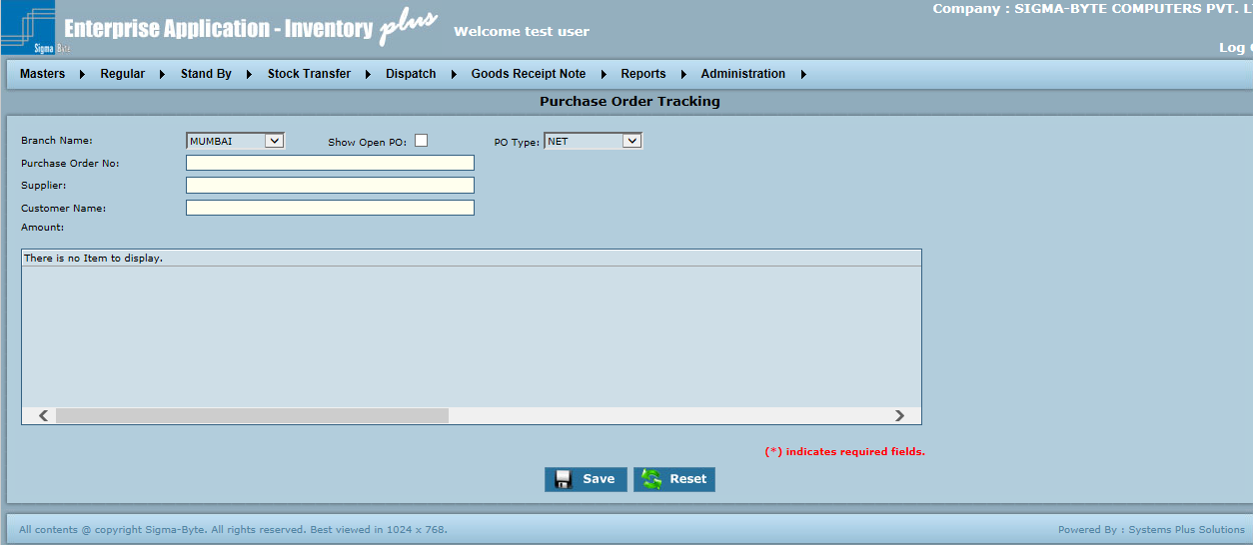

**Field Description**

|  |  |
| --- | --- |
| **Field Name** | **Description** |
| Branch Name | To select the required Branch in which the transaction is made. |
| PO Type | To Select the type of PO to be tracked. |
| Purchase Order No | Enter / Select the PO to be tracked. |
| Supplier | To add Supplier. |
| Supplier Location | To add Supplier Location. |
| Customer Name | To add Customer Name. |
| Amount | To add Amount. |
| Save | To add Purchase Order Tracking to the system. |
| Reset | To clear all the values in the Register screen. |
| Print | To Print Purchase Order Tracking. |

### Payment Entry

**Overview**

After the billing of invoices, payments are received from customer. Make an appropriate entry of the payment to keep a record

**Page Snapshot: Add Payment Entry**

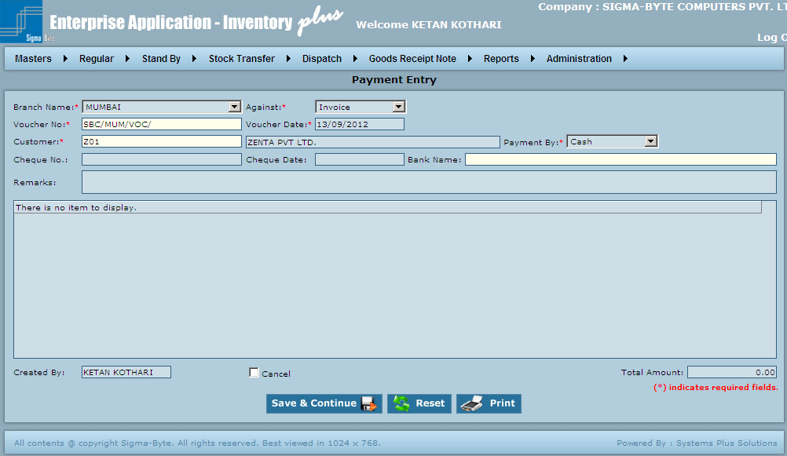

**Field Description**

|  |  |
| --- | --- |
| **Field Name** | **Description** |
| Branch Name | To Select the required Branch in which the transaction is made. |
| Against | To select Payment Entry is done Against On Account, Invoice, Advance or Retention. |
| Voucher No | This is an Auto Generated Number. If an existing Payment Voucher has to be modified, enter / select that Payment Voucher no. |
| Voucher Date | To add Date when the Payment Voucher was made. |
| Customer | To add Customer. |
| Payment By | To select Payment Mode. |
| Cheque No | Te enter the customer’s cheque no. (Only if payment type is Cheque) |
| Cheque Date |  |
| Bank Name | To add Bank Name. |
| Remarks | To add specific Remarks. |
| Cancel | Check this to Cancel Payment Entry. |
| Total Amount | To add Total amount. |
| Save & Continue | To add Purchase Order Tracking to the system. |
| Reset | To clear all the values in the Register screen. |
| Print | To Print Payment Entry. |

### Closing Screen

**Overview**

There are times when some particular IOF, SOF, etc needs to be excluded from the system for following the normal path. For such times, the closing screen is used.

Closing Screen options (Transaction Close options):

* Internal Order: This option is used to exclude a particular IOF from processing so that the normal path is not followed by IOF & its PO is not made. Material may be supplied from stock. So to close such IOFs, this screen may be used.
* Sales Order: This option is used to exclude a particular SOF from processing so that the normal path is not followed by SOF & its PO is not made. . Material may be supplied from stock. Also that particular SOF shall be excluded while making Invoice for a case when the material was not required / used at customer site. Such SOFs can be closed from this screen.
* Purchase Order: Certain materials in PO may not have been procured till date & also may not be required here after. For such materials, the PO, in normal transaction shall show the pending status. Such POs can be excluded from normal transaction through this screen.
* Internal Order – DN: DN can be made against certain IOF. If the materials in IOF are no longer required, the IOF shall always show pending status. To exclude such IOFs from system, use this screen.
* Sales Order – DN: Similar to IOFs, SOFs pending for DN can be closed from this screen.

**Page Snapshot: Add Closing**

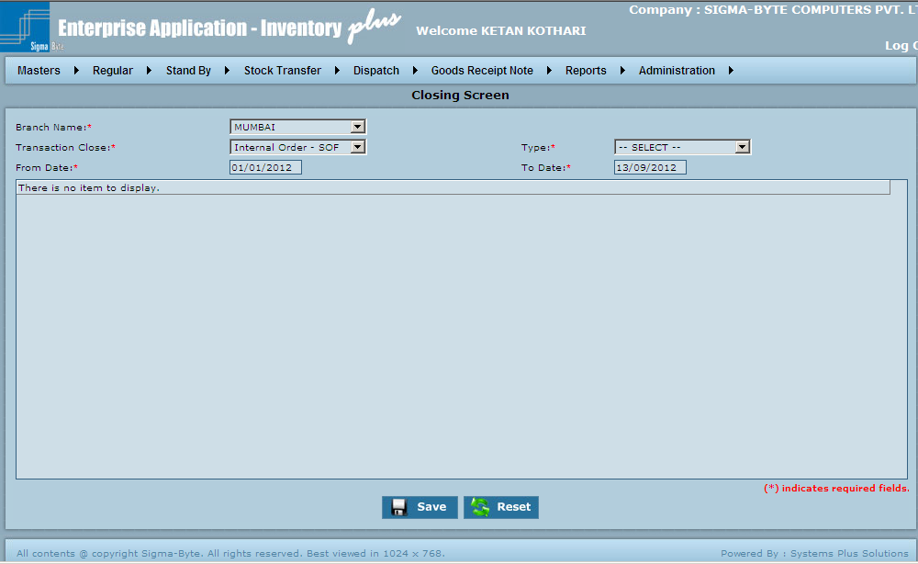

**Field Description**

|  |  |
| --- | --- |
| **Field Name** | **Description** |
| Branch Name | To Select the required Branch in which the transaction is made. |
| Type | To select Type. |
| Transaction Close | To Select the required Branch in which the transaction is made. |
| From Date | To add From Date. |
| To Date | To add To Date. |
| Save | To add Closing to the system. |
| Reset | To clear all the values in the Register screen. |

### Credit Note Screen

**Overview**

A credit note is a way of reporting reversals or refunds you owe back to other parities.At the time of saving Goods Return Note, user gets a prompt to create Credit Note.

**Page Snapshot: Credit Note**

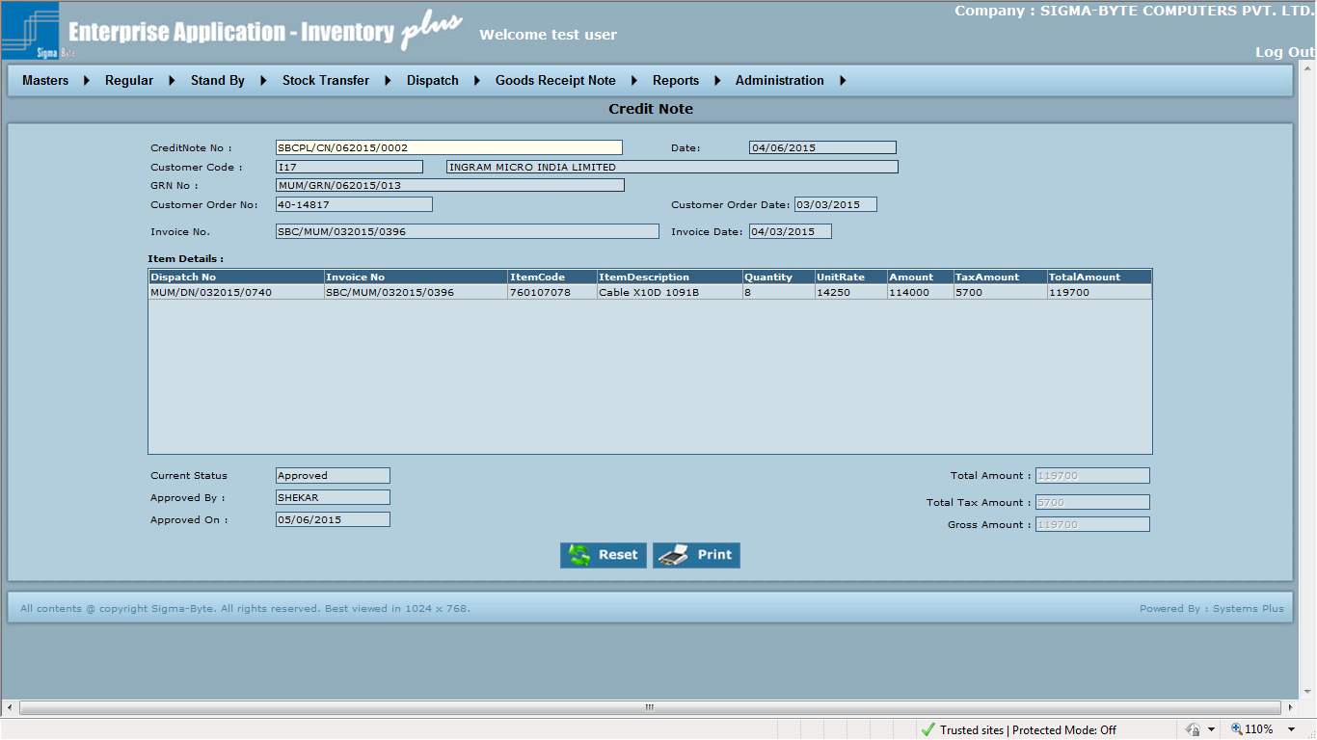

**Field Description**

|  |  |
| --- | --- |
| **Field Name** | **Description** |
| Credit Note No. | To select Credit Note No. |
| Date | To view Credit Note Date |
| GRN No. | To view GRN No. against which credit note is made. |
| Customer Code | To view Customer Code |
| Customer Order No. | To view Customer Order No. |
| Customer Order Date | To view Customer order Date. |
| Invoice No. | To view Invoice No. |
| Invoice Date | To view Invoice Date. |
| Print | To print Credit Note. |
| Reset | To clear all the values in the Credit Note screen. |

### Debit Note Screen

**Overview**

A debit note is a method of claiming costs paid by company to suppliers or clients.

**Page Snapshot: Add Debit Note**

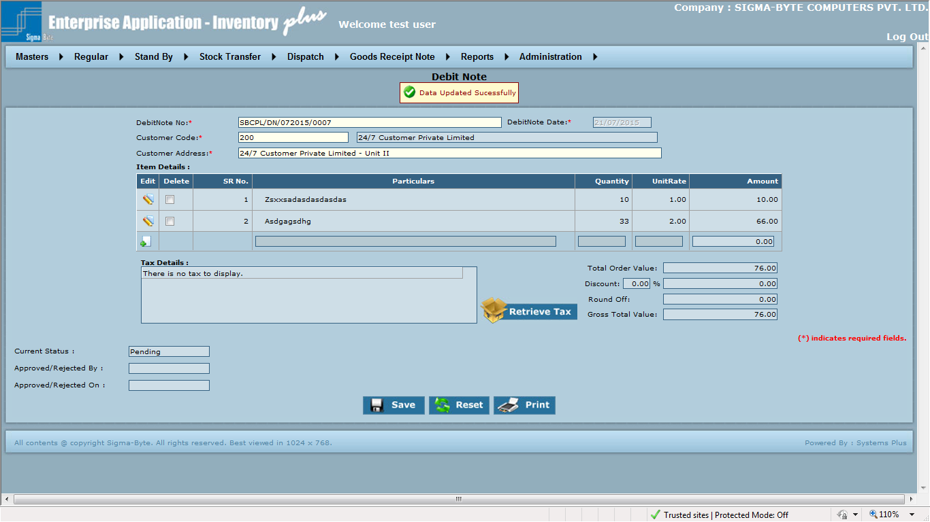

**Field Description**

|  |  |
| --- | --- |
| **Field Name** | **Description** |
| Debit Note | To select Debit Note. |
| Customer Code | To select Customer Code. |
| Customer Address | To Select Customer Address. |
| Debit Note Date | To add Debit Note Date. |
| Total Order Value | To display Total Order Value |
| Discount | It displays discount on total order value. |
| Round Off | It displays round off on total order value. |
| Gross Total Value | It displays Gross order value. |
| Print | To print Debit Note. |
| Save | To add Debit Note to the system. |
| Reset | To clear all the values in the Debit Note screen. |

# Stand By

**Overview**

Stand By Menu has sub menus of

* Stand By Given (IOF)
* Stand By Taken (PO)

**Page Snapshot: Stand By Menu**

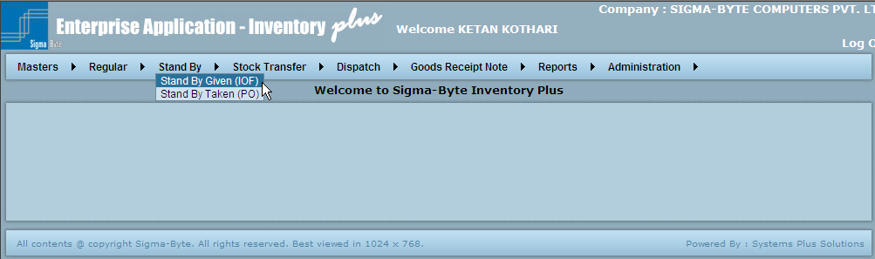

### Stand By Given (IOF)

**Overview**

Internal Order is made when the requirements of the clients are not on paper. A hard copy of Customer copy is not received. IOF is mostly made on verbal basis of Client’s or Technician’s Request working on that Site.

In cases where the material now required by the customer shall be returned later, this type of IOF is made.

**Page Snapshot: Stand By Given (IOF)**

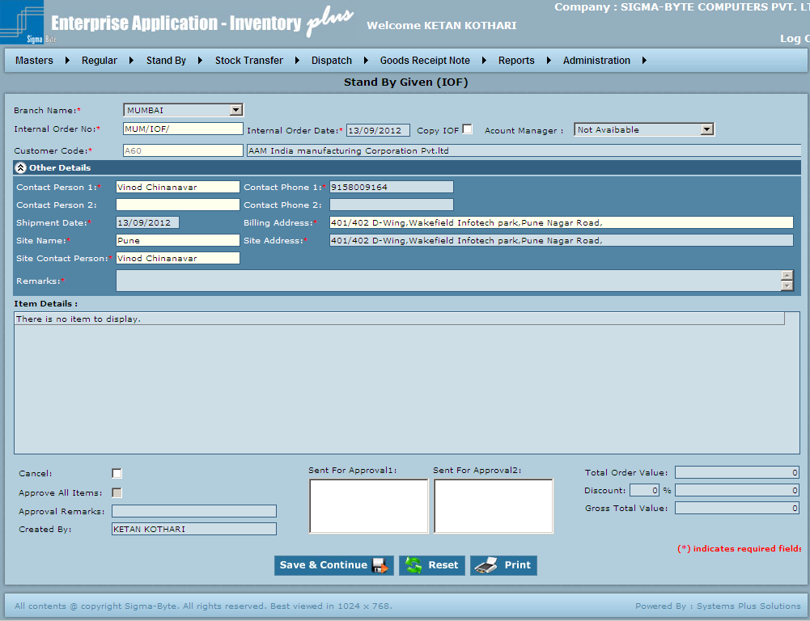

**Field Description**

|  |  |
| --- | --- |
| **Field Name** | **Description** |
| Branch Name | To select Branch Name. |
| Internal Order No | This is an Auto Generated Number. |
| Internal Order Date | To add Internal Order Date. |
| Copy IOF | Check this to Copy IOF. |
| Account Manager | To select Account Manager. |
| Customer Code | To add Customer Code. |
| Contact Person1/ Contact Person 2 | To add Contact Person details. |
| Contact Phone 1/Contact Phone 2 | To add Contact Phone details. |
| Shipment Date | To add Shipment Date. |
| Billing Address | To add Billing Address. |
| Site Name | To add Site Name. |
| Site Address | To add Site Address |
| Site Contact Person | To add Site Contact Person details. |
| Remarks | To add Remarks. |
| Item Details |  |
| Cancel | Check this to Cancel IOF. |
| Sent For Approval1/ Sent For Approval2 | To add Sent For Approval details. |
| Total Order Value | To add Total Order Value. |
| Approve All Items | Check this to Approve All Items. |
| Discount | To add Discount. |
| Approval Remarks | To add Approval Remarks. |
| Gross Total Value | To add Gross Total Value. |
| Save & Continue | To add Stand By Given (IOF) to the system. |
| Reset | To clear all the values in the Stand By Screen. |
| Print | To Print Stand By Given (IOF). |

### Stand By Taken (PO)

**Overview**

In cases where the material required from the supplier shall be returned later, this type of PO is made.

**Page Snapshot: Stand By Taken (PO)**

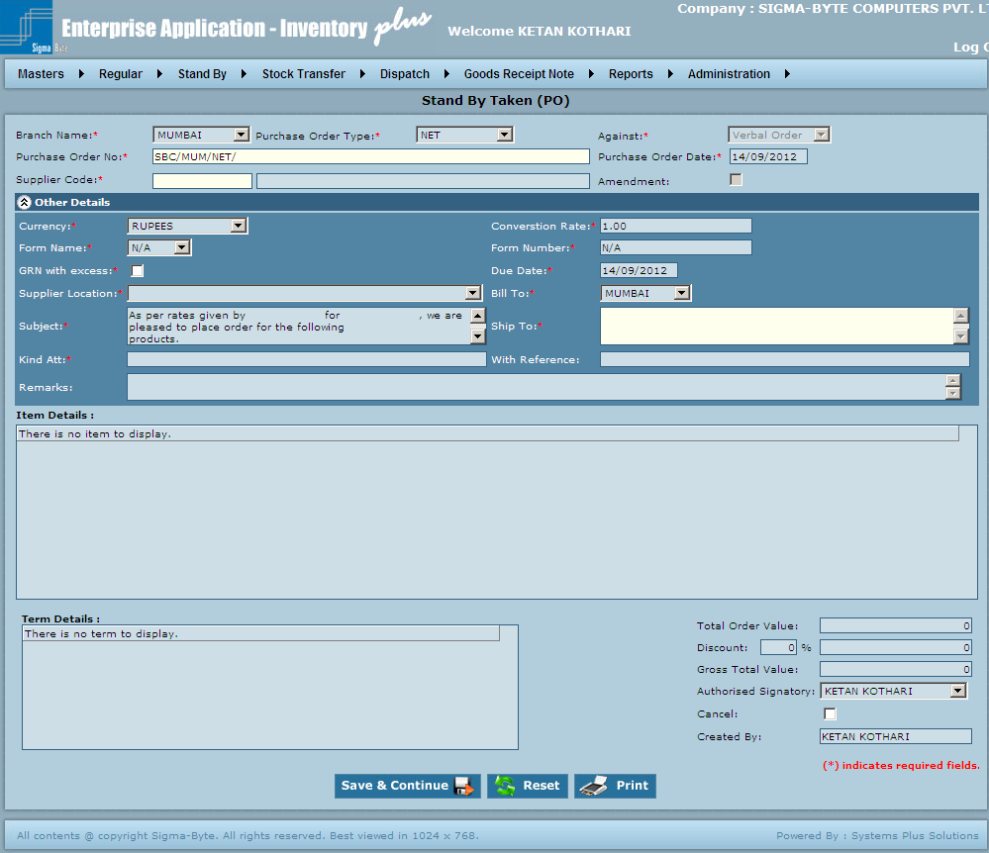

**Field Description**

|  |  |
| --- | --- |
| **Field Name** | **Description** |
| Branch Name | To select Branch Name. |
| Purchase Order Type | To select Purchase Order Type. |
| Against | Stand By Taken PO is by default against verbal order. |
| Purchase Order No | To select Purchase Order No. |
| Purchase Order Date | To add Purchase Order Date. |
| Supplier Code | To add Supplier Code. |
| Amendment |  |
| Currency | To select Currency. |
| Conversion Rate | To add Conversion Rate. |
| Form Name | To select Form Type. |
| Form Number | To add Form number. |
| GRN with excess |  |
| Due Date | To add Due Date. |
| Supplier Location | To select Supplier Location. |
| Bill To | To select Bill To City. |
| Subject | To add Subject details. |
| Ship To | To add Ship To details. |
| Kind Att | To add Kind Att details. |
| With Reference | To add With Reference details. |
| Remarks | To add Remarks. |
| Total Order Value | To add Total Order Value. |
| Discount | To add Discount. |
| Gross Total Value | To add Gross Total Value. |
| Authorized Signatory | To add Authorized Signatory. |
| Cancel | Check if want to Cancel PO |
| Created By | Check this to Cancel PO. |
| Save & Continue | To add Stand By Taken (PO) to the system. |
| Reset | To clear all the values in the Stand By Screen. |
| Print | To Print Stand By Taken (PO). |

# Stock Transfer

**Overview**

Regular Menu has submenus of

* Stock De allocation
* Stock Adjustment
* Opening Balance
* Inter Branch Stock Transfer

**Page Snapshot: Stock Transfer Menu**

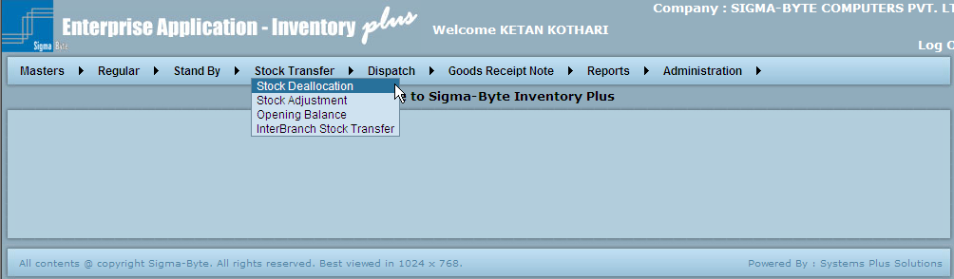

### Stock De-Allocation

**Overview**

If material persists in open stock or customer stock, it may be transferred to open stock / customer stock if the need arises.

This is done using the Stock Allocation screen.

**Types of Stock Allocation**:

1. From Free Stock to Customer stock.
2. From Customer stock to Customer stock.
3. From Customer stock to Free stock

**Page Snapshot: Stock De allocation**

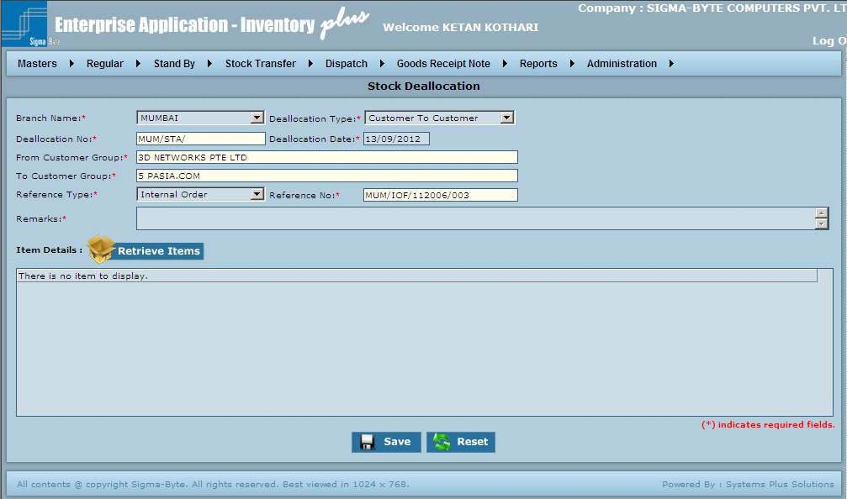

**Field Description**

|  |  |
| --- | --- |
| **Field Name** | **Description** |
| Branch Name | To select the required Branch in which the transaction is made. |
| De allocation Type | To select De allocation Type. |
| De allocation No | This is an Auto Generated Number. If an existing De Allocation has to be modified, enter / select that De Allocation no. |
| De allocation Date |  |
| From Customer Group | To add name of Customer from whose stock the items are to be deducted. |
| To Customer Group | To add Name of Customer to whose stock the items are to be added. |
| Reference Type | To select Reference Type. |
| Reference No | To add Reference No. |
| Remarks | To add Remarks. |
| Retrieve Items | Click on Retrieve Items Button to add new items & their respective quantity. |
| Save | To add Stock De allocation to the system. |
| Reset | To clear all the values in the Stock Transfer screen. |

### Stock Adjustment

**Overview**

Materials can be damaged in transition. They can also be stolen or lost. To make-up for all such unaccounted decrease in stock of materials, stock adjustment has to be done. This helps to fill up all the gaps that are found when system stock & physical stock is taken.

**Page Snapshot: Stock Adjustment**

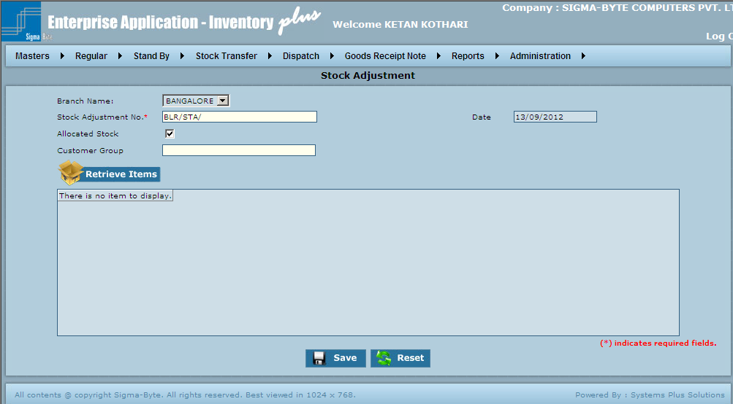

**Field Description**

|  |  |
| --- | --- |
| **Field Name** | **Description** |
| Branch Name | To select the required Branch in which the transaction is made. |
| Stock Adjustment No | This is an Auto Generated Number. If an existing Stock Adjustment No has to be modified, enter / select that Stock Adjustment no. |
| Date | To add Date when the Stock Adjustment was made. |
| Allocated Stock | Check if applicable. |
| Customer Group | To add Customer Group Whose Stock Adjustment is to be done. |
| Retrieve Items | Click on Retrieve Items Button to add new items & their respective quantity. |
| Save | To add Stock Adjustment to the system. |
| Reset | To clear all the values in the Stock Transfer screen. |

### Opening Balance

**Overview**

This Master is used to add an Opening Balance for an item.

**Page Snapshot: Opening Balance**

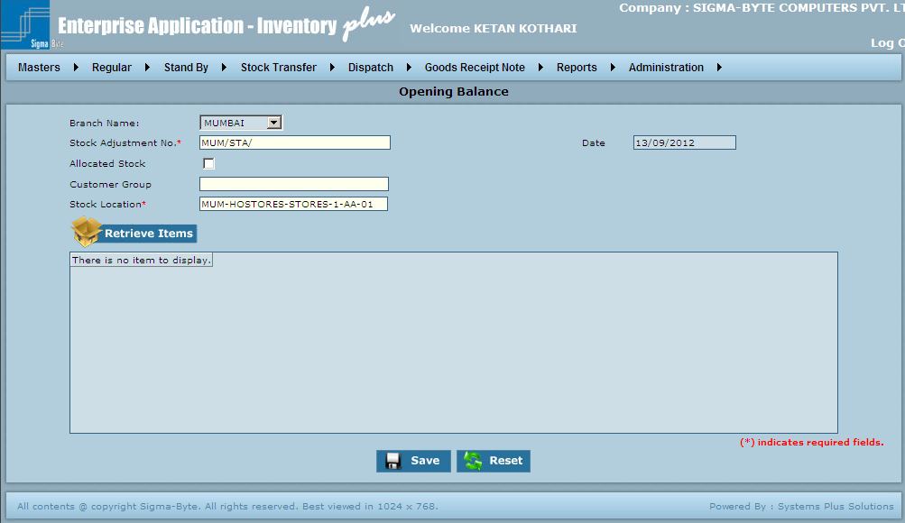

**Field Description**

|  |  |
| --- | --- |
| **Field Name** | **Description** |
| Branch Name | To select the required Branch in which the transaction is made. |
| Stock Adjustment No | This is an Auto Generated Number. If an existing Stock Adjustment No has to be modified, enter / select that Stock Adjustment no. |
| Date | To add Date when the Stock Adjustment was made. |
| Allocated Stock | Check if applicable. |
| Customer Group | To add Customer Group Whose Stock Adjustment is to be done. |
| Retrieve Items | Click on Retrieve Items Button to add new items & their respective quantity. |
| Save | To add Opening Balance to the system. |
| Reset | To clear all the values in the Stock Transfer screen. |

### Inter Branch Stock Transfer

**Overview**

This transaction is used to transfer material amongst branches, this type of IOF is made.

**Page Snapshot: Inter Branch Stock Transfer**

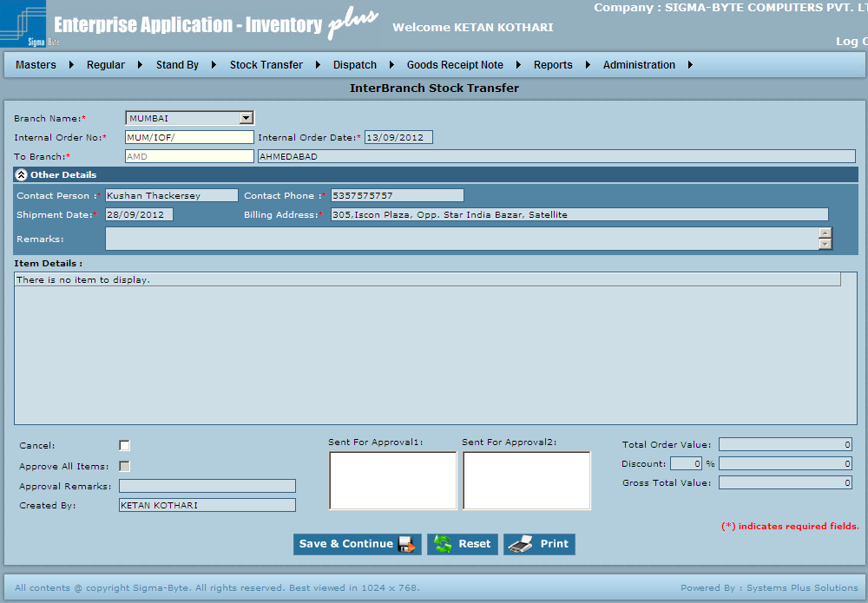

**Field Description**

|  |  |
| --- | --- |
| **Field Name** | **Description** |
| Branch Name | To select the required Branch in which the transaction is made. |
| Internal Order No | To add Internal Order No. |
| Internal Order Date | To add Internal Order Date. |
| To Branch | To add Branch. |
| Contact Person | To add Contact Person. |
| Contact Phone | To add Contact Phone. |
| Shipment Date | To add Shipment Date. |
| Billing Address | To add Billing Address. |
| Remarks | To add Remarks. |
| Cancel | Check this to Cancel IOF. |
| Sent For Approval1 | To add Sent For Approval Details. |
| Sent For Approval2 | To add Sent For Approval Details. |
| Total Order Value | To add Total Order Value. |
| Approve All Items | Check this to Approve All Items. |
| Discount | To add Discount. |
| Approval Remarks | To add Approval Remarks. |
| Gross Total Value | To add Gross Total Value. |
| Save & Continue | To add Inter Branch Stock Transfer to the system. |
| Reset | To clear all the values in the Stock Transfer screen. |
| Print | To Print Inter Branch Stock Transfer. |

# 

# ****Dispatch****

**Overview**

Regular Menu has submenus as

* Dispatch Note
* Delivery Challan
* Invoice Entry
* Inter Branch Invoice Entry

**Page Snapshot: Dispatch Menu**

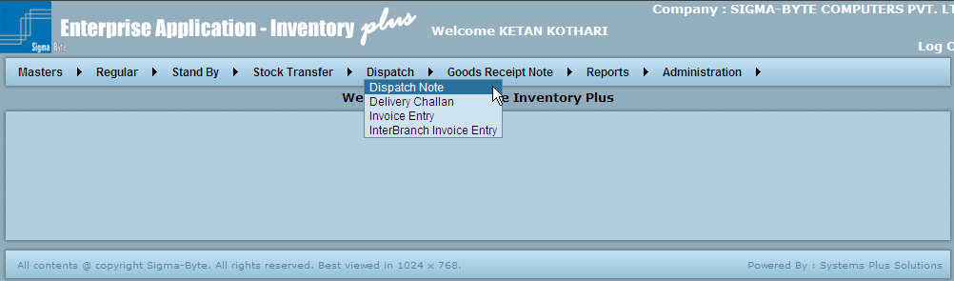

### Dispatch Note

**Overview**

Dispatch Note is an instruction for dispatch of materials to the customer. It can be raised against an IOF or SOF.

**DN Types:**

1. Chargeable: When the materials to be sent are to be charged.
2. Non-Chargeable: When the materials to be sent must not be charged.
3. Replacement: When the materials to be sent are as Replacements to faulty or damaged materials.
4. Returnable / Stand-By Given: When the materials to be sent to Customer are on returnable basis. These shall be returned after a definite time-period. . For further details, please refer the Stand by transaction flow at the end.
5. Stand-By Return to: When the materials to send are as returnable to the material taken on Stand by sometime back. The material is sent back to Supplier. . For further details, please refer the Stand by transaction flow at the end.
6. Stock Transfer: When the material to be sent amongst Branches.
7. Goods Reject: When the material is to be sent back to the supplier as the material he supplied was faulty / damaged.

**Page Snapshot: Dispatch Note**

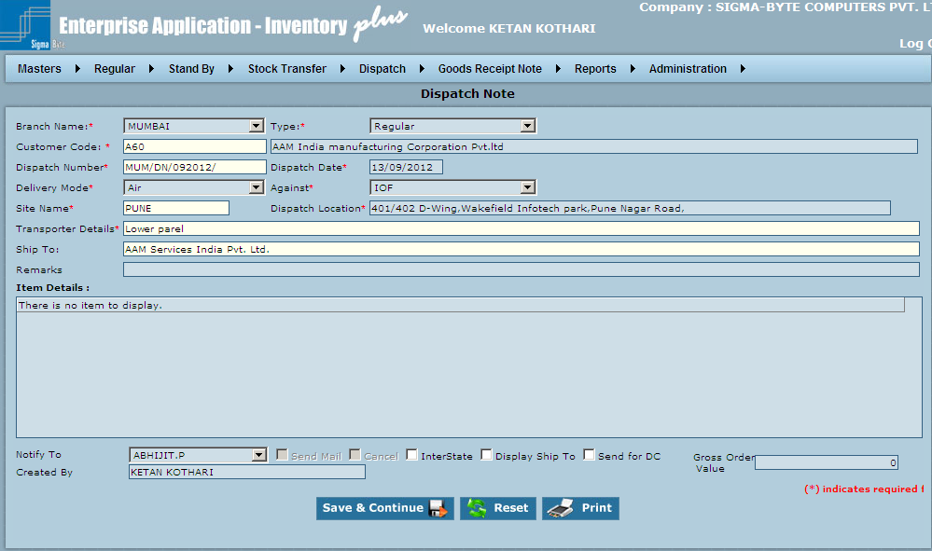

**Field Description**

|  |  |
| --- | --- |
| **Field Name** | **Description** |
| Branch Name | To select Branch Name. |
| Type | To select Dispatch Note Type. |
| Customer Code | To add Customer for which the DN is made. |
| Dispatch Number | To select Dispatch Number. |
| Dispatch Date | To add Dispatch Date. |
| Delivery Mode | To select Delivery Mode. |
| Against | To Select one from IOF or SOF. |
| Site Name | To add Site Name. |
| Dispatch Location | To add Dispatch Location. |
| Transporter Details | To add Transport Details. |
| Ship To | To select to whom to Ship. |
| Remarks | To add Remarks. |
| Notify To | To select Person to be notified when DN is received. |
| Send Mail | Check this box if the concerned person is to be notified by email. |
| Cancel | If the DN is to be cancelled for some reason, check this box. |
| InterState | If the material transfer is Interstate, like material transfer between Delhi & Noida. If it is an interstate transfer then an Invoice has to be attached with the DC. |
| Display Ship To | To add Customer Details whom to send. |
| Send for DC |  |
| Gross Order Value | To add Gross Order Value. |
| Save & Continue | To add Dispatch Note to the system. |
| Reset | To clear all the values in the Dispatch screen. |
| Print | To Print Dispatch Note. |

### Delivery Challan

**Overview**

Delivery Challan is a Document required for Legal purposes. It is made after the DN is received & just before the material is to be finally dispatched. It has all the types as described in DN. Since it is made after the DN, it must be of the same type as DN. All DC Types are same as DN types. For further details refer DN types above. DC can be interstate. For e.g.: If material is to be sent from Delhi to Noida, the state changes. This type of transaction needs invoice to be attached with the DC. Hence if DC is not received, Invoice cannot be made.

**DC Types:**

1. Chargeable
2. Non-Chargeable
3. Replacement
4. Returnable / Stand-By Given
5. Stand-By Return to
6. Stock Transfer
7. Goods Reject

**Page Snapshot: Delivery Challan**

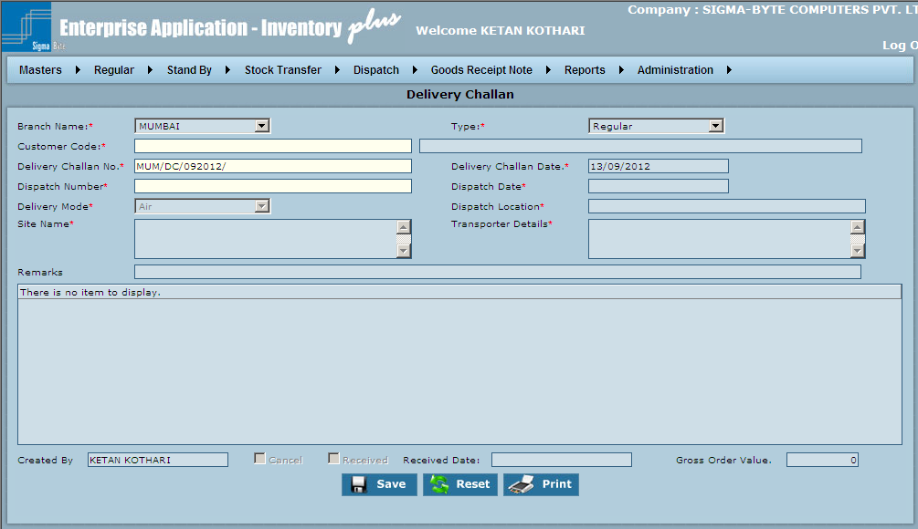

**Field Description**

|  |  |
| --- | --- |
| **Field Name** | **Description** |
| Branch Name | To select Branch Name. |
| Type | To select Dispatch Note Type. |
| Customer Code | To add Customer for which the DN is made. |
| Delivery Challan No | To add Delivery Challan No. |
| Delivery Challan Date | To add Delivery Challan Date. |
| Dispatch Number | To add Dispatch Number. |
| Dispatch Date | To add Dispatch Date. |
| Delivery Mode | To select Delivery Mode. |
| Dispatch Location | To add Dispatch Location. |
| Site Name | To add Site Name. |
| Transporter Details | To add Transport Details. |
| Remarks | To add Remarks. |
| Cancel | If the DC is to be cancelled for some reason, check this box. |
| Received | Check this box if the Duplicate copy of DC has been received from the customer after delivery. |
| Received Date | To add Received Date. |
| Gross Order Value | To add Gross Order Value. |
| Save & Continue | To add Delivery Challan to the system. |
| Reset | To clear all the values in the Dispatch screen. |
| Print | To Print Delivery Challan. |

### Invoice Entry

**Overview**

After material / services are given/ sent to the customer, the payment is claimed by submitting an Invoice. This includes the final amount payable by the customer. It is also made during stock transfers if the transfer is Interstate.

**Page Snapshot: Invoice Entry**

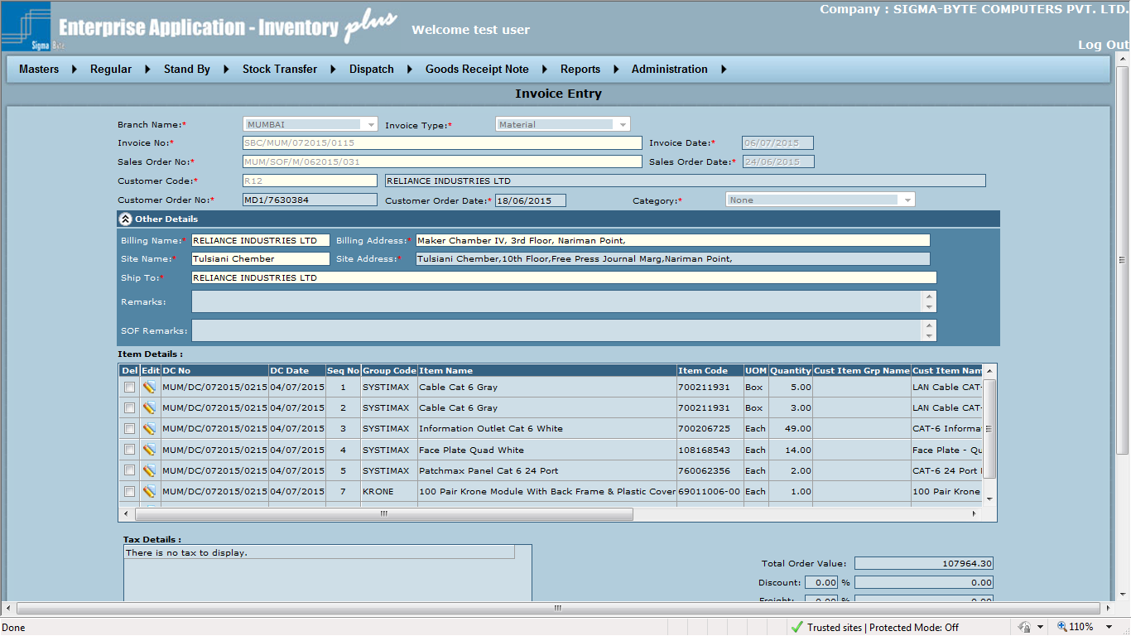

**Field Description**

|  |  |
| --- | --- |
| **Field Name** | **Description** |
| Branch Name | To select Branch Name. |
| Invoice Type | To Select one from the above listed DN types. |
| Invoice No | This is an Auto Generated Number. If an existing Invoice has to be modified, enter / select that Invoice no. |
| Invoice Date | This is an Auto Generated Number. If an existing Invoice has to be modified, enter / select that Invoice no. |
| Sales Order No | To select Sales Order No. |
| Sales Order Date | To add Sales Order Date. |
| Customer Code | To add Customer Code. |
| Customer Order No | To add Customer Order No. |
| Customer Order Date | To add Customer Order Date. |
| Category | To select Category. |
| Billing Name | Name which must appear on the Invoice |
| Billing Address | Address which must appear on the Invoice |
| Site Name | Site Name whom the Invoice must be sent. |
| Site Address | Site Address where Invoice must be sent |
| Ship To | To enter Shipping details. |
| Remarks | To enter Remarks. |
| SOF Remarks | To enter SOF remarks. |
| Original Copy | If it is the Original copy then check this box. |
| Payment Terms | As applicable |
| Cancel | Check this to Cancel Invoice. |
| Display Service Remark | Check this to Display Service Remark. |
| Save & Continue | To add Invoice Entry to the system. |
| Reset | To clear all the values in the Dispatch screen. |
| Print | To Print Invoice. |

### Inter Branch Invoice Entry

**Overview**

**Inter Branch Invoice Entry is used to raise Invoice between branches for specific company.**

**Page Snapshot: Inter Branch Invoice Entry**

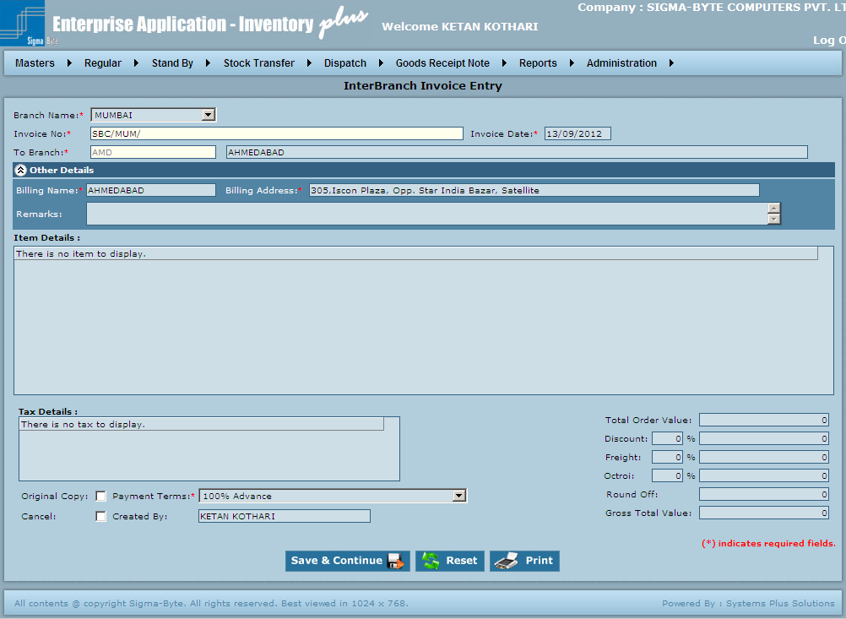

**Field Description**

|  |  |
| --- | --- |
| **Field Name** | **Description** |
| Branch Name | To select Branch Name. |
| Invoice No | This is an Auto Generated Number. If an existing Invoice has to be modified, enter / select that Invoice no. |
| Invoice Date | This is an Auto Generated Number. If an existing Invoice has to be modified, enter / select that Invoice no. |
| To Branch |  |
| Billing Name | Name which must appear on the Invoice |
| Billing Address | Address which must appear on the Invoice |
| Remarks | To enter Remarks. |
| Original Copy | If it is the Original copy then check this box. |
| Payment Terms | As applicable |
| Cancel | Check this to Cancel IOF. |
| Save & Continue | To add Inter Branch Invoice Entry to the system. |
| Reset | To clear all the values in the Dispatch screen. |

# ****Goods Receipt Note****

**Overview**

Goods Receipt Note Menu has submenus of

* GRN Against PO
* GRN Against Verbal
* GRN Against Goods Return
* GRN Against Inter Branch Transfer
* GRN Against Stand By Received
* GRN Against Stand By Return
* GRN Against Replacement

**Page Snapshot: Goods Receipt Note**

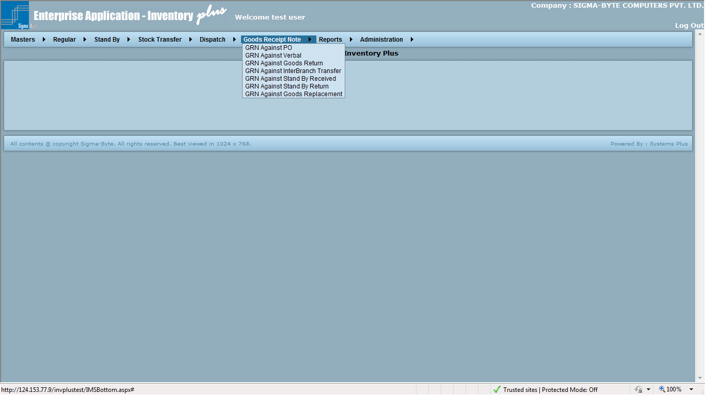

### GRN - Against PO

**Overview**

After the PO is made & sent to the supplier, the required material is supplied. While receiving the material an entry has to be made which is done using Goods Receipt Note Entry screen.

**Against PO:** This type of GRN is made if the material received is against a certain PO.

**Page Snapshot: GRN against PO**

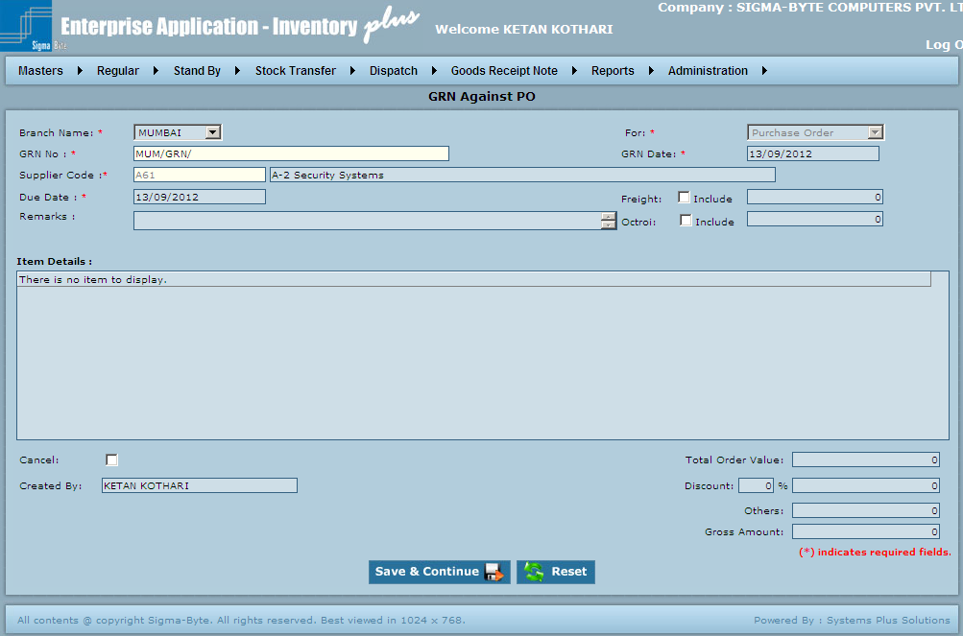

**Field Description**

|  |  |
| --- | --- |
| **Field Name** | **Description** |
| Branch Name | To select the required Branch. |
| For | To select Against what the GRN is created. |
| GRN No | This is an Auto Generated Number. |
| GRN Date | To add Date on which GRN is created. |
| Supplier Code | To add Supplier Code. |
| Due Date | To add Due Date. |
| Freight | If checked includes the Freight in Total Order Value. |
| Include | Add Freight as applicable. |
| Remarks | To add Remarks. |
| Octroi | If checked includes the Octroi in Total Order Value |
| Include | Add Octroi as applicable. |
| Item Details |  |
| Cancel | Check to cancel GRN. |
| Total Order Value | To add Total Order Value. |
| Discount | To add Discount. |
| Others | To add Others details. |
| Gross Amount | To add Gross Amount. |
| Save & Continue | To add GRN Against PO to the system. |
| Reset | To clear all the values in the Goods Receipt Note . |

### GRN - Against Verbal

**Overview**

After the PO is made & sent to the supplier, the required material is supplied. While receiving the material an entry has to be made which is done using Goods Receipt Note Entry screen.

**Against Verbal Order:** This type of GRN is made if material is received against a certain Verbal Order.

**Page Snapshot: GRN – Against Verbal**

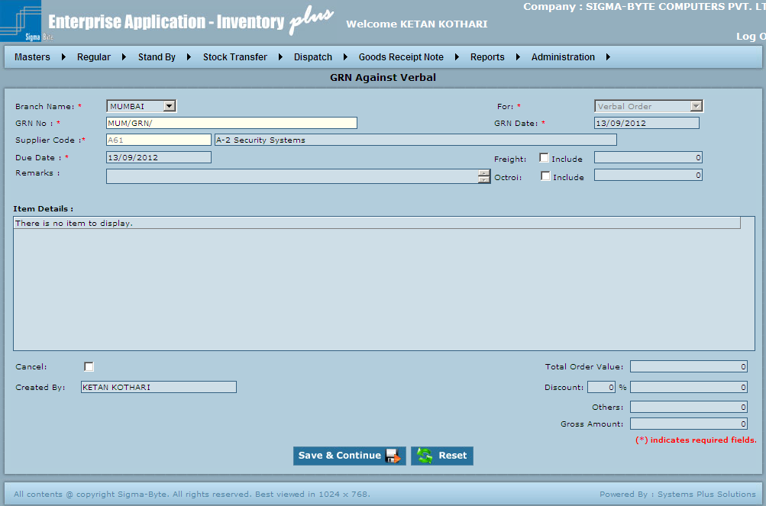

**Field Description**

|  |  |
| --- | --- |
| **Field Name** | **Description** |
| Branch Name | To select the required Branch. |
| For | To select Against what the GRN is created. |
| GRN No | This is an Auto Generated Number. |
| GRN Date | To add Date on which GRN is created. |
| Supplier Code | To add Supplier Code. |
| Due Date | To add Due Date. |
| Freight | If checked includes the Freight in Total Order Value. |
| Include | Add Freight as applicable. |
| Remarks | To add Remarks. |
| Octroi | If checked includes the Octroi in Total Order Value. |
| Include | Add Octroi as applicable. |
| **Item Details** |  |
| Cancel | Check to cancel GRN. |
| Total Order Value | To add Total Order Value. |
| Discount | To add Discount. |
| Others | To add Others details. |
| Gross Amount | To add Gross amount. |
| Save & Continue | To add GRN Against Verbal to the system. |
| Reset | To clear all the values in the Goods Receipt Note. |

### GRN - Against Goods Return

**Overview**

This type of GRN is made if the material is returned by the customer on account of damage or for any other reason.

**Page Snapshot: GRN - Against Goods Return**

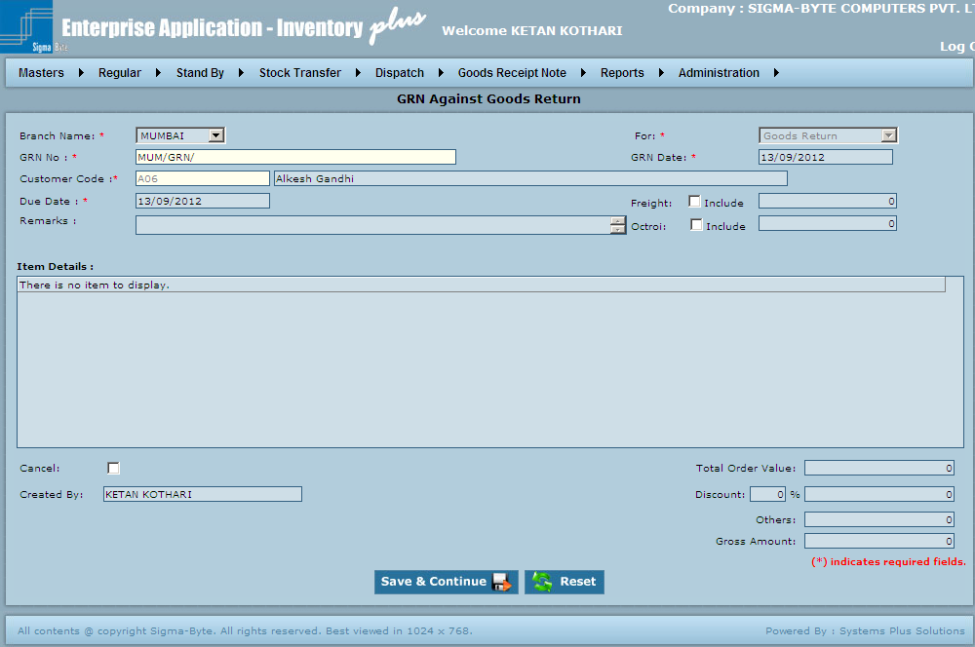

**Field Description**

|  |  |
| --- | --- |
| **Field Name** | **Description** |
| Branch Name | To select the required Branch. |
| For | To select Against what the GRN is created. |
| GRN No | This is an Auto Generated Number. |
| GRN Date | To add Date on which GRN is created. |
| Supplier Code | To add Supplier Code. |
| Due Date | To add Due Date. |
| Freight | If checked includes the Freight in Total Order Value. |
| Include | Add Freight as applicable. |
| Remarks | To add Remarks. |
| Octroi | If checked includes the Octroi in Total Order Value |
| Include | Add Octroi as applicable. |
| **Item Details** |  |
| Cancel | Check to cancel GRN. |
| Total Order Value | To add Total Order Value. |
| Discount | To add Discount. |
| Others | To add Others details. |
| Gross Amount | To add Gross Amount. |
| Save & Continue | To add GRN Against Goods Return to the system. |
| Reset | To clear all the values in the Goods Receipt Note. |

### GRN - Against Inter Branch Transfer

**Overview**

This type of GRN is made if the material is received on account of stock transfer from other branches.

**Page Snapshot: GRN Against Inter Branch Transfer**

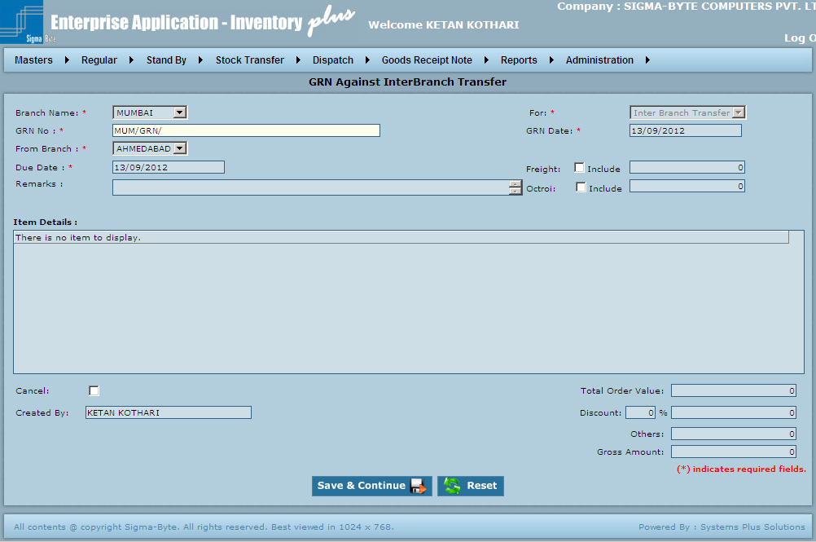

**Field Description**

|  |  |
| --- | --- |
| **Field Name** | **Description** |
| Branch Name | To select the required Branch. |
| For | To select Against what the GRN is created. |
| GRN No | This is an Auto Generated Number. |
| GRN Date | To add Date on which GRN is created. |
| Supplier Code | To add Supplier Code. |
| Due Date | To add Due Date. |
| Freight | If checked includes the Freight in Total Order Value. |
| Include | Add Freight as applicable. |
| Remarks | To add Remarks. |
| Octroi | If checked includes the Octroi in Total Order Value. |
| Include | Add Octroi as applicable. |
| **Item Details** |  |
| Cancel | Check to cancel GRN. |
| Total Order Value | To add Total Order Value. |
| Discount | To add Discount. |
| Others | To add Others. |
| Gross Amount | To add Gross Amount. |
| Save & Continue | To add GRN Against Inter Branch Transfer to the system. |
| Reset | To clear all the values in the Goods Receipt Note. |

### GRN - Against Stand By Received

**Overview**

This type of GRN is made if the material received from the supplier is as Stand-by. This material has to be returned after sometime.

**Page Snapshot: GRN - Against Stand By Received**

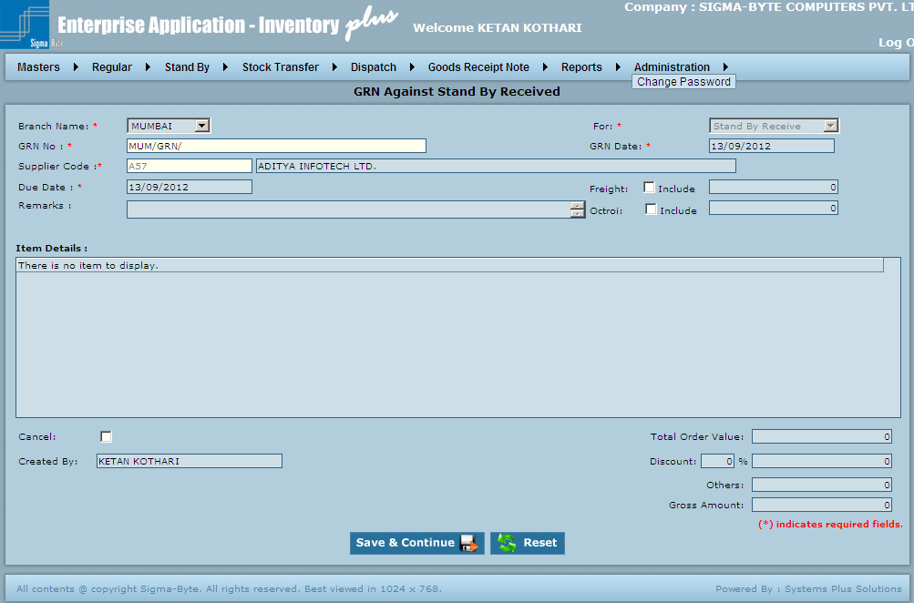

**Field Description**

|  |  |
| --- | --- |
| **Field Name** | **Description** |
| Branch Name | To select the required Branch. |
| For | To select Against what the GRN is created. |
| GRN No | This is an Auto Generated Number. |
| GRN Date | To add Date on which GRN is created. |
| Supplier Code | To add Supplier Code. |
| Due Date | To add Due Date. |
| Freight | If checked includes the Freight in Total Order Value. |
| Include | Add Freight as applicable. |
| Remarks | To add Remarks. |
| Octroi | If checked includes the Octroi in Total Order Value. |
| Include | Add Octroi as applicable. |
| **Item Details** |  |
| Cancel | Check to cancel GRN. |
| Total Order Value | To add Total Order Value. |
| Discount | To add Discount. |
| Others | To add Others details. |
| Gross Amount | To add Gross Amount. |
| Save & Continue | To add GRN Against Stand By Received to the system. |
| Reset | To clear all the values in the Goods Receipt Note. |

### GRN - Against Stand by Return

**Overview**

After the PO is made & sent to the supplier, the required material is supplied. While receiving the material an entry has to be made which is done using Goods Receipt Note Entry screen.

**Against Stand - By return:** This type of GRN is made if the material received from the customer is as Stand-By return.

I.e. the material had been given as Stand by sometime earlier.

**Page Snapshot: GRN - Against Stand by Return**

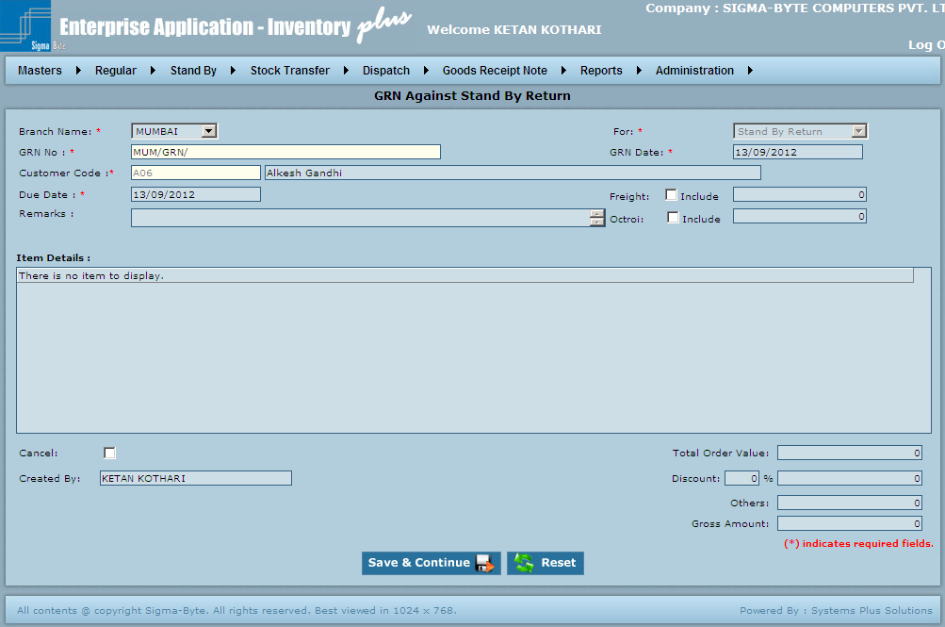

**Field Description**

|  |  |
| --- | --- |
| **Field Name** | **Description** |
| Branch Name | To select the required Branch. |
| For | To select Against what the GRN is created. |
| GRN No | This is an Auto Generated Number. |
| GRN Date | To add Date on which GRN is created. |
| Supplier Code | To add Supplier Code. |
| Due Date | To add Due Date. |
| Freight | If checked includes the Freight in Total Order Value. |
| Include | Add Freight as applicable. |
| Remarks | To add Remarks. |
| Octroi | If checked includes the Octroi in Total Order Value. |
| Include | Add Octroi as applicable. |
| **Item Details** |  |
| Cancel | Check to cancel GRN. |
| Total Order Value | To add Total Order Value. |
| Discount | To add Discount. |
| Others | To add Others Details. |
| Gross Amount | To add Gross Amount. |
| Save & Continue | To add GRN Against Stand By Return to the system. |
| Reset | To clear all the values in the Goods Receipt Note. |

### GRN - Against Goods Replacement

**Overview**

This type of GRN is made if the material is replaced by the customer on account of damage or for any other reason.

**Page Snapshot: GRN - Against Replacement**

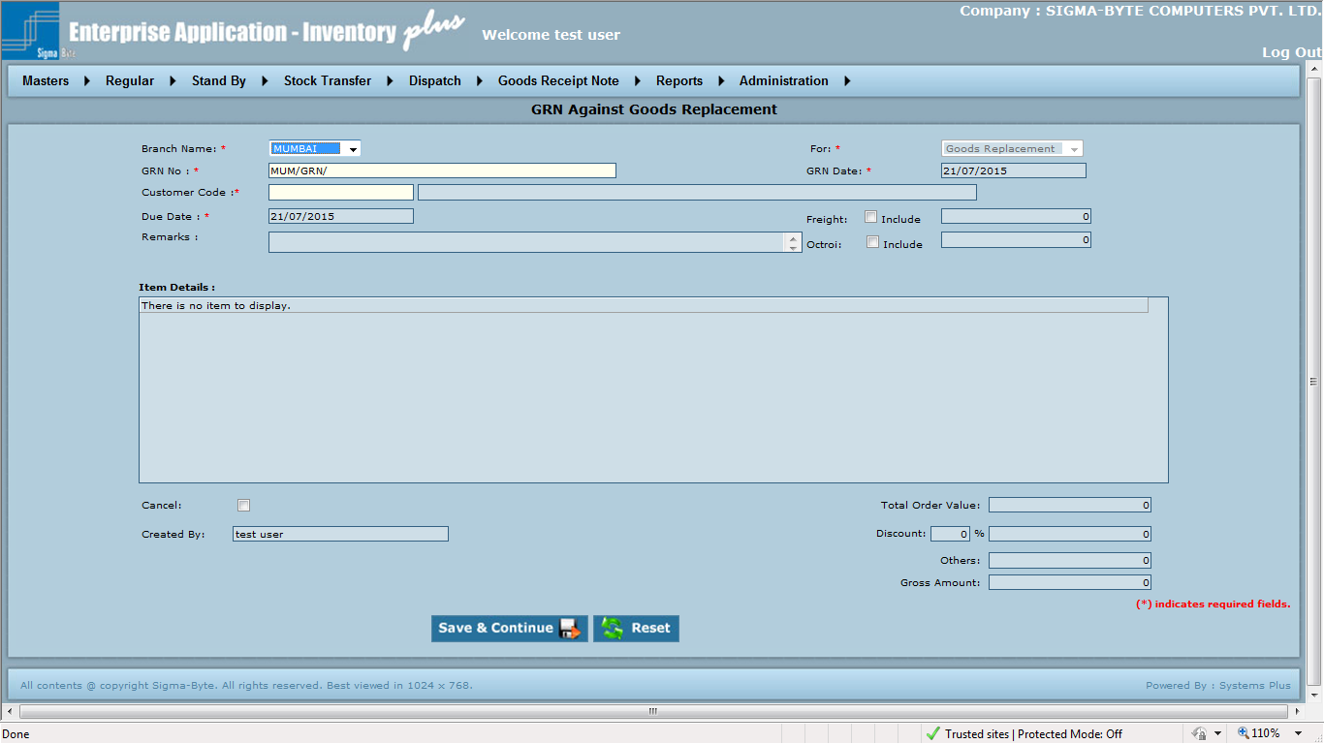

**Field Description**

|  |  |
| --- | --- |
| **Field Name** | **Description** |
| Branch Name | To select the required Branch. |
| For | To select Against what the GRN is created. |
| GRN No | This is an Auto Generated Number. |
| GRN Date | To add Date on which GRN is created. |
| Supplier Code | To add Supplier Code. |
| Due Date | To add Due Date. |
| Freight | If checked includes the Freight in Total Order Value. |
| Include | Add Freight as applicable. |
| Remarks | To add Remarks. |
| Octroi | If checked includes the Octroi in Total Order Value |
| Include | Add Octroi as applicable. |
| **Item Details** |  |
| Cancel | Check to cancel GRN. |
| Delivery Challan No. | Displays DC No of retrieved item |
| DC Date | Displays Date of DC No of retrieved item |
| Replacement DN No. | To select DN No of item which is replaced against retrieved item in item details Grid |
| Replacement DN Date | Displays Date of DN No of item which is replaced against retrieved item in item details Grid |
| Replacement Qty | Displays Qty of DN No of item which is replaced against retrieved item in item details Grid |
| Total Order Value | To add Total Order Value. |
| Discount | To add Discount. |
| Others | To add Others details. |
| Gross Amount | To add Gross Amount. |
| Save & Continue | To add GRN Against Goods Replacement to the system. |
| Reset | To clear all the values in the Goods Receipt Note. |

****Reports****

**Overview**

Report Menu has submenus of

* Pending Status
* Status Report
* Stock
* Billing Details
* Pending DC For Invoice
* Weighted Average
* Weighted Average (Without Tax)
* Bank Report
* Bank Report(Without Tax)
* Aging
* PO Reminder

**Page Snapshot: Reports**

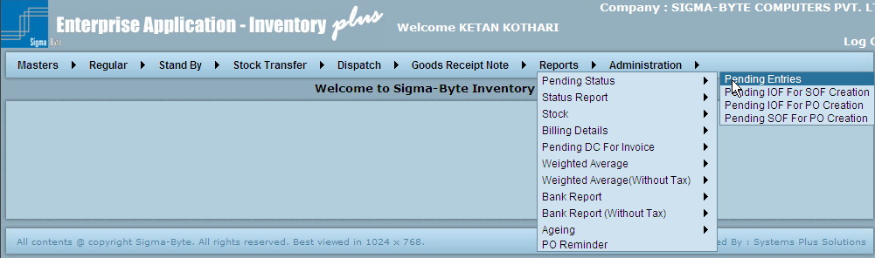

# Report - Pending Status

**Overview**

Pending Status has various reports as

* Pending Entries
* Pending IOF for SOF creation
* Pending IOF for PO creation
* Pending SOF for PO Creation

### Pending Entries

**Overview**

This Report gives an instant update of the following Pending transactions:

**Pending IOFs for Approval:** In this case the IOF has been received, but not processed further, i.e., the SOF has not been made. This is because the IOF has not been approved. So it shows the Name of IOF generator & the Approving authority.

**Pending SOFs for Approval:** In this case the SOF has been received, but not processed further. This is because the SOF has not been approved. So it shows the Name of SOF generator & the Approving authority.

**Pending Dispatch notes for DC creation:** These are the Despatch notes against which material has been sent. But for some reason the DC was not made. This shows the name of Creator.

**Pending Delivery challans for DC received:** These are cases where the DC has been made & sent to the Customer. But the received copy of same DC has not been received.

**Page Snapshot: Pending Entries (All)**

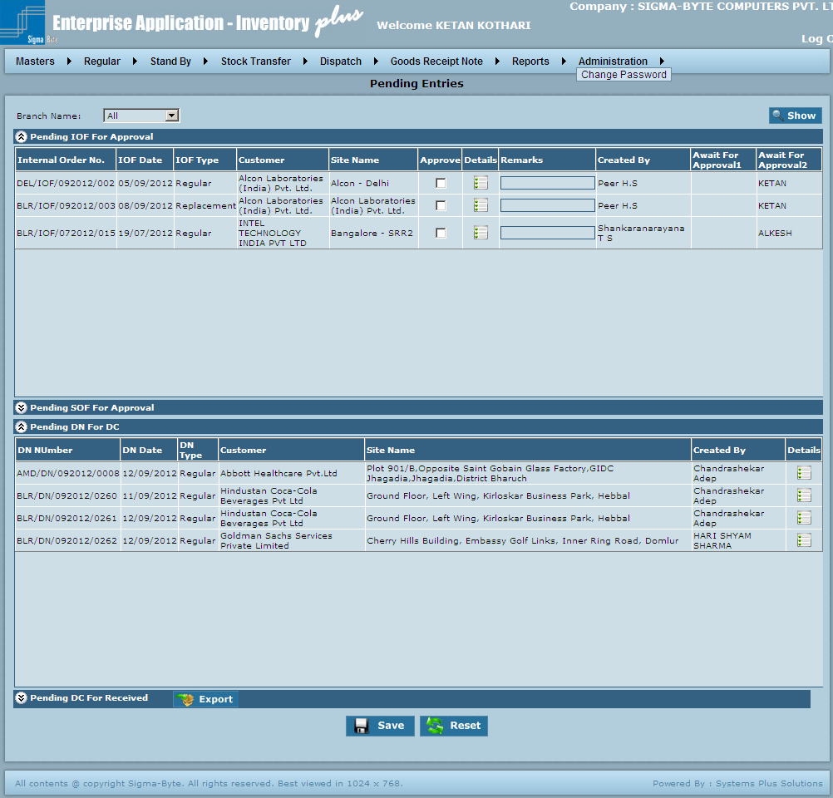

**Page Snapshot: Pending Entries (Selection Base)**

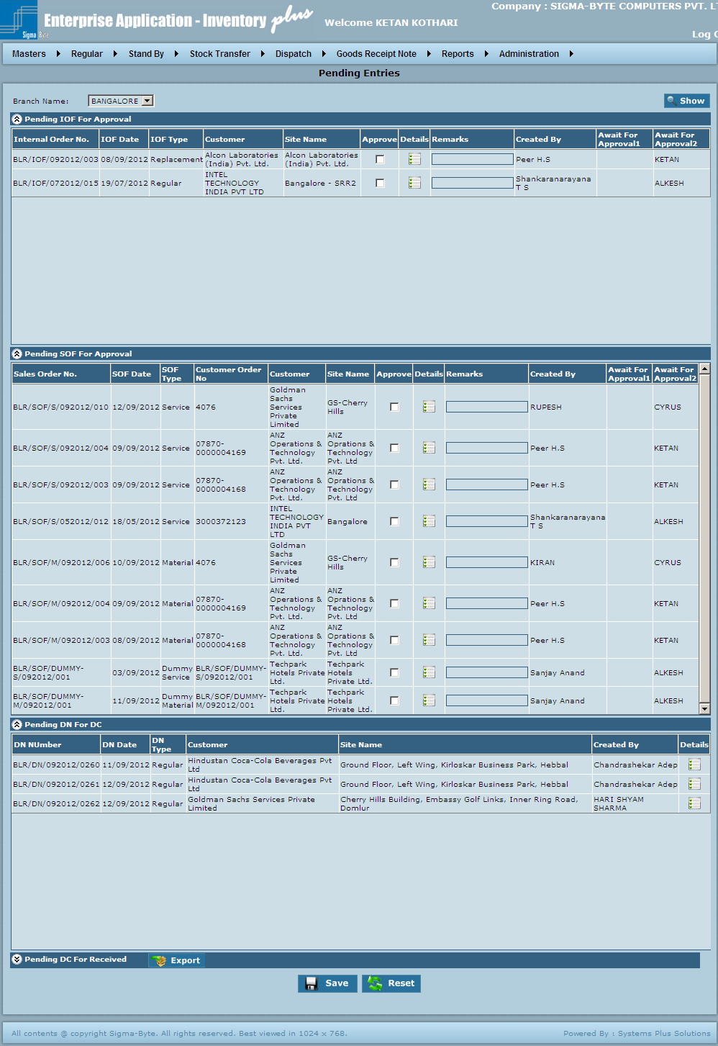

**Field Description**

|  |  |
| --- | --- |
| **Field Name** | **Description** |
| Branch Name | To select Branch Name. |
| Show |  |
| Save | To save Pending Entries. |
| Reset | Reset all the fields on Reports screen. |

### Pending IOF for SOF creation

**Overview**

This is a summary report of the IOFs pending for SOF creation. This report can be seen for all or one of the customers & IOFs.

**Page Snapshot: Pending IOF for SOF creation**

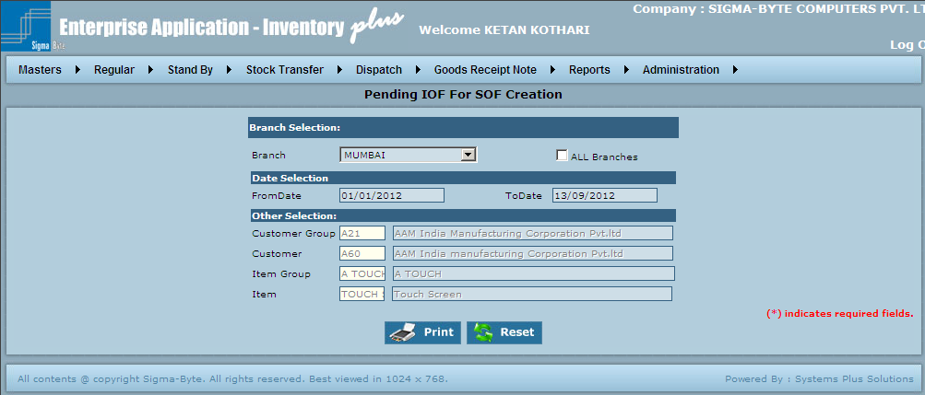

**Field Description**

|  |  |
| --- | --- |
| **Field Name** | **Description** |
| Branch Name | To select Branch Name. |
| All Branches | Check this box to select all Branches. |
| From Date | To select From Date. |
| To Date | To select To Date. |
| Customer Group | To select Customer Group. |
| Customer | To select Customer. |
| Item Group | To select Item Group. |
| Item | To select Item. |
| View Hierarchy data | If view hierarchy data is selected and user clicks on print then, only his and hierarchy data will be displayed. |
| View all data | This will show data of all users irrespective of hierarchy |
| Print | To Print the Report. |
| Reset | Reset all the fields on Reports screen. |

### Pending IOF for PO creation

**Overview**

This is a summary report of the IOFs pending for Purchase Order creation. This report can be seen for all or one of the customers & Item Groups.

**Page Snapshot: Pending IOF for PO creation**

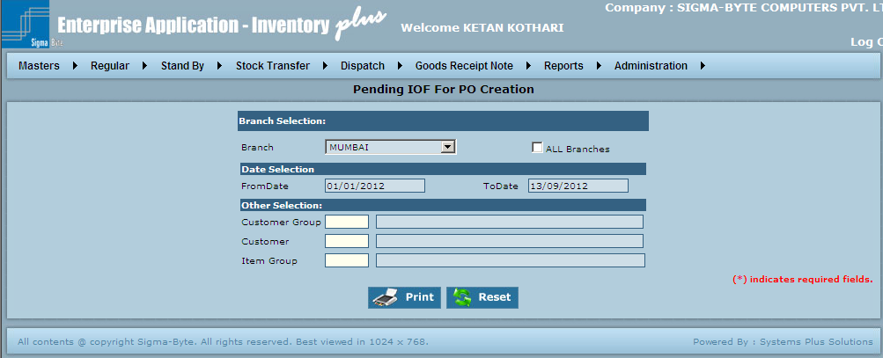

**Field Description**

|  |  |
| --- | --- |
| **Field Name** | **Description** |
| Branch Name | To select Branch Name. |
| All Branches | Check this box to select all Branches. |
| From Date | To select From Date. |
| To Date | To select To Date. |
| Customer Group | To select Customer Group. |
| Customer | To select Customer. |
| Item Group | To select Item Group. |
| Print | To Print the Report. |
| Reset | Reset all the fields on Reports screen. |

### Pending SOF for PO creation

**Overview**

This is a summary report of the SOFs pending for Purchase Order creation. This report can be seen for all or one of the customers & Item Groups.

**Page Snapshot: Pending SOF for PO creation**

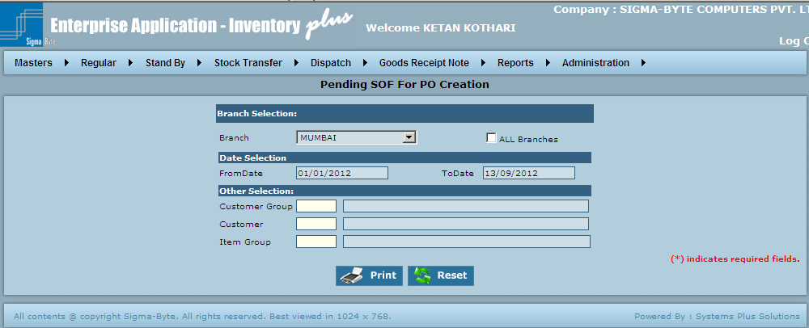

**Field Description**

|  |  |
| --- | --- |
| **Field Name** | **Description** |
| Branch Name | To select Branch Name. |
| All Branches | Check this box to select all Branches. |
| FromDate | To select From Date. |
| ToDate | To add To Date. |
| Customer Group | To add Customer Group. |
| Customer | To add Customer. |
| Item Group | To add Item Group. |
| View Hierarchy data | If view hierarchy data is selected and user clicks on print then, only his and hierarchy data will be displayed. |
| View all data | This will show data of all users irrespective of hierarchy |
| Print | To Print the Report. |
| Reset | Reset all the fields on Reports screen. |

# Status Report

**Overview**

**Status Report has various reports as**

* **IOF Status.**
* **Customer Order Status**
* **PO Status - Supplier Wise**
* **PO Status – Customer Wise**
* **GRN Details - Supplier Wise**
* **GRN Details – Customer Wise**

### IOF Status

**Overview**

This Report gives the status of Customer PO in terms of the material / services supplied vs. pending.

Thus how much order is still to be executed can be seen. This report covers only the IOFs.

**Page Snapshot: IOF Status** 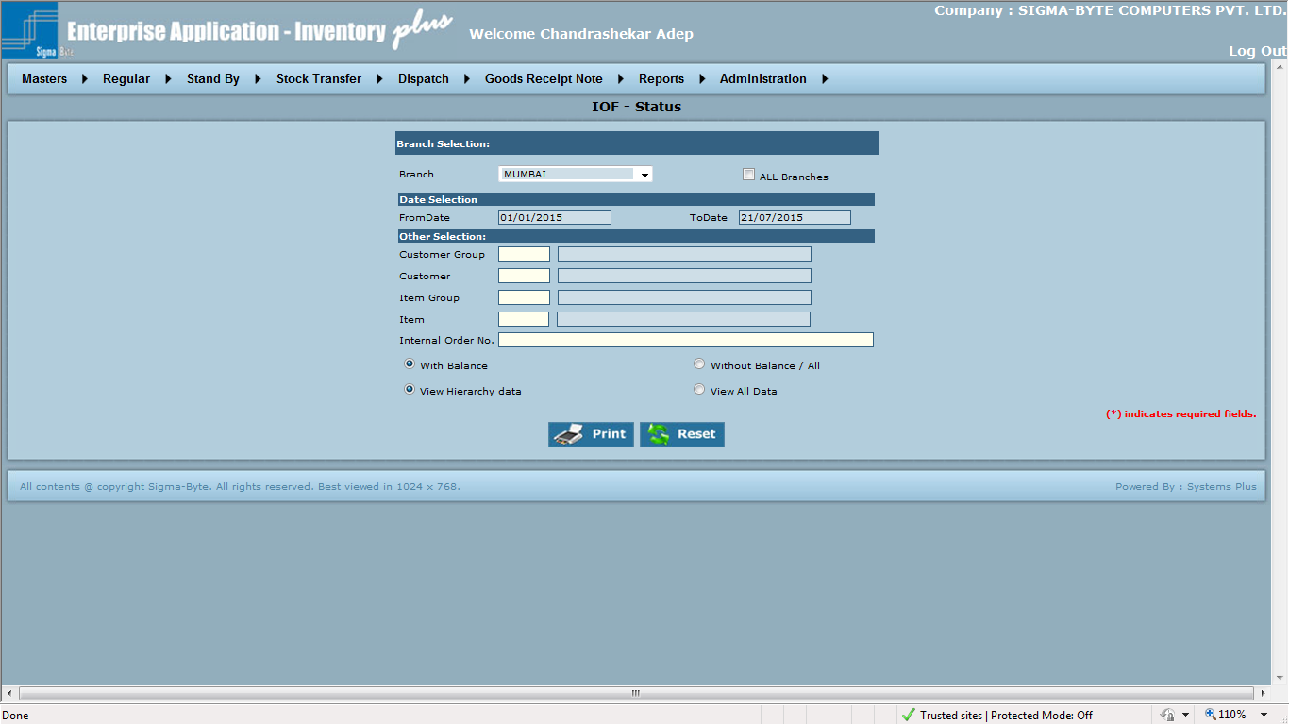

**Field Description**

|  |  |
| --- | --- |
| **Field Name** | **Description** |
| Branch Name | To select Branch Name. |
| All Branches | Check this box to select all Branches. |
| FromDate | To select From Date. |
| ToDate | To add To Date. |
| Customer Group | To add Customer Group. |
| Customer | To add Customer. |
| Item Group | To add Item Group. |
| Item | To add Item. |
| Internal Order No | To add Internal Order No. |
| With Balance | Check to Print IOF Status With Balance. |
| Without Balance / All | Check to Print IOF Status Without Balance. |
| View Hierarchy data | If View hierarchy Data is selected and user clicks on print then, only his and hierarchy data will be displayed. |
| View all data | This will show data of all users irrespective of hierarchy |
| Print | To Print the Report. |
| Reset | Reset all the fields on Reports screen. |

### Customer Order Status

**Overview**

This Report gives the status of Customer PO in terms of the material / services supplied vs. pending.

Thus how much order is still to be executed can be seen. This report covers only the SOFs.

**Page Snapshot: Customer Order Status**

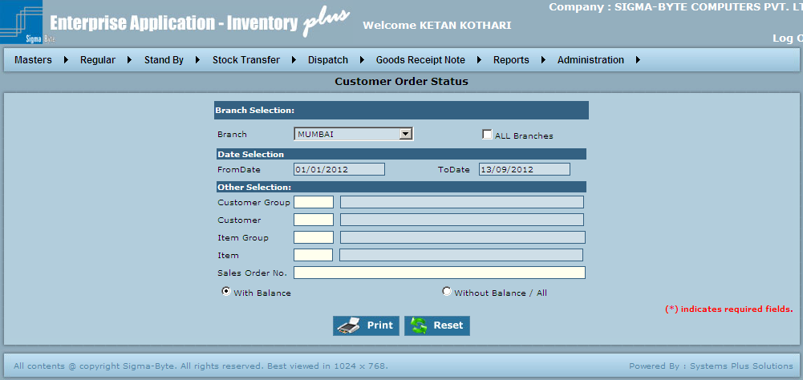

**Field Description**

|  |  |
| --- | --- |
| **Field Name** | **Description** |
| Branch Name | To select Branch Name. |
| All Branches | Check this box to select all Branches. |
| FromDate | To select From Date. |
| ToDate | To add To Date. |
| Customer Group | To add Customer Group. |
| Customer | To add Customer. |
| Item Group | To add Item Group. |
| Item | To add Item. |
| Sales Order No | To add Sales Order No. |
| With Balance | Check to Print Customer Order Status With Balance. |
| Without Balance / All | Check to Print Customer Order Status Without Balance. |
| View Hierarchy data | If view hierarchy data is selected and user clicks on print then, only his and hierarchy data will be displayed. |
| View all data | This will show data of all users irrespective of hierarchy |
| Print | To Print the Report. |
| Reset | Reset all the fields on Reports screen. |

### PO Status Supplier Wise

**Overview**

**PO Status Supplier Wise is used to view PO Status Supplier Wise Report.**

**Page Snapshot: PO Status Supplier Wise**

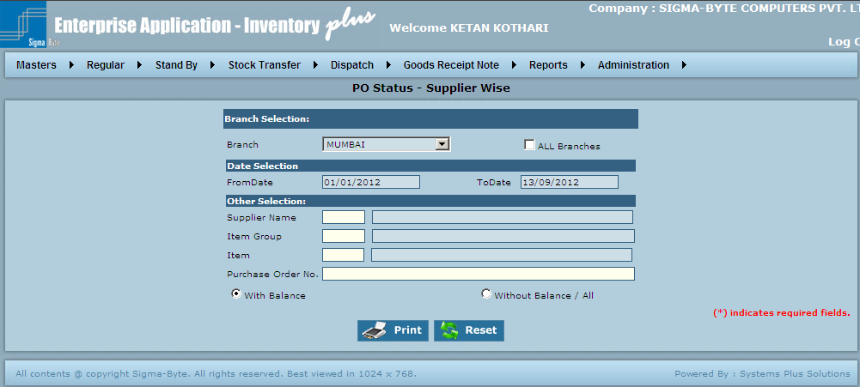

**Field Description**

|  |  |
| --- | --- |
| **Field Name** | **Description** |
| Branch Name | To select Branch Name. |
| All Branches | Check this box to select all Branches. |
| FromDate | To select From Date. |
| ToDate | To add To Date. |
| Supplier Name | To add Supplier Name. |
| Item Group | To add Item Group. |
| Item | To add Item. |
| Purchase Order No | To add Purchase Order No. |
| With Balance | Check to With Balance. |
| Without Balance / All | Check to Print Customer Order Status Without Balance. |
| View Hierarchy data | If view hierarchy data is selected and user clicks on print then, only his and hierarchy data will be displayed. |
| View all data | This will show data of all users irrespective of hierarchy |
| Print | To Print the Report. |
| Reset | Reset all the fields on Reports screen. |

### PO Status Customer Wise

**Overview**

**PO Status Customer Wise is used to view PO Status Customer Wise Report.**

**Page Snapshot: PO Status Customer Wise**

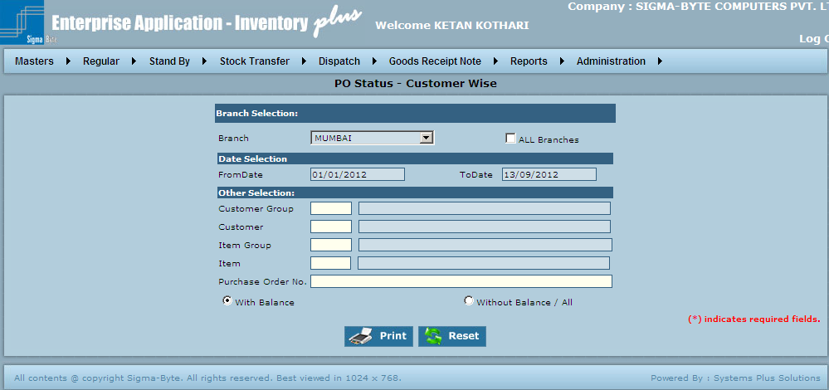

**Field Description**

|  |  |
| --- | --- |
| **Field Name** | **Description** |
| Branch Name | To select Branch Name. |
| All Branches | Check this box to select all Branches. |
| FromDate | To select From Date. |
| ToDate | To add To Date. |
| Customer Group | To add Customer Group. |
| Customer | To add Customer. |
| Item Group | To add Item Group. |
| Item | To add Item. |
| Purchase Order No | To add Purchase Order No. |
| With Balance |  |
| Without Balance / All |  |
| View Hierarchy data | If view hierarchy data is selected and user clicks on print then, only his and hierarchy data will be displayed. |
| View all data | This will show data of all users irrespective of hierarchy |
| Print | To Print the Report. |
| Reset | Reset all the fields on Reports screen. |

### GRN Details-Supplier Wise

**Overview**

**GRN Details-Supplier Wise is used to view GRN Details-Supplier Wise Report.**

**Page Snapshot: GRN Details-Supplier Wise**

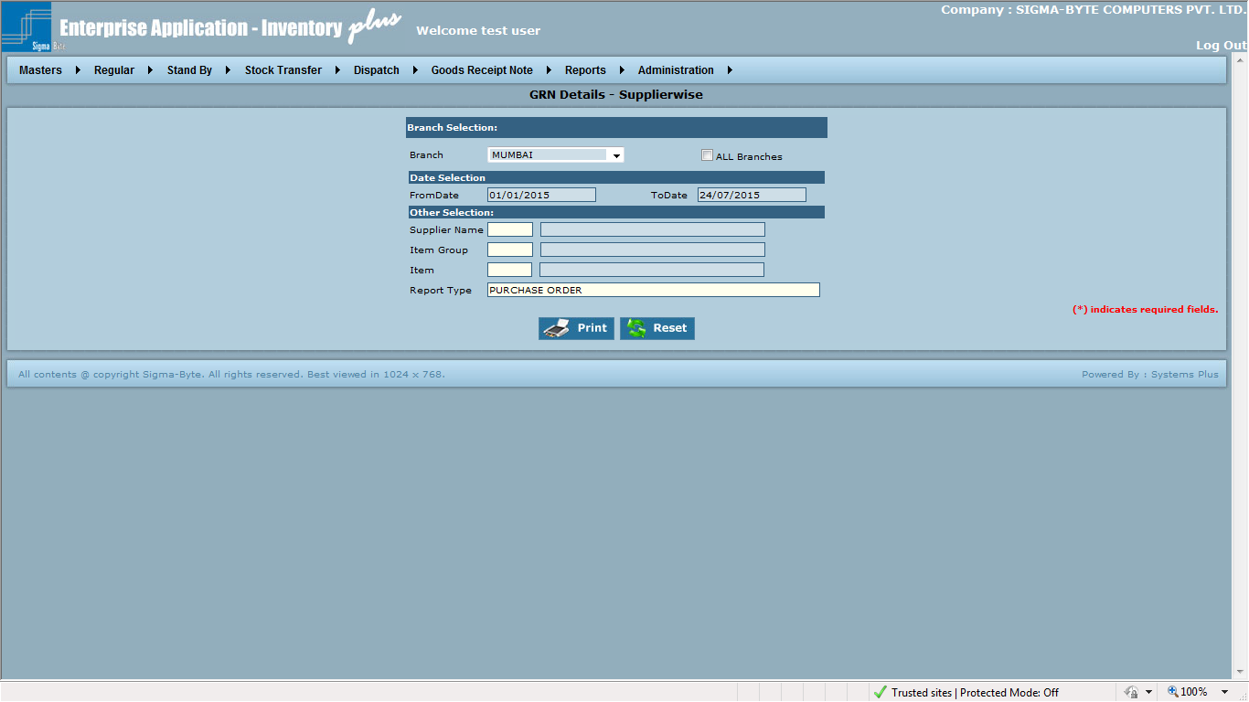

**Field Description**

|  |  |
| --- | --- |
| **Field Name** | **Description** |
| Branch Name | To select Branch Name. |
| All Branches | Check this box to select all Branches. |
| FromDate | To select From Date. |
| ToDate | To add To Date. |
| Supplier Name | To add Supplier Name. |
| Item Group | To add Item Group. |
| Item | To add Item. |
| Report Type | To select GRN Type for report |
| Print | To Print the Report. |
| Reset | Reset all the fields on Reports screen. |

### GRN Details-Customer Wise

**Overview**

**GRN Details-Customer Wise is used to view GRN Details-Customer Wise Report.**

**Page Snapshot: GRN Details-Customer Wise**

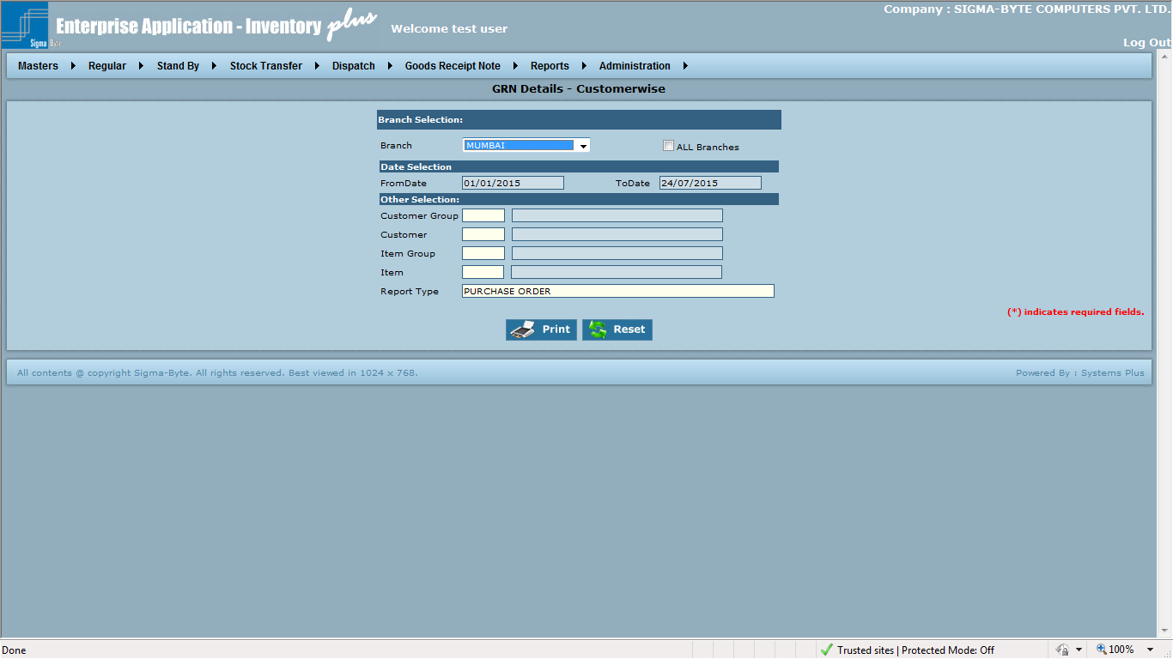

**Field Description**

|  |  |
| --- | --- |
| **Field Name** | **Description** |
| Branch Name | To select Branch Name. |
| All Branches | Check this box to select all Branches. |
| FromDate | To select From Date. |
| ToDate | To add To Date. |
| Customer Group | To add Customer Group. |
| Customer | To add Customer. |
| Item Group | To add Item Group. |
| Item | To add Item. |
| Report Type | To select GRN Type for report |
| Print | To Print the Report. |
| Reset | Reset all the fields on Reports screen. |

### Account Manager Wise Sales

**Overview**

**This report provides functionality to view records based on Business Line mapped with item group used in transaction. Also users can view records based on Account Manager.**

**Page Snapshot: Account Manager Wise Sales**

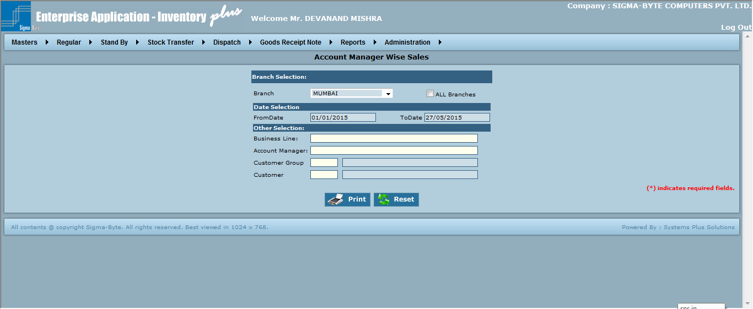

**Field Description**

|  |  |
| --- | --- |
| **Field Name** | **Description** |
| Branch Name | To select Branch Name. |
| All Branches | Check this box to select all Branches. |
| FromDate | To select From Date. |
| ToDate | To add To Date. |
| Customer Group | To add Customer Group. |
| Customer | To add Customer. |
| Item Group | To add Item Group. |
| Item | To add Item. |
| Print | To Print the Report. |
| Reset | Reset all the fields on Reports screen. |

### Product Wise Sales

**Overview**

**This report provides functionality to view records based on Business Line mapped with item group used in transaction. Also users can view records based on Account Manager.**

**Page Snapshot: Product Wise Sales**

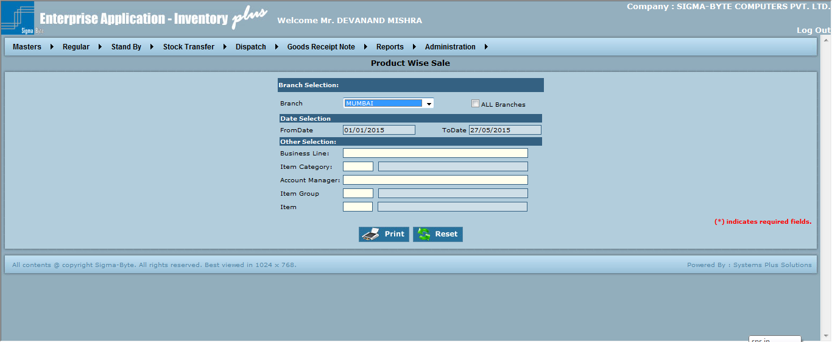

**Field Description**

|  |  |
| --- | --- |
| **Field Name** | **Description** |
| Branch Name | To select Branch Name. |
| All Branches | Check this box to select all Branches. |
| FromDate | To select From Date. |
| ToDate | To add To Date. |
| Customer Group | To add Customer Group. |
| Customer | To add Customer. |
| Item Group | To add Item Group. |
| Item | To add Item. |
| Print | To Print the Report. |
| Reset | Reset all the fields on Reports screen. |

# Stock Report

**Overview**

**Stock Report has various reports as**

* **Customer Wise**
* **Item Wise**
* **Item Wise As On Date**
* **Ledger**
* **Ledger As on Date**
* **With Tax Details**
* **Item Listing**
* **Weekly Status**

### Stock on Hand-Customer Wise

**Overview**

This report gives the details about the stock for a particular customer. User has the options of having the report for all or one Branch, Customer, Group & Item. Checking the Open box gives the report only for Free Stock.

**Page Snapshot: Stock On Hand Customer Wise**

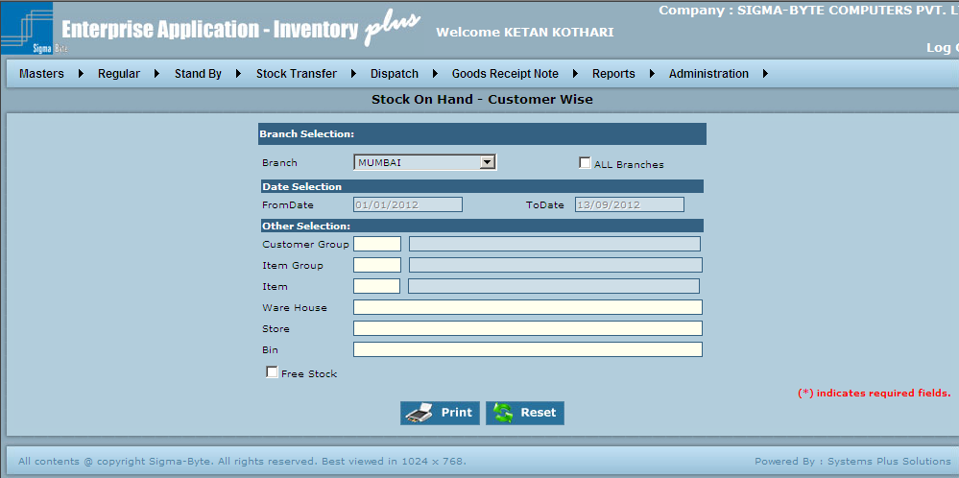

**Field Description**

|  |  |
| --- | --- |
| **Field Name** | **Description** |
| Branch Name | To select Branch Name. |
| All Branches | Check this box to select all Branches. |
| FromDate | To select From Date. |
| ToDate | To add To Date. |
| Customer Group | To add Customer Group. |
| Item Group | To add Item Group. |
| Item | To add Item. |
| Ware House | To add Ware House. |
| Store | To add Store. |
| Bin | To add Bin. |
| Free Stock |  |
| Print | To Print the Report. |
| Reset | Reset all the fields on Reports screen. |

### Stock on Hand-Item Wise

**Overview**

This report gives the details about the stock of a particular item. User has the options of having the report for all or one Branch, Customer, Group & Item. Checking the Open box gives the report only for Free Stock.

**Page Snapshot: Stock On Hand Item Wise**

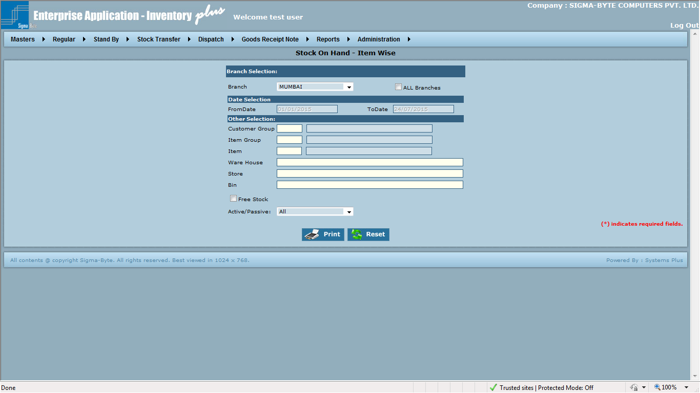

**Field Description**

|  |  |
| --- | --- |
| **Field Name** | **Description** |
| Branch Name | To select Branch Name. |
| All Branches | Check this box to select all Branches. |
| From Date | To select From Date. |
| To Date | To add To Date. |
| Customer Group | To add Customer Group. |
| Item Group | To add Item Group. |
| Item | To add Item. |
| Ware House | To add Ware House. |
| Store | To add Store. |
| Bin | To add Bin. |
| Free Stock |  |
| Active/Passive | To select Item type based on Active/Passive/All |
| Print | To Print the Report. |
| Reset | Reset all the fields on Reports screen. |

### Stock on Hand-Item Wise as On Date

**Overview**

This report is same as Stock on Hand – Item wise but with the date parameters so that the stock within a particular time period can be seen.

**Page Snapshot: Stock On Hand Item Wise As On Date**

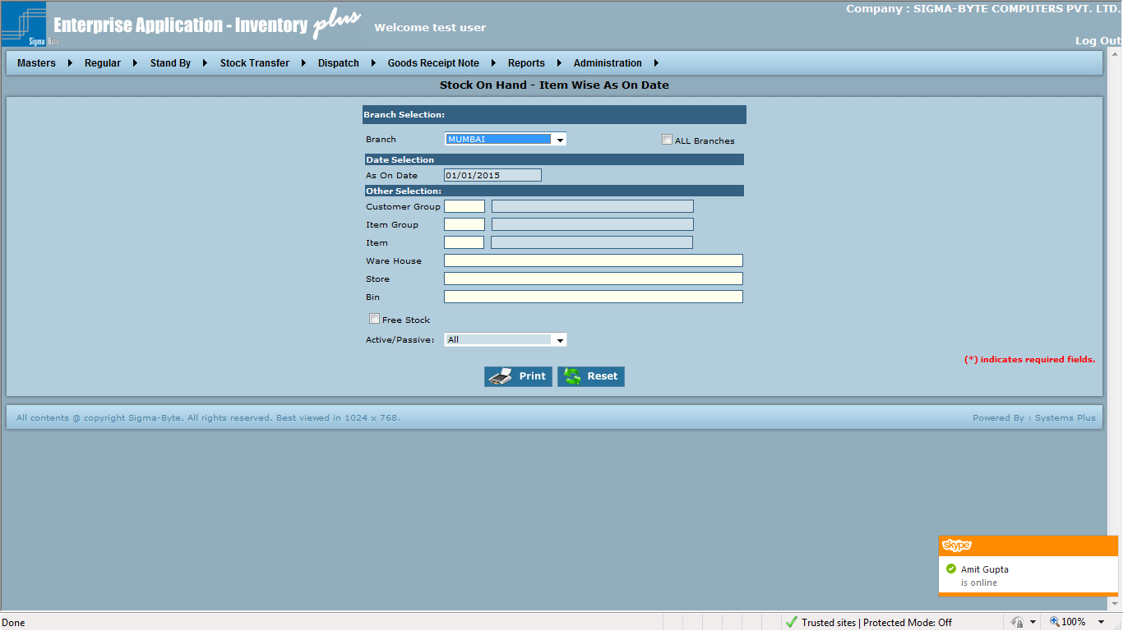

**Field Description**

|  |  |
| --- | --- |
| **Field Name** | **Description** |
| Branch Name | To select Branch Name. |
| All Branches | Check this box to select all Branches. |
| As On Date | To select As On Date. |
| Customer Group | To add Customer Group. |
| Item Group | To add Item Group. |
| Item | To add Item. |
| Ware House | To add Ware House. |
| Store | To add Store. |
| Bin | To add Bin. |
| Free Stock |  |
| Active/Passive | To select Item type based on Active/Passive/All |
| Print | To Print the Report. |
| Reset | Reset all the fields on Reports screen. |

### Stock Ledger

**Overview**

This report shows in detail the transactions for a particular item or all items thus finally giving the balance quantity at the time of viewing report. In this case only one item group can be selected thus restricting the report to all or particular items of only one item group.

**Page Snapshot: Stock Ledger**

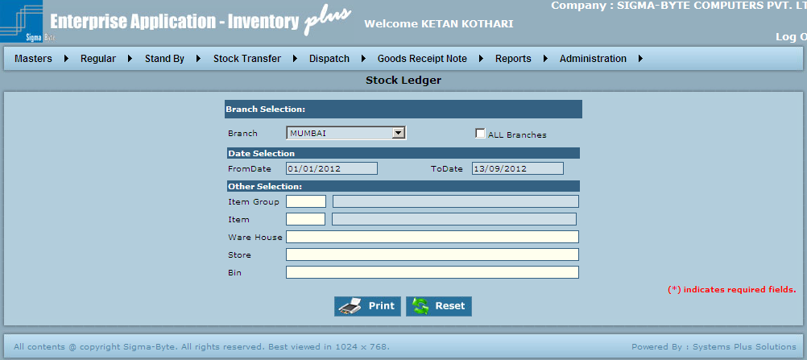

**Field Description**

|  |  |
| --- | --- |
| **Field Name** | **Description** |
| Branch Name | To select Branch Name. |
| All Branches | Check this box to select all Branches. |
| From Date | To add From Date. |
| To Date | To add To Date. |
| Item Group | To add Item Group. |
| Item | To add Item. |
| Ware House | To add Ware House. |
| Store | To add Store. |
| Bin | To add Bin. |
| Print | To Print the Report. |
| Reset | Reset all the fields on Reports screen. |

### Stock Ledger as On Date

**Overview**

This report is same as Stock Ledger but with the date parameters so that the stock transactions within a particular time period can be seen. In this case also only one item group can be selected thus restricting the report to all or particular items of only one item group.

**Page Snapshot: Stock Ledger As On Date**

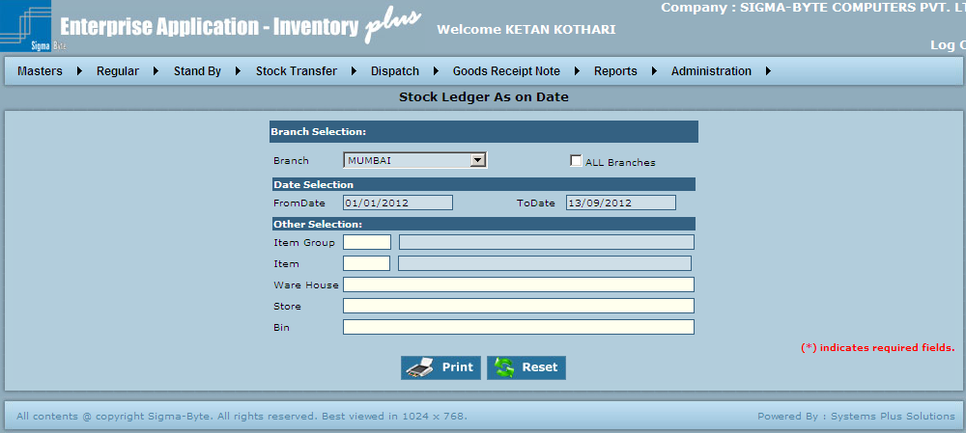

**Field Description**

|  |  |
| --- | --- |
| **Field Name** | **Description** |
| Branch Name | To select Branch Name. |
| All Branches | Check this box to select all Branches. |
| From Date | To add From Date. |
| To Date | To add To Date. |
| Item Group | To add Item Group. |
| Item | To add Item. |
| Ware House | To add Ware House. |
| Store | To add Store. |
| Bin | To add Bin. |
| Print | To Print the Report. |
| Reset | Reset all the fields on Reports screen. |

### Stock With Tax Details

**Overview**

This report provides the information about which items are covered under a particular tax, i.e.: for a particular item which kind of tax (e.g.: VAT tax 4%, VAT Tax 12.5% etc) has been paid. Also it gives the details about how much tax has been paid & how much is recovered from the customer.

**Page Snapshot: Stock With tax Details**

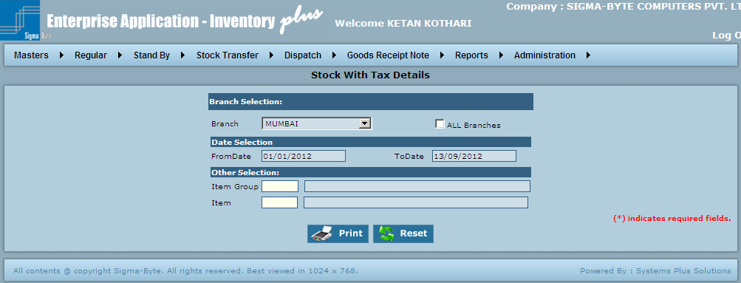

**Field Description**

|  |  |
| --- | --- |
| **Field Name** | **Description** |
| Branch Name | To select Branch Name. |
| All Branches | Check this box to select all Branches. |
| From Date | To add From Date. |
| To Date | To add To Date. |
| Item Group | To add Item Group. |
| Item | To add Item. |
| Print | To Print the Report. |
| Reset | Reset all the fields on Reports screen. |

### Item Listing

**Overview**

This report provides the user with a blank format which can be used for physical stock taking. All items in an Item Group are shown with their unit of measurement. This helps to save time in item listing for any item group.

**Page Snapshot: Item Listing**

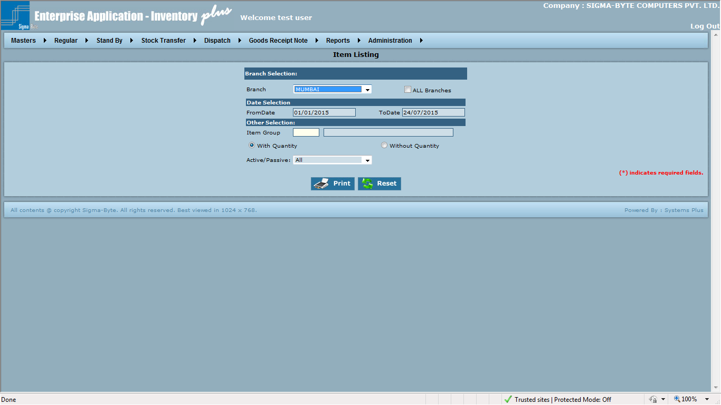

**Field Description**

|  |  |
| --- | --- |
| **Field Name** | **Description** |
| Branch Name | To select Branch Name. |
| All Branches | Check this box to select all Branches. |
| From Date | To add From Date. |
| To Date | To add To Date. |
| Item Group | To add Item Group. |
| With Quantity | Check to Print Item Listing Report With Quantity. |
| Without Quantity | Check to Print Item Listing Without Quantity. |
| Active/Passive | To select Item type based on Active/Passive/All |
| Print | To Print the Report. |
| Reset | Reset all the fields on Reports screen. |

### Weekly Stock Status

**Overview**

**Weekly Stock Status is used to view Weekly Stock Status Report.**

**Page Snapshot: Weekly Stock Status**

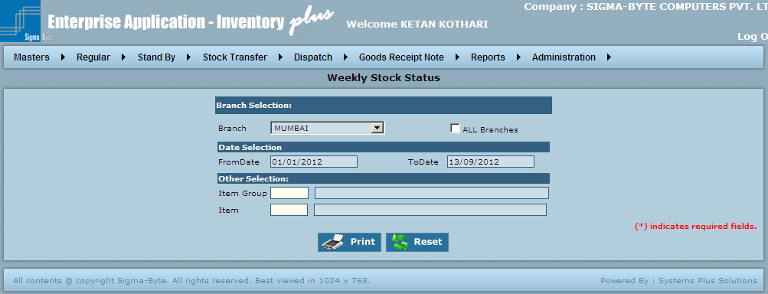

**Field Description**

|  |  |
| --- | --- |
| **Field Name** | **Description** |
| Branch Name | To select Branch Name. |
| All Branches | Check this box to select all Branches. |
| From Date | To add From Date. |
| To Date | To add To Date. |
| Item Group | To add Item Group. |
| Print | To Print the Report. |
| Reset | Reset all the fields on Reports screen. |

### Stock Summary

**Overview**

**It is used to view stock quantity, Pending Invoice quantity, Pending DN quantity, Pending GRN quantity.**

**Page Snapshot: Stock Summary**

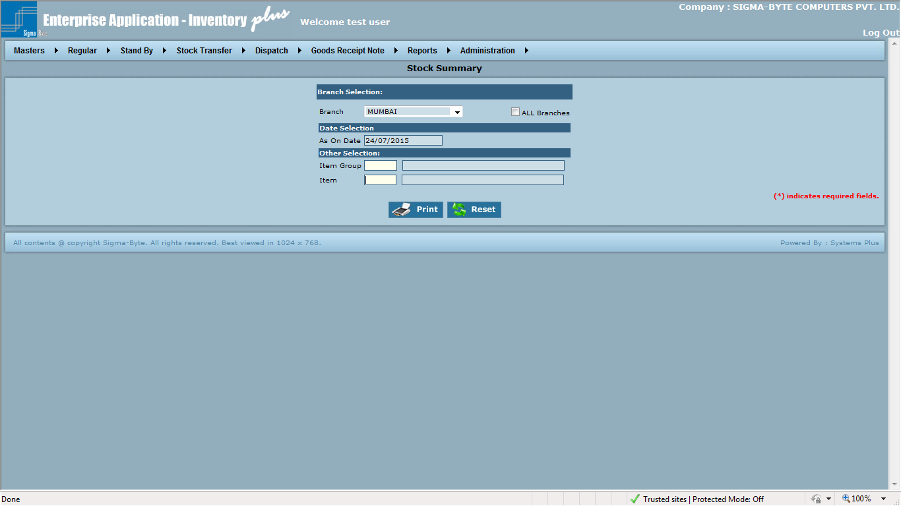

**Field Description**

|  |  |
| --- | --- |
| **Field Name** | **Description** |
| Branch Name | To select Branch Name. |
| All Branches | Check this box to select all Branches. |
| As On Date | To add As On Date. |
| Item Group | To add Item Group. |
| Item | To add Item. |
| Print | To Print the Report. |
| Reset | Reset all the fields on Reports screen. |

### Replacement

**Overview**

**Replacement is used to view replacement item details Report.**

**Page Snapshot: Replacement**

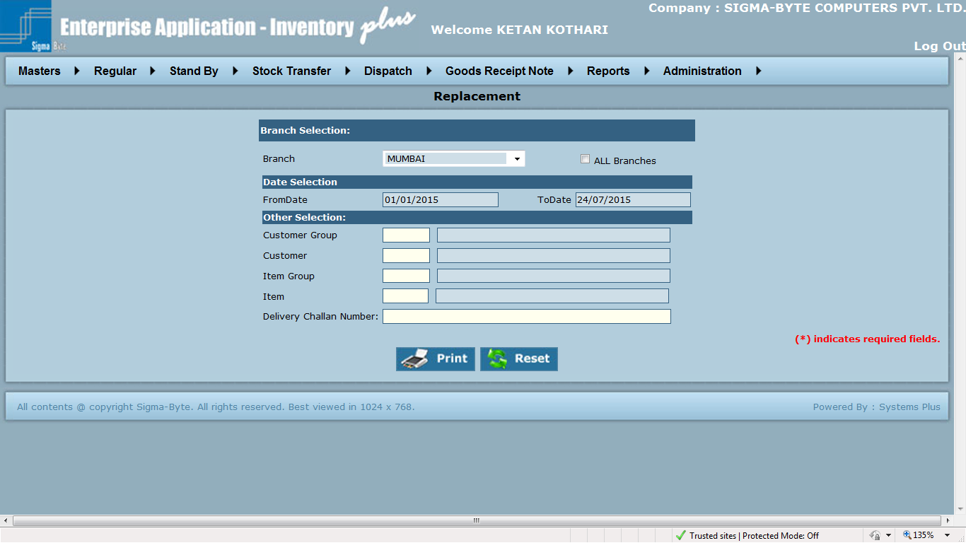

**Field Description**

|  |  |
| --- | --- |
| **Field Name** | **Description** |
| Branch Name | To select Branch Name. |
| All Branches | Check this box to select all Branches. |
| From Date | To add From Date. |
| To Date | To add To Date. |
| Customer Group | To add Customer Group. |
| Customer | To add Customer. |
| Item Group | To add Item Group. |
| Item | To add Item. |
| Delivery Challan Number | To select DC no details of item that is used as a replacement. |
| Print | To Print the Report. |
| Reset | Reset all the fields on Reports screen. |

### Serial No. Details

**Overview**

**Serial No. Details is used to view serial no related details of active items such as Serial No,**

**Warranty Received From , Warranty Received To, Warranty Given From , Warranty Given To.**

**Page Snapshot: Serial No. Details**

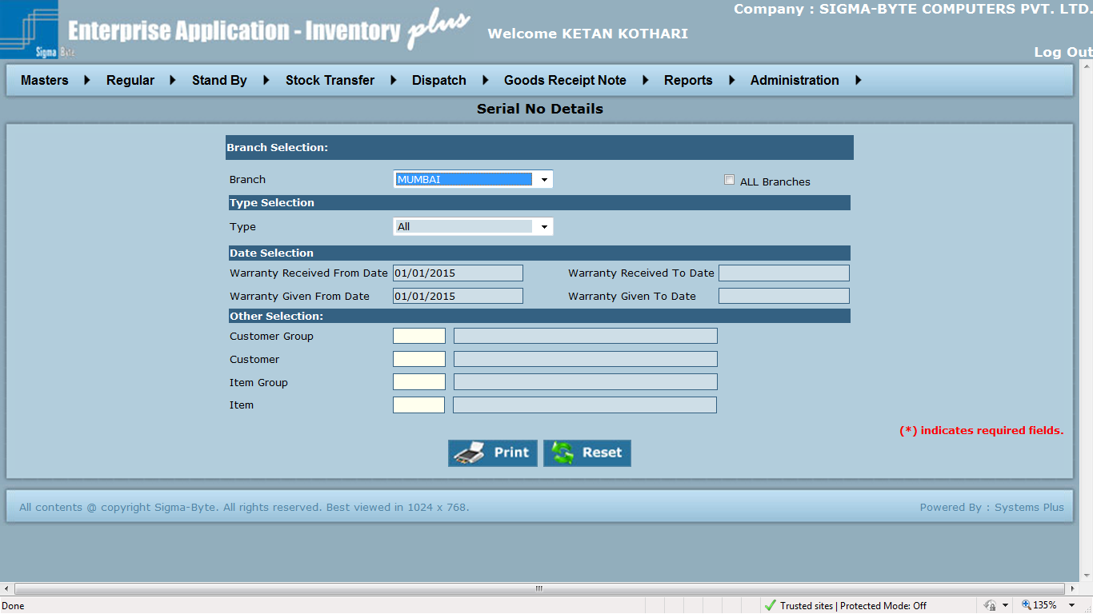

**Field Description**

|  |  |
| --- | --- |
| **Field Name** | **Description** |
| Branch Name | To select Branch Name. |
| All Branches | Check this box to select all Branches. |
| Warranty Received From Date | To add Warranty Received From Date. |
| Warranty Received To Date | To add Warranty Received To Date. |
| Warranty Given From Date | To add Warranty Given From Date. |
| Warranty Given To Date | To add Warranty Given To Date. |
| Customer Group | To add Customer Group. |
| Customer | To add Customer. |
| Item Group | To add Item Group. |
| Item | To add Item. |
| Print | To Print the Report. |
| Reset | Reset all the fields on Reports screen. |

# Billing Details

**Overview**

**Stock Report has various reports as**

* SOF - Invoice Details Customer Wise
* Billing Details - Item Wise
* Billed DC Customer Wise
* Billing Details – Summary
* Customer Outstanding
* Customer Ledger
* Customer Ledger

### SOF - Invoice Details Customer Wise

**Overview**

SOF - Invoice Details Customer Wise **is used to view** SOF - Invoice Details Customer Wise **Report.**

**Page Snapshot:** SOF - Invoice Details Customer Wise

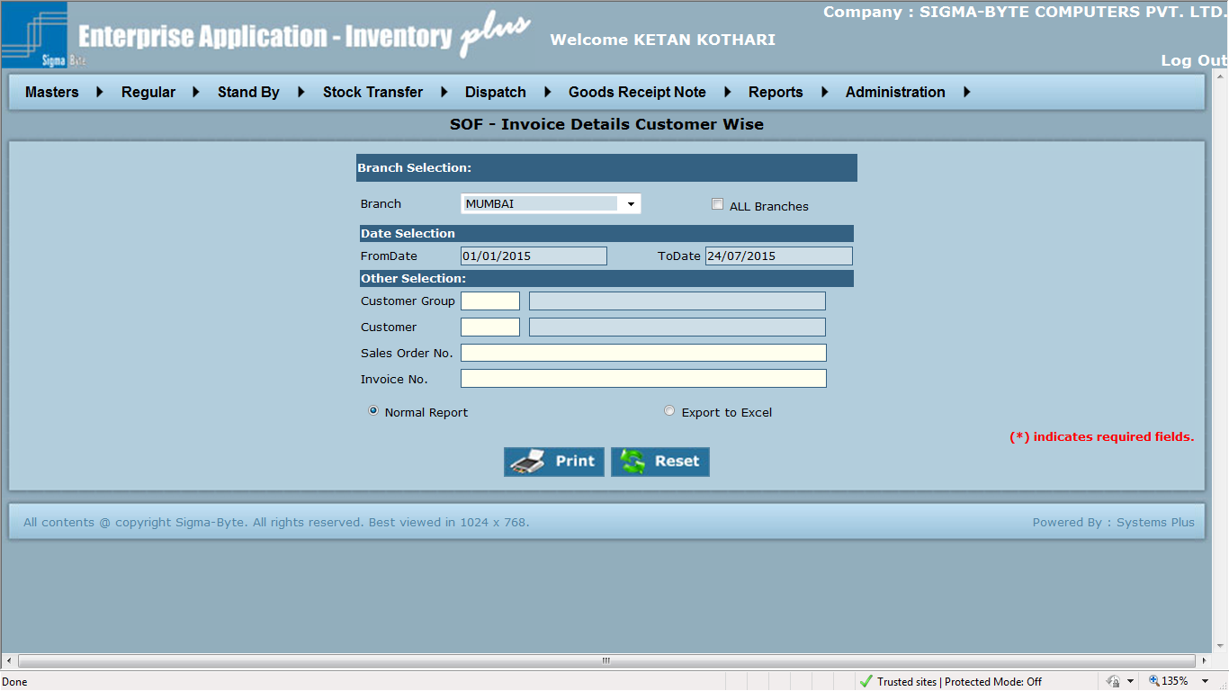

**Field Description**

|  |  |
| --- | --- |
| **Field Name** | **Description** |
| Branch Name | To select Branch Name. |
| All Branches | Check this box to select all Branches. |
| From Date | To add From Date. |
| To Date | To add To Date. |
| Customer Group | To add Customer Group. |
| Customer | To add Customer. |
| Sales Order No | To add Sales Order No. |
| Invoice No | To add Invoice No. |
| Normal Report | To print Report in general format. |
| Export To Excel | To print report in a format that could be exported to excel. |
| Print | To Print the Report. |
| Reset | Reset all the fields on Reports screen. |

### Billing Details - Item Wise

**Overview**

This report shows item wise invoice transactions. It shows the SOF quantity vs. Invoice quantity thus giving the Balance quantity.

**Page Snapshot: Billing Details - Item Wise**

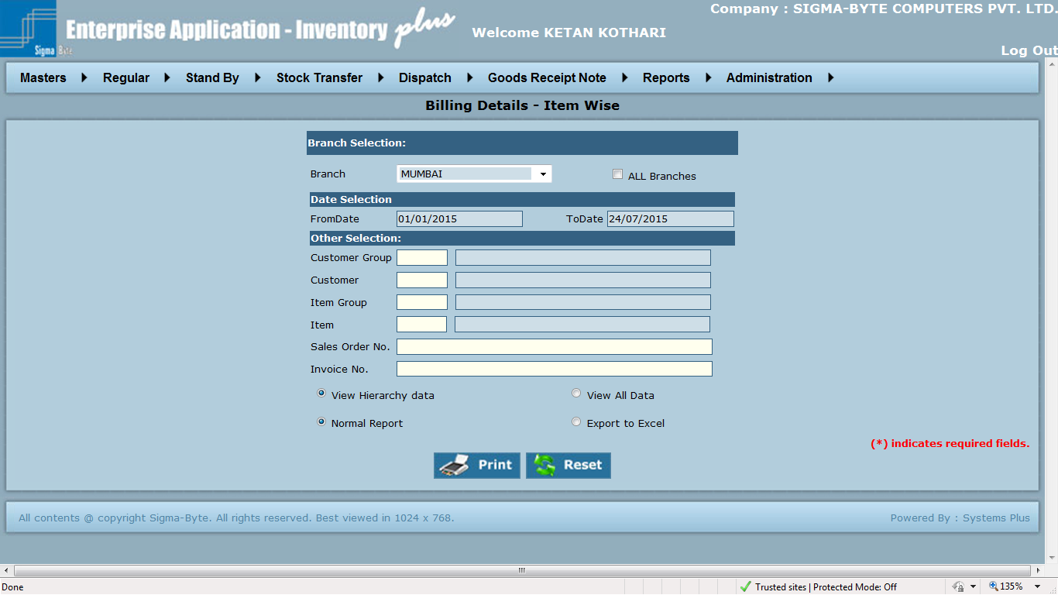

**Field Description**

|  |  |
| --- | --- |
| **Field Name** | **Description** |
| Branch Name | To select Branch Name. |
| All Branches | Check this box to select all Branches. |
| From Date | To add From Date. |
| To Date | To add To Date. |
| Customer Group | To add Customer Group. |
| Customer | To add Customer. |
| Item Group | To add Item Group. |
| Item | To add Item. |
| Sales Order No | To add Sales Order No. |
| View Hierarchy data | If view hierarchy data is selected and user clicks on print then, only his and hierarchy data will be displayed. |
| View all data | This will show data of all users irrespective of hierarchy |
| Normal Report | To print Report in general format. |
| Export To Excel | To print report in a format that could be exported to excel. |
| Print | To Print the Report. |
| Reset | Reset all the fields on Reports screen. |

### Billed DC Customer wise

**Overview**

This is a detailed report showing a comparison between DC quantity & Invoice quantity.

**Page Snapshot: Billed DC Customer Wise**

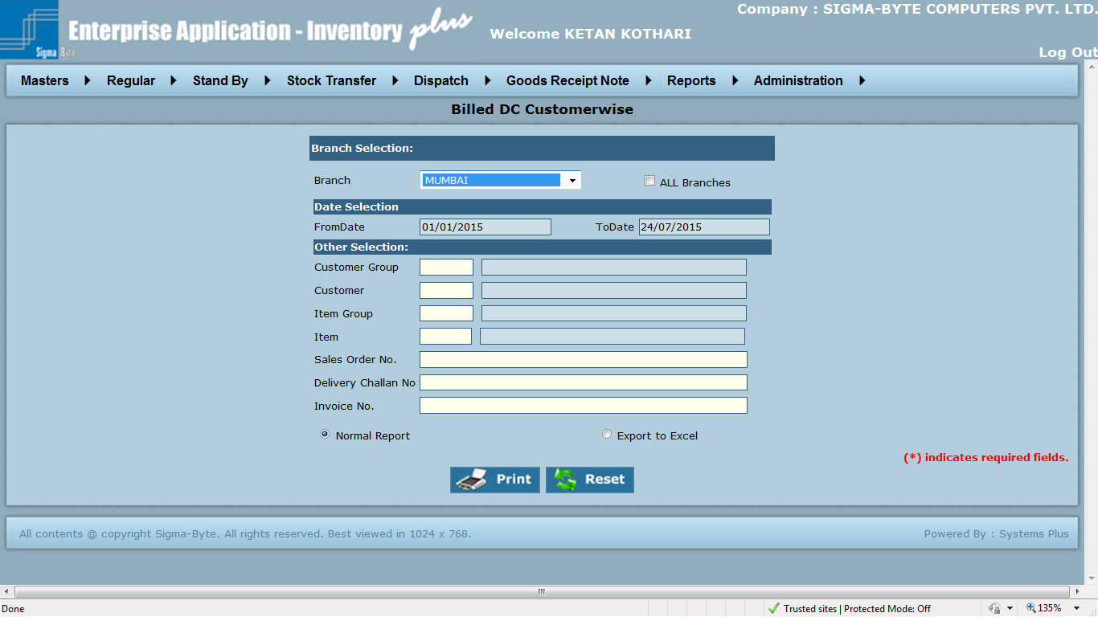

**Field Description**

|  |  |
| --- | --- |
| **Field Name** | **Description** |
| Branch Name | To select Branch Name. |
| All Branches | Check this box to select all Branches. |
| From Date | To add From Date. |
| To Date | To add To Date. |
| Customer Group | To add Customer Group. |
| Customer | To add Customer. |
| Item Group | To add Item Group. |
| Item | To add Item. |
| Sales Order No | To add Sales Order No. |
| Normal Report | To print Report in general format. |
| Export To Excel | To print report in a format that could be exported to excel. |
| Print | To Print the Report. |
| Reset | Reset all the fields on Reports screen. |

### Billing Details - Summary

**Overview**

This report gives an insight into the total transactions (amount wise) done for a particular customer. It shows the Customer order details on one side & Invoice details on other side, thus making it possible for a comparison in between both.

**Page Snapshot: Billing Details – Summary**

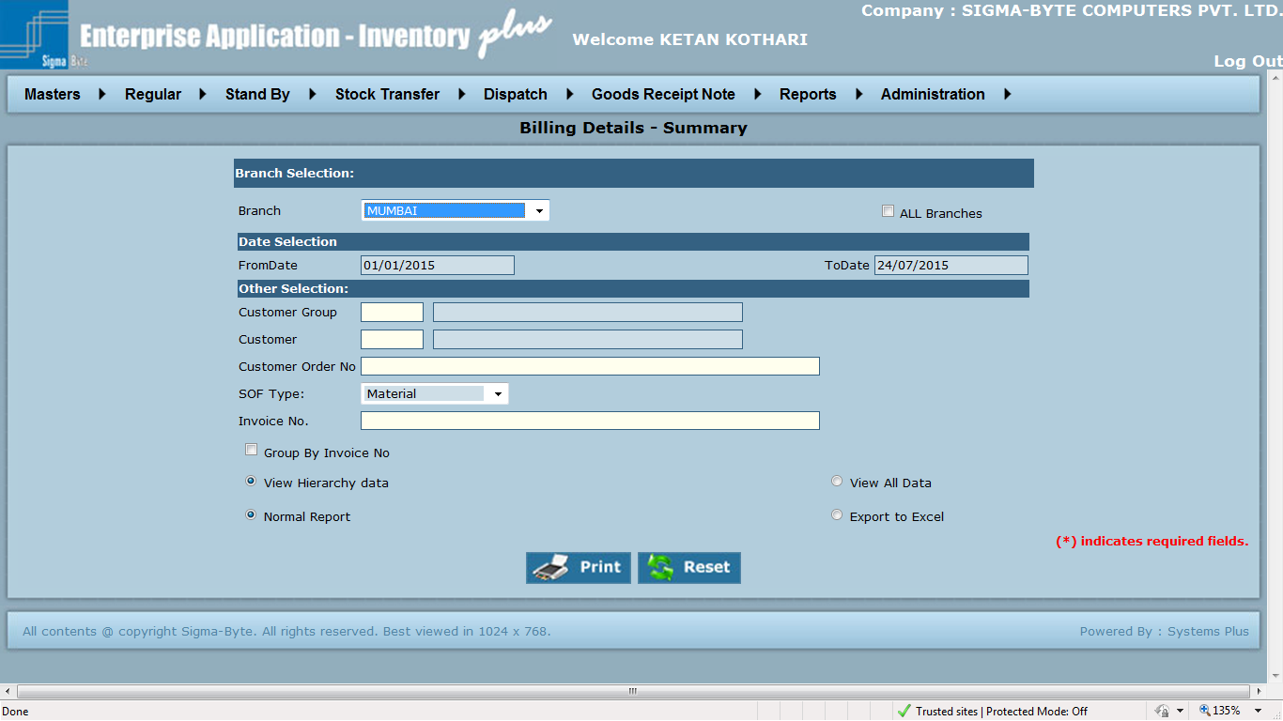

**Field Description**

|  |  |
| --- | --- |
| **Field Name** | **Description** |
| Branch Name | To select Branch Name. |
| All Branches | Check this box to select all Branches. |
| From Date | To add From Date. |
| To Date | To add To Date. |
| Customer Group | To add Customer Group. |
| Customer | To add Customer. |
| Sales Order No | To add Sales Order No. |
| View Hierarchy data | If view hierarchy data is selected and user clicks on print then, only his and hierarchy data will be displayed. |
| View all data | This will show data of all users irrespective of hierarchy |
| Normal Report | To print Report in general format. |
| Export To Excel | To print report in a format that could be exported to excel. |
| Print | To Print the Report. |
| Reset | Reset all the fields on Reports screen. |

### Customer Outstanding

**Overview**

Customer Outstanding **is used to** Customer Outstanding **Report.**

**Page Snapshot: Customer Outstanding**

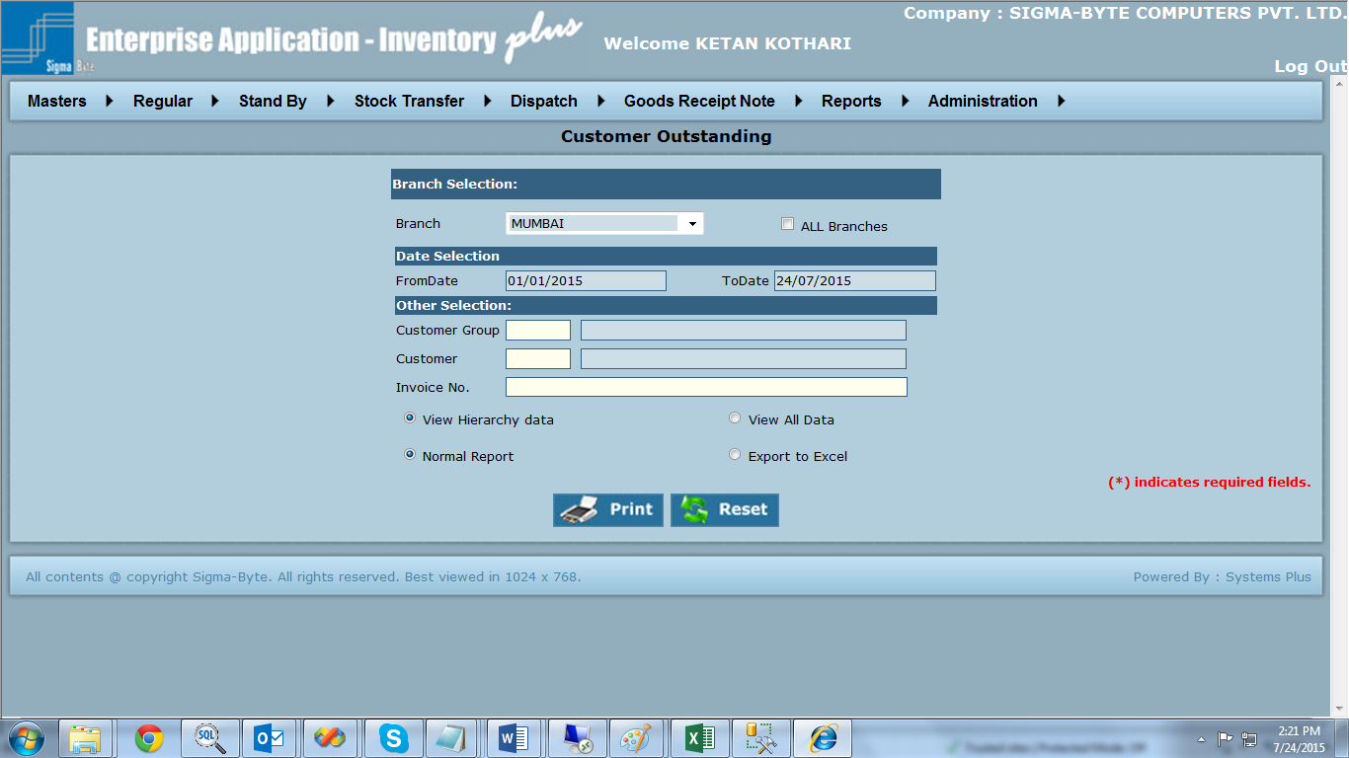

**Field Description**

|  |  |
| --- | --- |
| **Field Name** | **Description** |
| Branch Name | To select Branch Name. |
| All Branches | Check this box to select all Branches. |
| From Date | To add From Date. |
| To Date | To add To Date. |
| Customer Group | To add Customer Group. |
| Customer | To add Customer. |
| Invoice No | To add Invoice No. |
| View Hierarchy data | If view hierarchy data is selected and user clicks on print then, only his and hierarchy data will be displayed. |
| View all data | This will show data of all users irrespective of hierarchy |
| Normal Report | To print Report in general format. |
| Export To Excel | To print report in a format that could be exported to excel. |
| Print | To Print the Report. |
| Reset | Reset all the fields on Reports screen. |

### Customer Ledger

**Overview**

Customer Ledger **is used to** Customer Ledger**.**

**Page Snapshot: Customer Ledger**

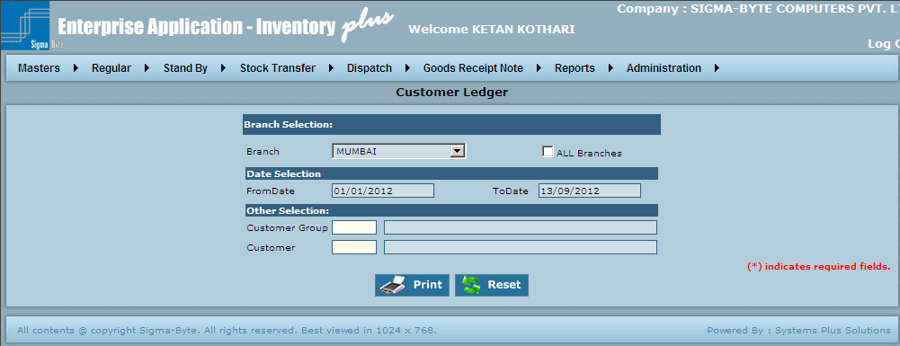

**Field Description**

|  |  |
| --- | --- |
| **Field Name** | **Description** |
| Branch Name | To select Branch Name. |
| All Branches | Check this box to select all Branches. |
| From Date | To add From Date. |
| To Date | To add To Date. |
| Customer Group | To add Customer Group. |
| Customer | To add Customer. |
| Print | To Print the Report. |
| Reset | Reset all the fields on Reports screen. |

### SOF-Invoice

**Overview**

SOF Invoice **is used to show the details of** SOF Invoice**.**

**Page Snapshot: SOF Invoice**

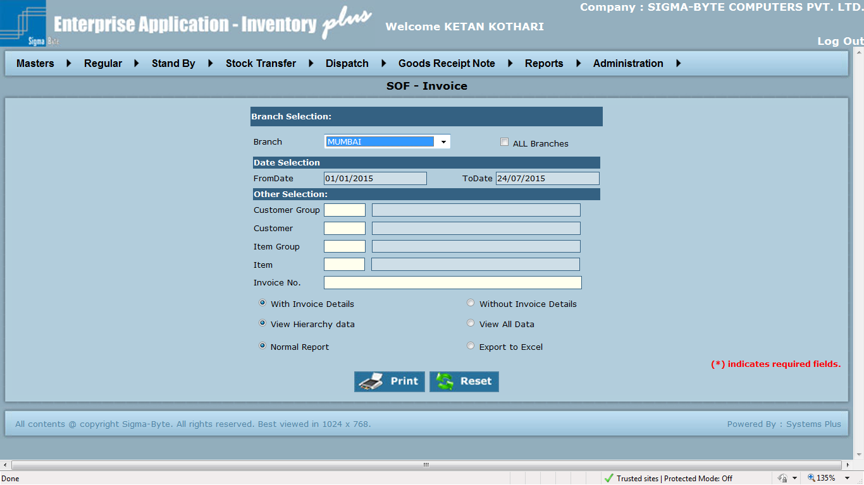

**Field Description**

|  |  |
| --- | --- |
| **Field Name** | **Description** |
| Branch Name | To select Branch Name. |
| All Branches | Check this box to select all Branches. |
| From Date | To add From Date. |
| To Date | To add To Date. |
| Customer Group | To add Customer Group. |
| Customer | To add Customer. |
| Item Group | To add Item Group. |
| Item | To add Item. |
| With Invoice Details |  |
| Without Invoice Details |  |
| View Hierarchy data | If view hierarchy data is selected and user clicks on print then, only his and hierarchy data will be displayed. |
| View all data | This will show data of all users irrespective of hierarchy |
| Normal Report | To print Report in general format. |
| Export To Excel | To print report in a format that could be exported to excel. |
| Print | To Print the Report. |
| Reset | Reset all the fields on Reports screen. |

# Pending DC For Invoice

**Overview**

**Pending DC for Invoice – IOF**: This report gives a list of all the IOFs which are still pending for complete execution. The listed IOF have been partially executed.

**Pending DC for Invoice – SOF**: This report gives a list of all the SOFs which are still pending for complete execution. The listed SOF has been partially executed.

**Pending DC for Invoice – All**: This is a combination report of Pending DC for Invoice – IOF & Pending DC for Invoice – SOF. This report gives a combined list of IOFs & SOFs still pending for complete execution.

Pending DC for Invoice **has various reports as**

* **Item Wise**
* **Item Wise(Value)**
* **Customer Wise**
* **Customer Wise(Value)**

### Item Wise

**Page Snapshot: Item Wise**

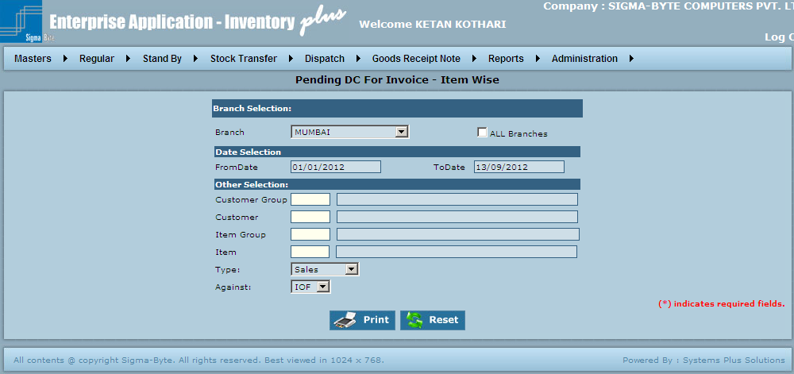

**Field Description**

|  |  |
| --- | --- |
| **Field Name** | **Description** |
| Branch Name | To select Branch Name. |
| All Branches | Check this box to select all Branches. |
| From Date | To add From Date. |
| To Date | To add To Date. |
| Customer Group | To add Customer Group. |
| Customer | To add Customer. |
| Item Group | To add Item Group. |
| Item | To add Item. |
| Print | To Print the Report. |
| Reset | Reset all the fields on Reports screen. |

### Item Wise (Value)

**Page Snapshot: Item Wise Value**

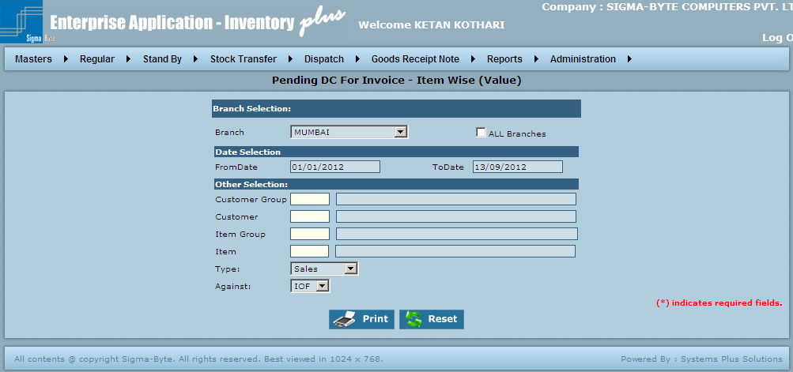

**Field Description**

|  |  |
| --- | --- |
| **Field Name** | **Description** |
| Branch Name | To select Branch Name. |
| All Branches | Check this box to select all Branches. |
| From Date | To add From Date. |
| To Date | To add To Date. |
| Customer Group | To add Customer Group. |
| Customer | To add Customer. |
| Item Group | To add Item Group. |
| Item | To add Item. |
| Type | To select Type. |
| Against | To select Against. |
| Print | To Print the Report. |
| Reset | Reset all the fields on Reports screen. |

### Customer Wise

**Page Snapshot: Customer Wise**

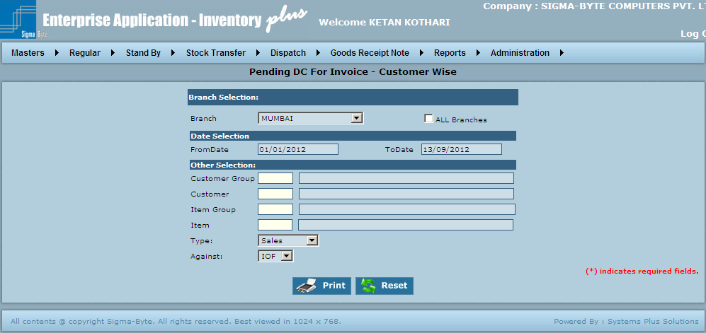

**Field Description**

|  |  |
| --- | --- |
| **Field Name** | **Description** |
| Branch Name | To select Branch Name. |
| All Branches | Check this box to select all Branches. |
| From Date | To add From Date. |
| To Date | To add To Date. |
| Customer Group | To add Customer Group. |
| Customer | To add Customer. |
| Item Group | To add Item Group. |
| Item | To add Item. |
| Type | To select Type. |
| Against | To select Against. |
| Print | To Print the Report. |
| Reset | Reset all the fields on Reports screen. |

### Customer Wise (Value)

**Page Snapshot: Customer Wise Value**

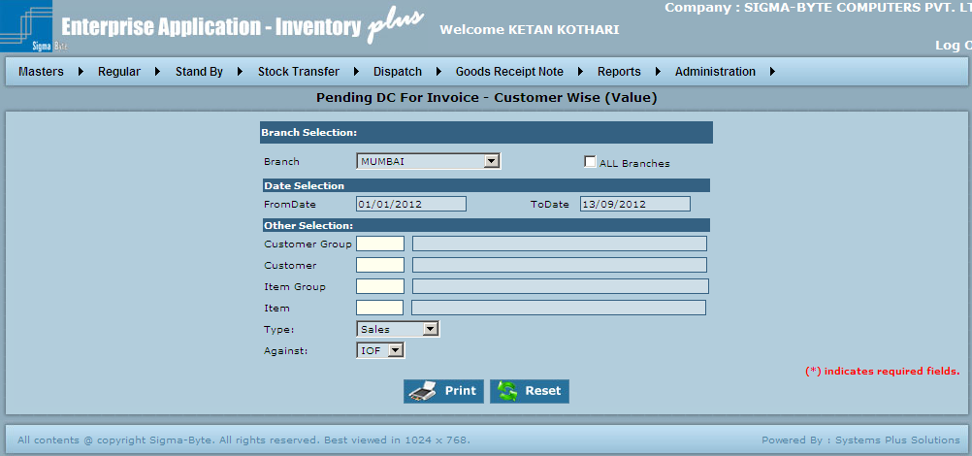

**Field Description**

|  |  |
| --- | --- |
| **Field Name** | **Description** |
| Branch Name | To select Branch Name. |
| All Branches | Check this box to select all Branches. |
| From Date | To add From Date. |
| To Date | To add To Date. |
| Customer Group | To add Customer Group. |
| Customer | To add Customer. |
| Item Group | To add Item Group. |
| Item | To add Item. |
| Type | To select Type. |
| Against | To select Against. |
| Print | To Print the Report. |
| Reset | Reset all the fields on Reports screen. |

# Weighted Average

**Overview**

Weighted Average has various reports as

* Customer Wise
* Unbilled

### Weighted Average Customer Wise

**Overview**

Weighted Average **Customer Wise Value is used to view** Weighted Average **Customer Wise Report.**

**Page Snapshot: Weighted Average Customer Wise**

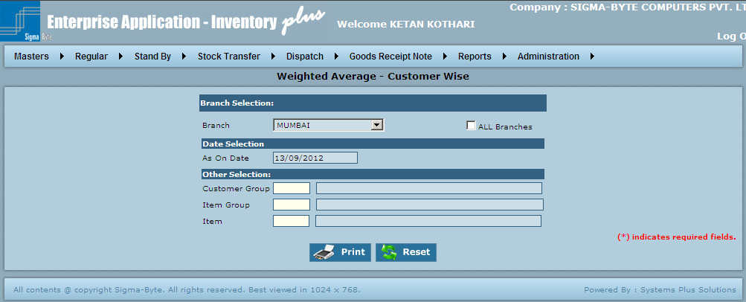

**Field Description**

|  |  |
| --- | --- |
| **Field Name** | **Description** |
| Branch Name | To select Branch Name. |
| All Branches | Check this box to select all Branches. |
| As On Date | To add As On Date. |
| Customer Group | To add Customer Group. |
| Item Group | To add Item Group. |
| Item | To add Item. |
| Print | To Print the Report. |
| Reset | Reset all the fields on Reports screen. |

### Unbilled Weighted Average

**Overview**

Unbilled Weighted Average **is used to view** Unbilled Weighted Average **Report.**

**Page Snapshot: Unbilled Weighted Average**

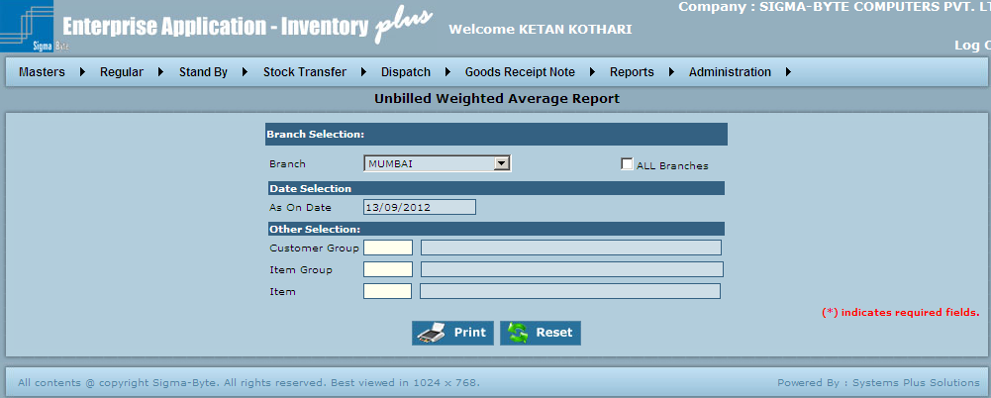

**Field Description**

|  |  |
| --- | --- |
| **Field Name** | **Description** |
| Branch Name | To select Branch Name. |
| All Branches | Check this box to select all Branches. |
| As On Date | To add As On Date. |
| Customer Group | To add Customer Group. |
| Item Group | To add Item Group. |
| Item | To add Item. |
| Print | To Print the Report. |
| Reset | Reset all the fields on Reports screen. |

# Weighted Average (Without Tax)

**Overview**

Weighted Average (Without Tax) has various reports as

* Customer Wise
* Unbilled

### Weighted Average - Customer Wise (Without Tax)

**Page Snapshot: Weighted Average - Customer Wise (Without Tax)**

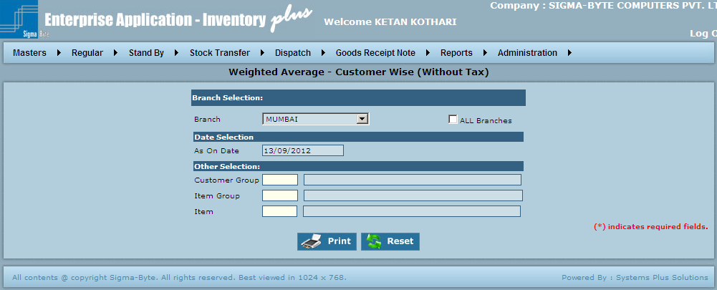

**Field Description**

|  |  |
| --- | --- |
| **Field Name** | **Description** |
| Branch Name | To select Branch Name. |
| All Branches | Check this box to select all Branches. |
| As On Date | To add As On Date. |
| Customer Group | To add Customer Group. |
| Item Group | To add Item Group. |
| Item | To add Item. |
| Print | To Print the Report. |
| Reset | Reset all the fields on Reports screen. |

### Unbilled Weighted Average Report (Without Tax)

**Page Snapshot: Unbilled Weighted Average Report (Without Tax)**

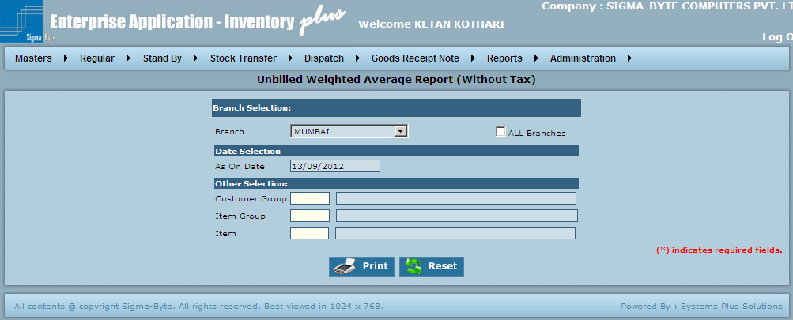

**Field Description**

|  |  |
| --- | --- |
| **Field Name** | **Description** |
| Branch Name | To select Branch Name. |
| All Branches | Check this box to select all Branches. |
| As On Date | To add As On Date. |
| Customer Group | To add Customer Group. |
| Item Group | To add Item Group. |
| Item | To add Item. |
| Print | To Print the Report. |
| Reset | Reset all the fields on Reports screen. |

# Bank Report

**Overview**

This report gives a summary report of the transactions of all or one item. This gives the stock on hand with the unit rate. Thus the total value of stock on hand can be calculated at any given point of time.

Bank Report has various reports as

* Item Wise
* Customer Wise

### Bank Report - Item Wise

**Page Snapshot: Bank Report - Item Wise**

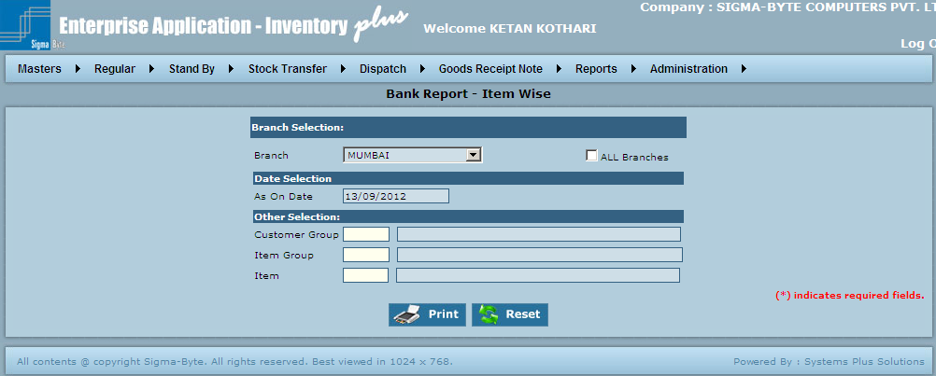

**Field Description**

|  |  |
| --- | --- |
| **Field Name** | **Description** |
| Branch Name | To select Branch Name. |
| All Branches | Check this box to select all Branches. |
| As On Date | To add As On Date. |
| Customer Group | To add Customer Group. |
| Item Group | To add Item Group. |
| Item | To add Item. |
| Print | To Print the Report. |
| Reset | Reset all the fields on Reports screen. |

### Bank Report - Customer Wise

**Page Snapshot: Bank Report - Customer Wise**

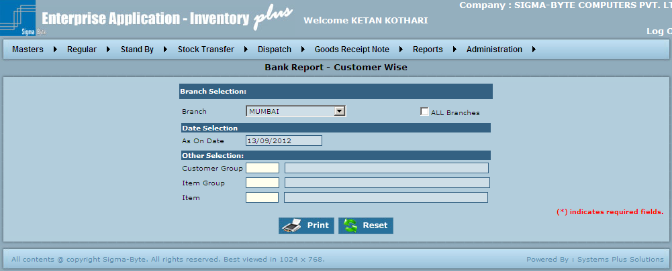

**Field Description**

|  |  |
| --- | --- |
| **Field Name** | **Description** |
| Branch Name | To select Branch Name. |
| All Branches | Check this box to select all Branches. |
| As On Date | To add As On Date. |
| Customer Group | To add Customer Group. |
| Item Group | To add Item Group. |
| Item | To add Item. |
| Print | To Print the Report. |
| Reset | Reset all the fields on Reports screen. |

# Bank Report (Without Tax)

**Overview**

This report gives a summary report of the transactions of all or one item. This gives the stock on hand with the unit rate. Thus the total value of stock on hand can be calculated at any given point of time.

Bank Report (Without Tax) has various reports as

* Item Wise
* Customer Wise

### Bank Report - Customer Wise (Without Tax)

**Page Snapshot: Bank Report - Customer Wise (Without Tax)**

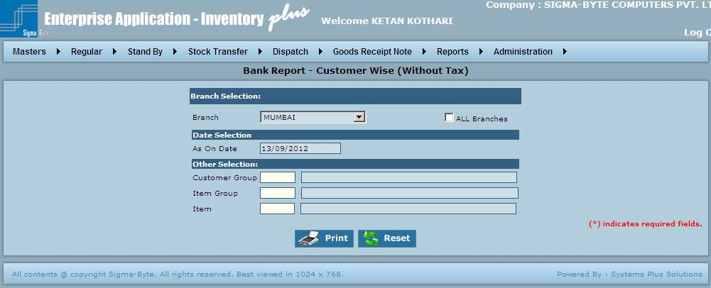

**Field Description**

|  |  |
| --- | --- |
| **Field Name** | **Description** |
| Branch Name | To select Branch Name. |
| All Branches | Check this box to select all Branches. |
| As On Date | To add As On Date. |
| Customer Group | To add Customer Group. |
| Item Group | To add Item Group. |
| Item | To add Item. |
| Print | To Print the Report. |
| Reset | Reset all the fields on Reports screen. |

### Bank Report - Item Wise (Without Tax)

**Page Snapshot: Bank Report – Item Wise (Without Tax)**

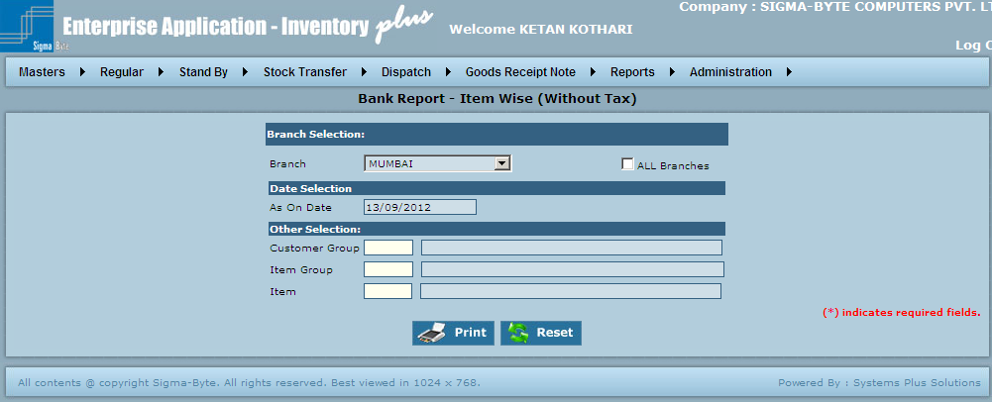

**Field Description**

|  |  |
| --- | --- |
| **Field Name** | **Description** |
| Branch Name | To select Branch Name. |
| All Branches | Check this box to select all Branches. |
| As On Date | To add As On Date. |
| Customer Group | To add Customer Group. |
| Item Group | To add Item Group. |
| Item | To add Item. |
| Print | To Print the Report. |
| Reset | Reset all the fields on Reports screen. |

# Stock Aging

**Overview**

This report gives a Customer wise summary of the age of stock allocated for a particular customer. It shows how much stock was allocated for a customer & since when was the stock allocated. The user has option of selecting one or more Branches, Customers, Groups & Items. It shows all the items in stock for a particular customer.

Aging has various reports as

* Item Wise
* Customer Wise
* Outstanding

### Stock Ageing - Item Wise

**Page Snapshot: Stock Ageing - Item Wise**

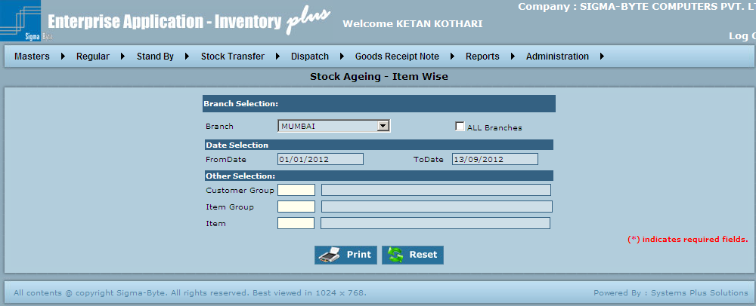

**Field Description**

|  |  |
| --- | --- |
| **Field Name** | **Description** |
| Branch Name | To select Branch Name. |
| All Branches | Check this box to select all Branches. |
| From Date | To add From Date. |
| To Date | To add To Date. |
| Customer Group | To add Customer Group. |
| Item Group | To add Item Group. |
| Item | To add Item. |
| Print | To Print the Report. |
| Reset | Reset all the fields on Reports screen. |

### Stock Ageing - Customer Wise

**Page Snapshot: Stock Ageing - Customer Wise**

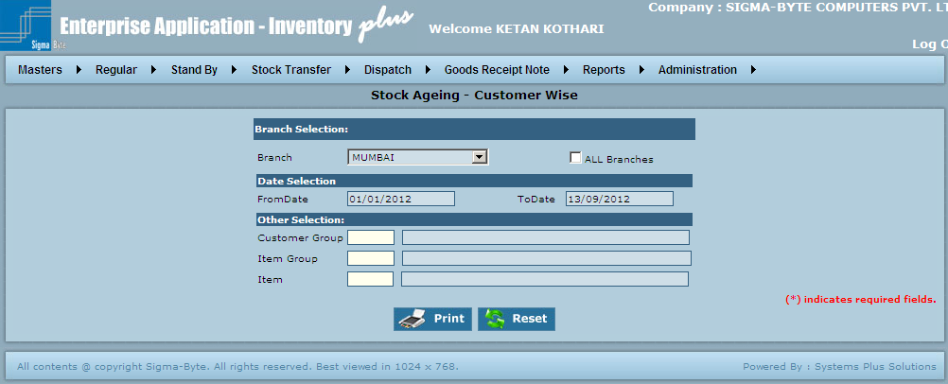

**Field Description**

|  |  |
| --- | --- |
| **Field Name** | **Description** |
| Branch Name | To select Branch Name. |
| All Branches | Check this box to select all Branches. |
| From Date | To add From Date. |
| To Date | To add To Date. |
| Customer Group | To add Customer Group. |
| Item Group | To add Item Group. |
| Item | To add Item. |
| Print | To Print the Report. |
| Reset | Reset all the fields on Reports screen. |

**Outstanding With Ageing Report**

**Page Snapshot: Stock Outstanding With Ageing Report**

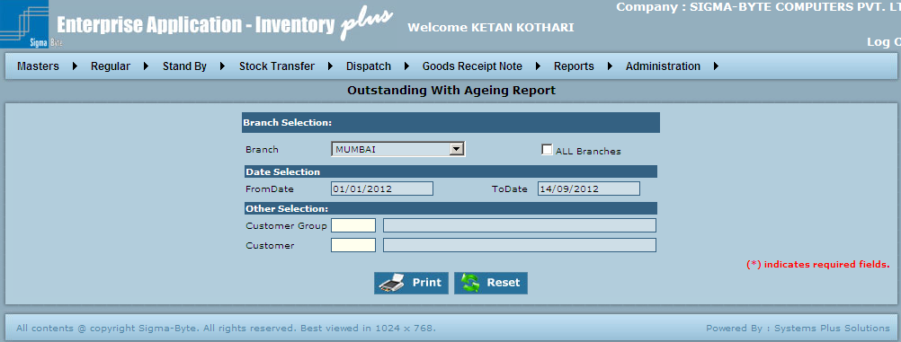

**Field Description**

|  |  |
| --- | --- |
| **Field Name** | **Description** |
| Branch Name | To select Branch Name. |
| All Branches | Check this box to select all Branches. |
| From Date | To add From Date. |
| To Date | To add To Date. |
| Customer Group | To add Customer Group. |
| Customer | To add Customer. |
| Reset | Reset all the fields on Reports screen. |

# PO Reminder

**Overview**

PO Reminder Report **is used to view** PO Reminder Report**.**

**Page Snapshot:** PO Reminder

**Field Description**

|  |  |
| --- | --- |
| **Field Name** | **Description** |
| Branch Name | To select Branch Name. |

